Virus

2015 Q 3

- The diagram shows the structure of a type of virus.

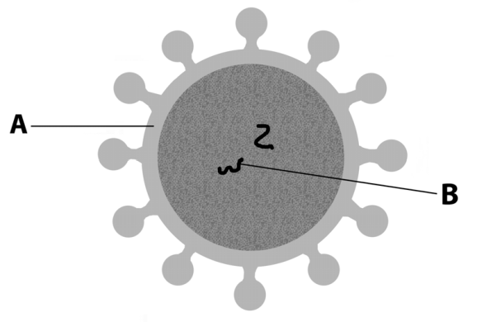

  - What is the main chemical constituent of part A?

  - Viruses are obligate parasites. What does this mean in relation to viruses?

  - B is one of two possible biomolecules. Name one of these.

  - Name one virus that causes disease in plants.

  - How do scientists distinguish between different viruses?

  - Viruses are difficult to classify into a kingdom. Why is this so?

  - Give one way in which viruses are economically important to humans.

2013 Q 12 a
- (a) (i) A virus has been described as a piece of genetic material that has escaped from a cell. Give one piece of evidence that supports this description.

- Viruses are examples of obligate parasites. Explain why this is the case.

- Give an example of how a virus might be beneficial to mankind.

2010 Q 6
6. The diagram shows a virus attached to a host cell.
Virus
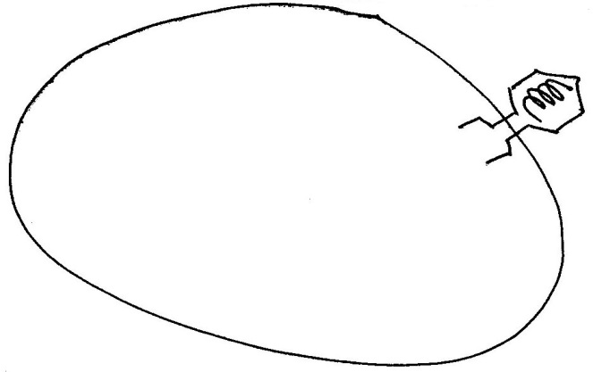
Host cell
B

A

(a)(i) What is part A made of ?
(ii) What is part B made of ?
(b) Briefly describe how viruses reproduce …
(c) During 2009 swine flu spread through the population of many countries. Younger people were more at risk of becoming ill with swine flu than older people. Using your knowledge of the immune system, suggest a reason for this.

2007 Q 14 b
(b) | (i)  (ii)  (iii)  (iv) | Comment on the difficulty of defining viruses as living organisms. What are the two main biochemical components of a virus particle? Name two diseases caused by viruses.  Give an example of a beneficial application of a virus.

2005 Q 15
  - (i) Comment briefly on the difficulty in classifying viruses as living organisms.
- Name two diseases of humans caused by viruses.

2015 Q 3

(a) Protein
(b) Can only replicate (or reproduce) in a cell
or can only replicate using a cell
(c) RNA or DNA
(d) mosaic (virus)
(e) Shape (of protein coat) or type of nucleic acid or antibody
(antigen) reaction or size or host species or structure
(f) Non cellular or no (cell) organelles
(g) Manufacture of vaccines or enhancement of plant phenotype (or
example) or used in medical research or control of bacteria
or genetic engineering (or described) or pathogenic
or biological control or harms plants (or harms animals)

2013 Q 12
- (a) (i) Composed of nucleic acid (or DNA or RNA)  - Can only replicate (or reproduce) inside a cell (or host)  - Genetic engineering or vaccine (production) or cancer treatment  or pest control or disease control | 3  3  3

2010 Q 6
6. | (a) | A = protein;  B = Nucleic acid or DNA or RNA | 3  3
 | (b) | Attachment / (viral) nucleic acid into (host) cell / uses host structures (or described) / part(s) replicated / virus assembly / release (or lysis)  Any three | 3(3)
 | (c) | (Older people) previous exposure / antibodies (or active immunity or memory cells) | 3 + 2

2007 Q 14 b
(b) | (i) | obligate parasite or explained / non-cellular / can be crystallised / no metabolism / one nucleic acid | 2(3)
 | (ii) | DNA or RNA or nucleic acid / protein | 2(3)
 | (iii) | smallpox / chicken pox / measles / polio / ‘flu / common cold / leaf mosaic / others [allow AIDS or HIV] | 2(3)
 | (iv) | bacteriophage or used in genetic engineering or vaccine production or vector (in disease treatment) | 3
 | (v) | substance produced by micro-organisms / that kills (some) micro- organisms or bacteria or fungi | 2(3)
 | (vi) | (antibiotics) have no effect (on viruses) or promote resistant bacteria | 3

2005 Q 15

- (i) non-cellular / one nucleic acid / can reproduce in host cell only
or obligate parasite / do not possess organelles or named organelle
any two 2(3)
- Cold / ‘flu / polio / rabies / mumps / measles / AIDS (HIV)
any two 2(3)
- B-cells/ T-cells or two named T cells e.g. helper / killer / suppressor / memory
any two 2(3)
B-cells – produce antibodies/agglutination or lysis / memory
T-cells – recognise / destroy infected or damaged cells / memory / activation / suppress immune system
Helper T – stimulate B cells or stimulate killer T cells/ recognise antigens / Killer T – Destroy infected or damaged cells /
Suppressor T – Switch off immune system or explained / Memory T – memorise antigen
any two 2(3)
- yes 3
in both cases the result is the production of antibodies 3

