Q 2014 12 a
i) Name the structures found in stems, equivalent to stomata in leaves, which are involved in gaseous exchange in plants.
(ii) Name two compounds that leave the plant through the structures referred to in part (i). (9)

MS 2014 12 a
(a) | (i) | *Lenticels |  |  | 3
 | (ii) | Water / carbon dioxide |  |  | 2(3)

Q 2014 14 b and c
(b) (i) Draw a diagram of a transverse section through a young dicotyledonous stem as seen under the low power lens of a microscope. Indicate on your diagram a location for each of the following: dermal tissue, ground tissue, vascular tissue.
(ii) 1. Which of the above tissue types has a different location in a young root?
2. Where precisely is the tissue type referred to in 1. found in the root?
3. Give one function of ground tissue.
(iii) Draw labelled diagrams to show the detailed structure of the two vascular tissues of plants.
(iv) Which of the tissues referred to in (iii) is composed of living cells?
(v) What is the function of meristematic tissue?
(c) (i) Explain how water enters root hairs and then passes to the vascular tissue.
(ii) In which of the vascular tissues will water now rise through the plant?
(iii) Give two features of the tissue referred to in (ii) that facilitate this upward movement of water.
(iv) Name and briefly explain any two processes involved in the upward movement of water in plants.

MS 2014 14 b

14. | (b) | (i) | Diagram: |  | 3, 0
 |  |  | Labels correctly located: |  | 3(1)
 |  | (ii) | 1. | *Vascular | 3
 |  |  | 2. | In the centre | 3
 |  |  | 3. | Support or storage or photosynthesis | 3
 |  | (iii) | Diagram 1 (phloem): tube + companion cell (or sieve plate) |  | 3, 0
 |  |  | [accept transverse section]
 |  |  | Diagram 2 (xylem): tube + 1 wall feature (or tapering ends) |  | 3, 0
 |  |  | Labels (diagram 1): phloem, sieve tube, sieve plate, companion cell
 |  |  | or (companion cell) nucleus, (sieve tube) cytoplasm
 |  |  | Labels (diagram 2): xylem, pits, thick wall, tracheid, vessel
 |  |  | [maximum of two labels from either diagram] |  | 3(1)
 |  | (iv) | Phloem |  | 3
 |  | (v) | Mitosis or cell division or growth or to produce new cells |  | 3

14. | (c) | (i) | Osmosis / soil water more dilute or cytoplasm of the root cells more
 |  |  | concentrated / cell to cell (by osmosis) |  | 3(3)
 |  | (ii) | *Xylem |  | 3
 |  | (iii) | Narrow / continuous tube (no end walls or open ended) or pits /
 |  |  | no cell contents / attraction of H2O to walls / thick wall |  | 2(3)
 |  | (iv) | Root pressure / transpiration / adhesion / cohesion |  | 2(3)
 |  |  | Two explanations:
 |  |  | Root pressure: | H2O in pushes H2O up
 |  |  | Transpiration: | H2O out pulls H2O up (or creates tension)
 |  |  | Adhesion: | H2O attracted to walls
 |  |  | Cohesion: | H2O (molecules) attracted to each other or allows
 |  |  |  | continuous stream | 2(3)

Q 2012 5
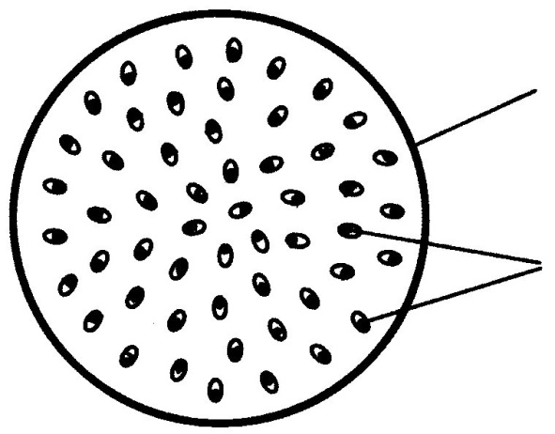
The diagram shows a transverse section through the stem of a monocotyledonous (monocot) plant.
Epidermis
A

(a) What is meant by the term monocotyledonous?
(b) Give an example of a monocotyledonous plant.
(c) Name the structures labelled A.
(d) How do you know from the diagram that the section is taken from:
(i) a stem?
(ii) a monocot?
(e) How are the veins arranged in the leaves of monocots?
(f) How does the vein arrangement in the leaves of dicot plants differ from that in monocots?

MS 2012 5
5. |  |  | 8 + 7 + 5(1)
 | (a) | One seed leaf or one embryonic leaf
 | (b) | Example of monocot
 | (c) | Vascular bundles
 | (d) | (i) More than one (vascular) bundle
(ii) Bundles scattered or described
 | (e) | Parallel or described
(f) Reticulate or net or branched or described

Q 2010 13 a
Give a role for each of the following parts of a flower: sepals, anther, stigma. (9)
MS 2010 13 a
(a) | Sepals: protect flower (or bud) or photosynthesis or attract insects | 3
 | Anthers: produce pollen | 3
 | Stigma: traps (or catches) pollen [allow where pollen lands if qualified] | 3

Q 2009 7
(a) (i) Why is a dicotyledonous (dicot) plant so called?
(ii) Name a dicotyledonous plant.

(b) (i) Describe in detail how you prepared a microscope slide of a transverse section of the stem of a dicotyledonous plant.
(ii) Give an account of the procedures that you followed in order to view your slide under the microscope
(iii) In the space below draw enough of your section to show and label the location of each of the following:
1. Phloem. 2. Xylem. 3. Ground tissue.

MS 2009 7
7. | (a) | (i) | Two embryonic leaves or two seed leaves | 3
 |  | (ii) | Any dicot named | 3
 | (b) | (i) | (Cut) thin (section) / (cut) away from self / with blade or scalpel or microtome / how transferred to slide / cover slip / how applied / (use of) water | 3(3)
 |  | (ii) | (Slide) onto stage / lamp on or mirror / adjust (light) / start with low power lens / how focused | 3(3)
 |  | (iii) | Diagram: | 3, 0
 |  |  | Labels: | 3(1)

Q 2008 14 c i
Draw a large labelled diagram of a transverse section through a young root.

MS 2008 14 c i
(i) | Diagram | 3, 0
 | Labels: dermal tissue, ground tissue, vascular tissue [accept xylem or
 | phloem for vascular] | 3(2)

Q 2007 6
6. The diagrams represent two forms of a vascular plant tissue, as seen under the microscope.
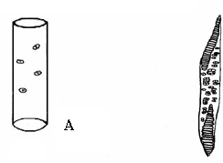

  - Name this vascular tissue
  - Identify the two forms of this tissue.
  - The walls of A and B are reinforced with a hard material. Name this material
  - Where precisely is this vascular tissue found in the stem of a young dicotyledonous plant?
(e) Name another vascular tissue

MS 2007 6
Q 6. | (a) | xylem |  | 2
 | (b) | A = vessel | B = tracheid | 2(6)
 | (c) | lignin |  | 2
 | (d) | vascular bundle | or next to phloem | 2
 | (e) | phloem | [allow animal example] | 2

Q 2006 14 c
The diagram shows part of a transverse section through a dicotyledonous stem.
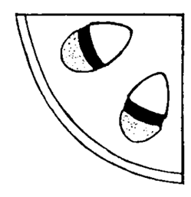

(i) Copy the diagram into your answer book and identify each of the following by placing the appropriate letter on your diagram:
phloem P, ground tissue G, xylem X, dermal tissue D.
(ii) In which of the tissues that you have identified are sugars mainly transported?
(iii) State a function of D.
(iv) In the course of your practical work you cut and observed a transverse section of a stem. Answer the following in relation to that procedure.
1. What did you use to cut the section?
2. How did you support the stem while you were cutting the section?
3. How did you transfer the section to a microscope slide?
(v) State one way in which a transverse section through a monocotyledonous stem differs from the one that you cut.

MS 2006 14 c
(i) 4 labels – P (phloem), G (ground tissue), X ( xylem),  D (dermal tissue) | 4(3)
(ii) P (phloem) | 3
(iii) protection or example of protection e.g. water loss, infection  or comment on turgor | 3
(iv) 1. blade or scalpel | 3
2. pith / holder / hand or implied | 3
3. mounted needle or section lifter or forceps or paintbrush | 3
(v) Difference: vascular bundles scattered | 3

Q 2004 4 a

- The diagram shows part of the under surface of a leaf as seen through the microscope. A is an aperture. B and C are cells.
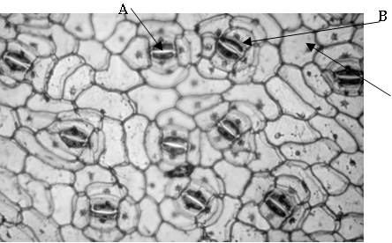

Name A, B, C.
What is the function of A? ……………………………………………….……………………. Name a factor that influences the diameter of A…………………………………...…………….….. Name the apertures in stems that are equivalent to A...…….………………………………………

MS 2004 4 a
A = stoma
B = guard cell
C = (epi)dermal cell
Function: To allow movement (exchange) of gas (or air or water vapour) or transpiration
Factor: CO2 (allow light or potassium ions or water)
Apertures: Lenticels or stomata

Q 2004 8
(a) Observation of a transverse section of a dicotyledonous stem reveals vascular and other tissues. Name two of the tissues that are not vascular tissues.
(b) Answer the following questions in relation to the preparation of a microscope slide of a transverse section of a dicotyledonous stem.
State one reason why you used an herbaceous stem rather than a woody one.
Explain how you cut the section.
Why is it desirable to cut the section as thinly as possible?
Draw a diagram of the section as seen under the microscope. Label the vascular tissues that can be seen.
State one precise function of each of the vascular tissues labelled in your diagram.

MS 2004 8
(a) dermal / ground / meristematic any two 2(3)
[allow correctly named tissue e.g. cambium]

(b) Why:
Easier to cut (thin) sections or relevant comment on tissue arrangement (e.g. easier to see vascular bundles) 3

Method described:
Cut thin / named instrument e.g. blade, microtome, scalpel / between nodes / named support e.g. pith, carrot, wax / at right angle (across) / any safety procedure stated /
any two 2(3)
To ensure light can pass through or to see (cells) clearly 3

Diagram 3, 0
[Diagram - section with vascular bundles in ring (4) or at least one bundle divided]
Labels: xylem and phloem in correct position  Functions: | labels | 3
Phloem:– transport of food (or minerals or auxins) |  | 3
Xylem:– transport of water or minerals |  | 3

