Q 2016 9
- (a) (i) Explain what is meant by the term dormancy in seeds.

(ii) How does digestion contribute to successful seed germination?

- Answer the following questions in relation to the investigation you carried out to show digestive activity during seed germination.

State whether you carried out this investigation using starch agar or skimmed milk (protein) agar.

  - Name a type of enzyme in the seed that carries out this digestion.

  - Why were the seeds soaked in water at the start of the investigation?

  - When preparing the seeds, they were also split and sterilised.

    - Why is it recommended that you sterilise the seeds?

    - Why were the split seeds placed open-side down on the agar?

  - How did you know that digestive activity had occurred on one of your investigation plates?

  - How did you know that digestive activity had not occurred on one of your investigation plates?

  - Give one reason for what you observed in part (v).

MS 2016 9
9. | (a) |  | 2(3)
 | (i) | Dormancy: Period of low (or no) metabolism or period during which germination
 |  |  | does not occur or period of no growth or period of low (or no) activity
 | (ii) | Contribution of digestion: To make nutrients (or food) soluble or to make nutrients (or
 |  | food) available or to make nutrients (or food) transportable (to the embryo)
 |  | or to make nutrients (or food) more easily absorbed (by embryo)
9. | (b) |  | 4(4) + 4(2)
Starch agar or skimmed milk agar: if neither stated, award maximum of six points i.e. [4(4) + 2(2)]
Enzyme in (i) must match named substrate i.e. starch or protein
Named reagent colour changes must match named substrate in parts (iv) and (v)
 | (i) | Type of enzyme: Amylase or protease (or named protease)
 | (ii) | Why soak seeds: To enable metabolic activity (or digestion) or to start up the
germination process or to allow nutrients dissolve (or to move) or to activate enzymes
or to soften the testa or to break dormancy
 | (iii) | 1. | Why sterilise seeds: To kill (or remove) all microorganisms
 |  | 2. | Why open-side down: Enzyme exposed to (or in contact with) the substrate
 | (iv) | How know had occurred: (Flooded plates with) iodine or biuret (solution)
 |  |  | Clear areas around (under) seeds (or described)
 | (v) | How know had not occurred: No clear areas or all areas stain positive colour
 | (vi) | Reason for observation in (v): Seeds were dead or enzyme had been denatured

Q 2015 Q 15 a
Answer any two of (a), (b), (c). (30, 30)

- Seeds may be classified as either endospermic or non-endospermic, based on whether food is stored in endosperm or cotyledon tissue. Seeds may also be either monocotyledonous or dicotyledonous.
  - Following fertilisation, from precisely which part of the flower is the seed formed?
  - What is meant by the term monocotyledonous?
  - Name two biomolecules stored in endosperm or cotyledon tissue.
  - Give one way knowledge of seed dormancy has been useful to humans.
  - The graph below shows the changes in dry mass of both endosperm and embryo tissue of a germinating endospermic seed over a three-week period after sowing. (Dry mass is the mass of a tissue with its water content removed.)

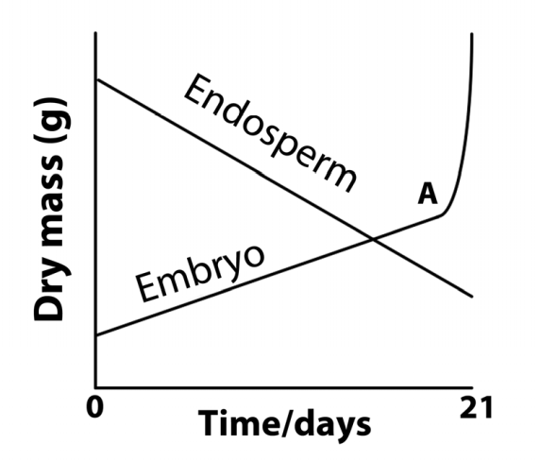
Time (days)

    - Suggest why the measurement of dry mass is preferred in these investigations.
    - Explain why the dry mass of the endosperm tissue decreases over the three weeks.
    - What process begins at A?
    - Would you expect the total dry mass of the seed (embryo plus endosperm) to have remained the same up to A?
Explain your answer.

MS 2015 Q 15 A
(a) | - *Ovule  - One seed leaf  - Lipids (or fats or oils) / protein / carbohydate (or named) / vitamin(s)  - How to store (seeds) or when to sow (seeds) or maximise the growing season or seed treatment before sowing (or examples)  - 1. Water content could vary between seeds  - Food is transferred to the embryo or respiration or loss of CO2  - *Photosynthesis  - (No as) it will lose mass  (Due to) respiration or loss of CO2 | 3
 |  | 3
 |  | 2(3)
 |  | 3
 |  | 3
 |  | 3
 |  | 3
 |  | 3
 |  | 3

Q 2014 7
- (a) (i) Name a part of a seed in which food for germination is stored.

(ii) Name the three factors necessary for seeds to germinate.

- Answer the following questions on seed germination.

  - At the start of the investigation to show digestive activity during germination the seeds were sterilised.

    - Why is this necessary?

    - How did you sterilise the seeds?

  - Name the substance that is used as a medium on which to germinate the seeds.

  - What substance, to be digested by the seeds, was added to the above medium?

  - What control did you use in this demonstration?

  - How did you demonstrate that digestive activity had taken place?

MS 2014 7
7. | (a) | (i) | *Cotyledon or *endosperm |  | 3
 |  | (ii) | Water / oxygen / suitable temperature (or warmth) |  | 3(1)
 | (b) | (i) | 1. | To kill (or inhibit) any microorganisms (or bacteria and fungi) | 3
 |  |  | 2. | Disinfectant or named disinfectant. | 3
 |  | (ii) | Agar |  | 3
 |  | (iii) | Starch or milk or protein |  | 3
 |  | (iv) | (Same set-up and procedure with) boiled seeds |  | 3
 |  | (v) | Iodine (or biuret) (solution) / negative result (or described) beneath
 |  |  | seeds / indicates the absence of (or digestion of) starch (or protein) |  | 3(3)

Q 2014 Q 14 A
(30, 30)
  - (i) Name:
    - the site of production of a pollen grain and
    - the structure on which it must land to complete pollination.
    - Name two methods of cross pollination.
    - Many species of plant have mechanisms that prevent self-pollination. Suggest how such plants could benefit from this.
    - Describe in detail the events that follow the arrival of a pollen grain at the destination referred to in (i), up to and including fertilisation.
    - Which part of a flower usually develops into a fruit?

MS 2014 Q 14 A

14. | (a) | (i) | Anther [accept stamen] | 3
 |  |  | *Stigma | 3
 |  | (ii) | Wind / animal (or example) / water | 2(3)
 |  | (iii) | Greater variation or explained or prevents inbreeding or explained | 3
 |  | (iv) | Pollen (grain) germinates or pollen tube produced / grows through
 |  |  | style / generative nucleus divides by mitosis / to form 2 (male) gametes
 |  |  | / entry into embryo sac / one (gamete) fertilises the egg (cell) /
 |  |  | one fertilises the polar nuclei. | 4(3)
 |  | (v) | *Ovary | 3

Q 2010 13 c
- (a) Give a role for each of the following parts of a flower: sepals, anther, stigma. (9)

- (i) Describe the development of pollen grains from microspore mother cells.
    - What is meant by the term fertilisation?
    - Give a brief account of the process of fertilisation in flowering plants. (27)

- (i) What is meant by the dormancy of seeds?
- Give one way in which the dormancy of seeds is of benefit to plants.
- Suggest one way in which a knowledge of dormancy is useful to farmers and gardeners.
- Water, oxygen and a suitable temperature are all required for the germination of seeds. In the case of each of these factors describe its effect on the process of germination.
- Which part of the embryo in a germinating seed gives rise to each of the following parts of the seedling?
  - The root
  - The shoot. (24)

MS 2010 13 c
13. | (a) | Sepals: protect flower (or bud) or photosynthesis or attract insects |  | 3
 |  | Anthers: produce pollen |  | 3
 |  | Stigma: traps (or catches) pollen [allow where pollen lands if qualified] |  | 3
 | (b) | (i) | Meiosis / 4 (or tetrad ) / haploid / micospores / (divides by) mitosis / tube and generative nucleus / pollen grain matures (or wall forms)  Any four | 4(3)
 |  | (ii) | Fusion of gametes or formation of zygote | 3
 |  | (iii) | Generative nucleus / mitosis / two male gametes (or nuclei) / one fuses with egg / to form zygote / other (male gamete or nucleus) fuses with (two) polar nuclei / to form endosperm  Any four | 4(3)
 | (c) | (i) | Period of reduced metabolism (or period of reduced activity) or period of no growth. | 3
 |  | (ii) | Survival or germination delayed until conditions suitable for growth or greater time for embryo development (or greater time for dispersal) or reduced competition | 3
 |  | (iii) | (Optimum) storage conditions or (optimum) sowing (or ploughing) time or (maximise) the growing season or seed treatment before sowing (or examples) | 3
 |  | (iv) | Water: for enzyme action (or example of enzyme action) or as a solvent or transport of materials or bursting the testa [allow washing away inhibitors]  Suitable required for (optimum or increased) enzyme activity  temperature:  Oxygen: needed for (aerobic) respiration
 |  |  |  | 3
 |  |  |  | 3
 |  |  |  | 3
 |  | (v) | 1. *Radicle | 3
 |  |  | 2. *Plumule | 3

Q 2012 14 A
  - (i) Give a brief account of the role of each of the following in flowering plant reproduction.
- Petal.
- Anther.
- Stigma.
- Name one structure through which the pollen tube grows in order to reach the embryo sac.
- Within the pollen tube the generative nucleus divides to form two male gametes.
  - What type of division takes place?
  - With what does each male gamete fuse in the embryo sac?
  - Name the product of each fusion.
- As the seed forms following fertilisation, a food store develops in one of two structures. Name any one of these structures.

MS 2012 14 A
14. (a) | (i) | 1. Attracts insects (or other pollinators) | 3
 |  | 2. (Site of) pollen manufacture or (site of) pollen release | 3
 |  | 3. Pollen lands on it or pollen sticks to it or pollen germination | 3
 | (ii) | Stigma or style or ovary or micropyle | 3
 | (iii) | - *mitosis  - egg [allow ovum or female gamete] polar nuclei | 3
 |  |  | 3
 |  |  | 3
3. *zygote |  |  | 3
endosperm (nucleus) |  |  | 3
 | (iv) | Endosperm or cotyledon (or seed leaf or embryonic leaf) | 3

Q 2010 13
(a) Give a role for each of the following parts of a flower: sepals, anther, stigma. (9)

- (i) Describe the development of pollen grains from microspore mother cells.
    - What is meant by the term fertilisation?
    - Give a brief account of the process of fertilisation in flowering plants. (27)

- (i) What is meant by the dormancy of seeds?
- Give one way in which the dormancy of seeds is of benefit to plants.
- Suggest one way in which a knowledge of dormancy is useful to farmers and gardeners.
- Water, oxygen and a suitable temperature are all required for the germination of seeds. In the case of each of these factors describe its effect on the process of germination.
- Which part of the embryo in a germinating seed gives rise to each of the following parts of the seedling?
  - The root
  - The shoot. (24)

MS 2010 13
13. | (a) | Sepals: protect flower (or bud) or photosynthesis or attract insects |  | 3
 |  | Anthers: produce pollen |  | 3
 |  | Stigma: traps (or catches) pollen [allow where pollen lands if qualified] |  | 3
 | (b) | (i) | Meiosis / 4 (or tetrad ) / haploid / micospores / (divides by) mitosis / tube and generative nucleus / pollen grain matures (or wall forms)  Any four | 4(3)
 |  | (ii) | Fusion of gametes or formation of zygote | 3
 |  | (iii) | Generative nucleus / mitosis / two male gametes (or nuclei) / one fuses with egg / to form zygote / other (male gamete or nucleus) fuses with (two) polar nuclei / to form endosperm  Any four | 4(3)
 | (c) | (i) | Period of reduced metabolism (or period of reduced activity) or period of no growth. | 3
 |  | (ii) | Survival or germination delayed until conditions suitable for growth or greater time for embryo development (or greater time for dispersal) or reduced competition | 3
 |  | (iii) | (Optimum) storage conditions or (optimum) sowing (or ploughing) time or (maximise) the growing seasoN or seed treatment before sowing (or examples) | 3
 |  | (iv) | Water: for enzyme action (or example of enzyme action) or as a solvent or transport of materials or bursting the testa [allow washing away inhibitors]  Suitable required for (optimum or increased) enzyme activity  temperature:  Oxygen: needed for (aerobic) respiration
 |  | V | RADICAL  PLUMULE

Q 2009 8
- (a) (i) What is meant by germination?
(ii) Why is digestion necessary in a germinating seed?

(b) (i) Digestive activity during germination can be demonstrated by using agar plates.
What is an agar plate?

- An extra food material is added to the agar plate for this demonstration.
Give an example of such an extra food material.
- Outline the procedures that you carried out in setting up this demonstration.

- What control did you use for this demonstration?

- What procedure did you carry out in order to show that digestive activity had taken place?

- Describe the results that you obtained in:
  - The experimental plate

  - The control plate.

MS2009 8
8. | (a) | (i)  (ii) | Growth of seed (or embryo part or of embryo)  To make (food) soluble or to make (food) transportable | 3  3
 | (b) | (i) | Petri dish containing a jelly (or solid medium) | 3
 |  | (ii) | Starch or milk | 3
 |  | (iii) | Soak (seeds) / split (seeds) / how sterilised correctly / position (seeds) on agar / keep plate warm or stated temperature (max. 35 oC) | 2(3)
 |  | (iv) | Boiled seeds | 3
 |  | (v) | Starch agar: Iodine (solution) or milk agar: biuret solution. | 3
 |  | (vi) | - No blue-black (under seeds) or no purple (under seeds)  - Blue-black (under seeds) or purple (under seeds) | 3  3

Q 2007 14 a
(a) | (i)  (ii)  (iii)  (iv)  (v) | From what structure in the carpel does the seed develop? State two locations in the seed where food may be stored.  The embryo plant within the seed has a number of parts. List two of these parts, apart from food stores, and give a role for each of them.  Following dispersal, the seed undergoes a period of dormancy. What is dormancy? Suggest two advantages of dormancy.

MS 2007 14a

(i) | ovule* | 3
(ii) | cotyledon / endosperm | 2(3)
(iii) | radicle / plumule | 2(3)
 | develops root / develops shoot | 2(3)
(iv) | when it does not germinate (despite favourable conditions) or period of low metabolism or explained | 3
(v) | germination at suitable time / time for embryo to develop / survival of plant during unfavourable conditions / increased dispersal | 2(3)

Q 2009 Q 15 A

- Answer any two of (a), (b) and (c). (30, 30)

(a) (i) What is meant by vegetative propagation?
- Horticulturists use a number of methods to artificially propagate plants. Suggest one advantage of artificial propagation.
- Describe two methods used by horticulturists to artificially propagate plants.
- Give two differences between vegetative propagation and propagation involving seeds.
- Seeds and fruits need to be dispersed. Give:
  - Two methods of dispersal.
  - Two advantages of dispersal to the plant.

MS 2009 Q 15 A
15. | (a) | (i) | Production of new plant from root or from stem or from leaf or  plant asexual reproduction (or described) | 3
 |  | (ii) | Fast or preserves desirable features or cheap or more reliable | 3
 |  | (iii) | Cuttings (or described) / layering (or described) / grafting (or described) / micro propagation (or described) | 2(3)
 |  | (iv) | No gametes (or one parent) / identical plants or example / rapid production / no outside agent | 2(3)
 |  | (v) | - Wind / animal / self (or mechanical) / water  - Colonisation / reduces competition / elaboration of competition | 2(3)  2(3)

Q 2007 14 A
(i)  (ii)  (iii)  (iv)  (v) | From what structure in the carpel does the seed develop? State two locations in the seed where food may be stored.  The embryo plant within the seed has a number of parts. List two of these parts, apart from food stores, and give a role for each of them.  Following dispersal, the seed undergoes a period of dormancy. What is dormancy? Suggest two advantages of dormancy.

MS 2007 14 A
(i) | ovule* | 3
(ii) | cotyledon / endosperm | 2(3)
(iii) | radicle / plumule | 2(3)
 | develops root / develops shoot | 2(3)
(iv) | when it does not germinate (despite favourable conditions) or period of low metabolism or explained | 3
(v) | germination at suitable time / time for embryo to develop / survival of plant during unfavourable conditions / increased dispersal | 2(3)

Q 2006 14 A
- Answer the following in relation to sexual reproduction in flowering plants.
  - State a role for each of the following: sepal, anther, stigma, ovary.
  - Distinguish between pollination and fertilization.
  - The two male gametes in the pollen tube are derived from the generative nucleus. Do these gametes form as a result of mitosis or meiosis? Explain your answer.
  - Describe the fate of each of the male gametes.
  - State one method that is used to produce seedless fruits.

MS 2006 14 A

(i) sepal: protection / photosynthesis / attracts insects | 3
anther: pollen - production or storage or release) | 3
stigma: receives pollen  ovary: produces or contains ovule or embryo sac or  female gametes/ becomes fruit / site of fertilisation | 3  3
(ii) Pollination v fertilisation:  transfer (of pollen) versus fusion | 3
(iii) mitosis  from haploid (generative nucleus) or chromosome number retained or two (daughter cells) produced | 3  3
(iv) one fuses with “egg” (nucleus) | 3
other fuses with (primary) endosperm nucleus or polar nuclei | 3
(v) growth regulator / selective propagation | 3

Q 2004 14 A
  - The diagram shows a vertical section through a carpel.

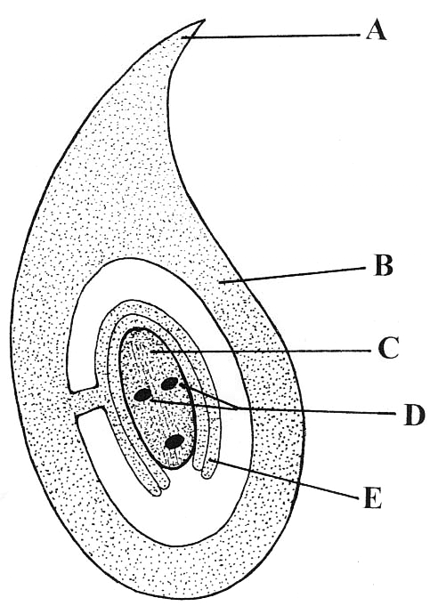

    - Name A, B, C, D, E.
    - What happens to the two nuclei labelled D?
    - In the case of B and E state what may happen to each of them after fertilisation.
    - Copy the diagram into your answer book and add a pollen tube that has completed its growth. Label the nuclei in the pollen tube.

MS 2004 14 A
  - A = stigma or style 2
B = ovary 2
C = embryo sac (allow nucellus) 2
D = polar nuclei 2
E = ovule (allow integuments) 2

  - What happens to D:
Fuse / form diploid (or primary endosperm) / (then fusion) to triploid or
fertilisation / endosperm nucleus 2

  - E becomes the seed or testa 2
B becomes the fruit 2

Diagram 6, 3, 0
2 named nuclei labels 2(2

