**RNA**

Ok, so you know that DNA stays in the nucleus and stored messages… well how does it’s message get sent to the rest of the cell? The answer is RNA.

RNA exactly like DNA in every way EXCEPT:

1. It is made with **ribose**, not deoxyribose.
2. It tends to form **single strands**, not double.
3. It has no Thymine (T) – instead it has **Uracil (U**).

RNA has several jobs in the cell, but right now we’re going to focus on ONE job – as a messenger as **messenger RNA (mRNA)**.

mRNA is used to take a message from the DNA and take it to where it’s needed in the cell (see next lesson on Protein Synthesis). To do so, the DNA molecule is opened up in the correct place and **copied into RNA** by an enzyme called **RNA polymerase**.

Use your knowledge of the base pair rule to transcribe these single DNA strands into mRNA (remember Uracil…)

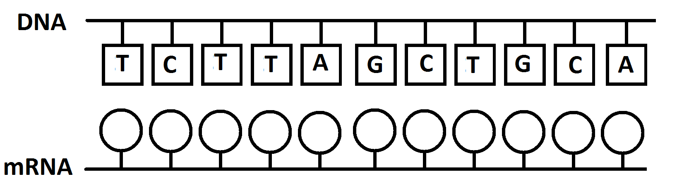

**Summary Questions**:

1. What shape is a DNA molecule?
2. What does DNA stand for?
3. What are the four bases? What does each bond with?
4. What are the differences between DNA and RNA?
5. What is the process of ‘coding’ DNA into RNA called?