Respiration
Q 2016 11

- (i) In the context of cell metabolism what does NAD stand for?
(ii) Name two types of particles that are transferred by NAD

(c ) Answer the following questions from your knowledge of respiration.
- Name the 3-carbon molecule that is an intermediate compound in both aerobic and anaerobic respiration.
- What name is given to the biochemical pathway by which this intermediate compound is produced?
- What happens to the intermediate compound referred to in (i) above when oxygen is available and used in the breakdown of glucose? In your answer refer to:
- Krebs cycle.
- Electron transport system.
- What is produced from the intermediate compound referred to in (i) above when oxygen is not
available
- in muscle?
- in yeast?

MS 2016 11

- (i) Nicotinamide Adenine Dinucleotide
(ii) Electrons and Hydrogen ions

(c) (i) Pyruvate or pyruvic acid
(ii) Glycolysis
(iii) Converted to Acetyl (co-enzyme A) or enters mitochondrion
1. or Kreb’s cycle: CO2 produced/ ATP produced/ NADH production
2. or electron transport system: protons (or H+ ions) combine with O2 or electrons (e-) combine with O2/ to form water/ energy to ADP and P/ to make ATP
Any one further point from 1 or from 2
(iv) 1. Lactic acid or Lactate
2. Ethanol (and carbon dioxide)

Q 2015 12 (c)

The diagram below represents stages in respiration in yeast cells.

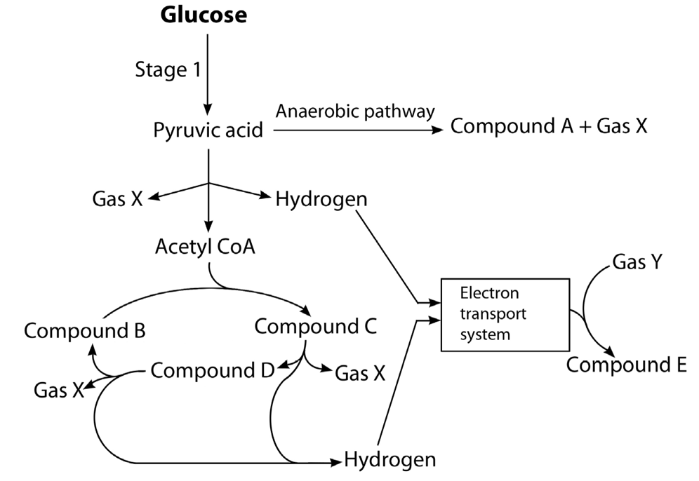
Other
compounds
D

- Name Stage 1 and state its location in yeast cells.

- Copy the table below into your answer book and complete it by inserting a letter or name, from the diagram above, to identify a compound which has the number of carbon atoms shown.

Number of carbon atoms | Compound
6
3
2

- Name Gas X and Gas Y.

- Name the compound D and give two functions of this compound in yeast cells.

MS 2015 12 (c)

(i) Name: *Glycolysis

Location: *Cytosol (or *cytoplasm)

(ii)
Number of carbon atoms | Compound
6 | Glucose or (Compound C)
3 | Pyruvic acid
2 | Acetyl CoA or (Compound A)

(iii)
Gas X: *Carbon dioxide [accept CO2]
Gas Y: *Oxygen [accept O2]

(iv) Compound D: *Water [accept H2O]
Two functions solvent / biochemical reactant / maintain
(constant) temperature / maintain shape / transport /

Q 2014 6
6. (a) Suggest an advantage of using ATP as an energy store in cells.
(b) Name two processes requiring ATP that occur in cells.
(c) Name two substances, other than carbon dioxide, into which pyruvate may be broken down under anaerobic conditions in cells.
(d) What is the name of the two-carbon compound into which pyruvate is broken down under aerobic conditions?
(e) Briefly describe the fate, under aerobic conditions, of the two-carbon compound referred to in part (d)

MS2014 6
(a) High-energy molecule (or bond) or easily broken down or easily re-formed or reusable
or energy easily released
(b) Any two named cell processes e.g. (photo)synthesis, respiration, (active) transport
mitosis (or named phase of mitosis)
(c) 1. Lactic Acid
2. Ethanol [accept alcohol]
(d) Acetyl (Co-enzyme A)
(e) Enters Krebs Cycle (or explained) or (broken down) to CO2 and H2O

Q 2013 14 (b) and (c)
(b) Write notes on each of the following topics. You are required to make a minimum of three points concerning each topic. Marks will not be given for word diagrams alone.
(i) Metabolism.
(ii) Krebs Cycle.
(ii) ADP.

(c) (i) Explain the term fermentation.
(ii) Name an organism that is used in industrial fermentation.
(iii) To which kingdom does this organism belong?
(iv) Name a compound which is used as a carbon source in the fermentation referred to in part (ii).
(v) In industrial fermentations bioprocessing with immobilised cells is sometimes used.
1. Explain the terms bioprocessing and immobilised.
2. Give an advantage of using immobilised cells.
3.Name the compound from which the immobilising beads are formed in the laboratory.
4. Give the general name for the vessel used for such reactions.

MS 2013 14 (b) and (c)
- If any ‘note’ consists only of a word diagram, flow-chart or chemical equation, then a maximum of two scoring points may be awarded.

(i) Metabolism:
(The sum of) all reactions in cell (or organism) / controlled by enzymes /
catabolism explained or catabolism + example /
anabolism explained or anabolism + example 4 + 2(3)

(ii) Krebs Cycle:
occurs in second stage of respiration / in mitochondria / when O2 present (or aerobic) / starts with Acetyl Co-enzyme A / ATP produced / hydrogen (pairs) produced or energised electrons /
CO2 produced 4 + 2(3)

(iii) ADP:
Adenosine di-phosphate / a low energy (molecule) / + phosphate (P) /+ energy / ATP formed 4 + 2(3)

(c) (i) Anaerobic respiration
(ii) Yeast
(iii) *Fungi
(iv) Any named carbohydrate
(v) 1. Bioprocessing: using micro-organisms (or enzymes)to form product(s)
Immobilised: fixed to inert material (or named material) or fixed to each other or trapped in gel (or named material)
2. Can be re-used (or recovered) or pure product (or described)
3. Alginate
4. Bioreactor 3

Q 2012 12 (c)
(c) Write a brief note on each of the following items in relation to respiration.
(i) Glycolysis.
(ii) Acetyl Co-enzyme A.
(iii) Adenosine triphosphate.
(iv) Electron transport chain.

MS 2012 12 (c)
(i) First stage of respiration / in cytoplasm (or in cytosol) / anaerobic / starts with glucose (or indicated) / produces pyruvate / low energy release
(ii) Aerobic / formed from pyruvate / 2-carbon (group) / joins Krebs cycle / in mitochondrion
(iii) High energy bonds (or high energy molecule) / energy store / releases energy/ forming ADP (or formed from ADP) / large ATP production in stage 2
(iv) Aerobic / in mitochondrion / carries high-energy electrons / from NADH or from Krebs cycle / to protons / formation of water / ATP produced or high energy release

Q 2011 6

- Cellular respiration may occur in one stage or two stages.
Give two differences, other than location, between Stage 1 and Stage 2.
- Where in a cell does Stage 1 occur?
- What term is used to describe respiration in which only Stage 1 occurs?
- Name a chemical end product of the type of respiration referred to in (c).
- In Stage 2 of respiration electrons pass along an electron transport chain, releasing energy. In what molecule is this energy stored in the cell?
- To what are these electrons transferred at the end of the electron transport chain?

MS 2011 6
(a) (i), (ii) Stage 1 does not require O2 or is anaerobic, produces a small amount of energy (or produces a small amount of ATP)
(b) Cytoplasm or cytosol
(c) Anaerobic or fermentation
(d) Ethanol or lactic acid or CO2
(e) ATP
(f) Oxygen or H+ (or protons)

Q 2009 12 (a)
(a) ATP and NAD / NADP+ play important roles in cell activities.

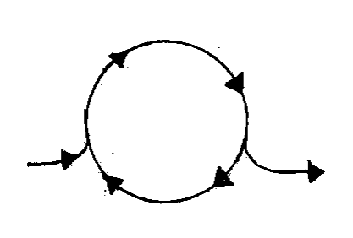
ATP
Y
in
X

Y Y
out

- Name the substance X, formed by the loss of a phosphate group.
- The ATP cycle is kept going by Y. What is Y?
- Suggest a role for NAD / NADP+ in cell activities

Q 2009 12 (b)

(b) (i) What name is given to the first stage of respiration?
(ii) The first stage ends with the formation of pyruvate (pyruvic acid). In anaerobic conditions, what is produced from this pyruvate:
1 In muscle cells?
2 In yeast cells?
(iii) If conditions are aerobic, pyruvate next passes to an organelle in which the second stage of respiration takes place. Name this organelle.
(iv) In this organelle pyruvate is broken down to CO2 and a two-carbon compound. Name this two-carbon compound.
(v) This two-carbon compound passes directly into a series of reactions in the second stage of respiration. Name this series of reactions and give one product, other than electrons, of these reactions.
(vi) The electrons released from the above reactions pass along a transport chain and in the process energy is released. To what use is this energy put?
(vii) At the end of the transport chain what happens to the electrons?

MS 2009 12 (a) and (b)
- (i) ADP
(ii) Energy
(iii) Capturing or transferring electrons or protons or hydrogen (ions)

- (i) Glycolysis
(ii) 1. Lactate (lactic acid)
2. Ethanol (and CO2)
(iii) Mitochondrion
(iv) Acetyl (Co-enzyme A)
(v) Krebs cycle
CO2 or ATP or Hydrogen ions or protons
(vi) Forming ATP (or described)
(vii) To oxygen or involved in H2O formation

Q 2008 5

(a) Write a balanced equation on the line below to represent aerobic respiration.
(b) The first stage of respiration takes place in the cytosol. What is the cytosol?
(c) Does the first stage of respiration release a small or large amount of energy?
(d) What is fermentation?
(e) Where in the cell does the second stage of aerobic respiration take place?
(f) Is oxygen required for the second stage of aerobic respiration?
(g) Suggest a situation in which some cells in the human body may not be able to engage in the second stage of aerobic respiration

MS 2008 5

- C6H12O6 + 6O2 → 6CO2 + 6H2O (+ energy)
- cytoplasm minus organelles (or structures or particles) or liquid part of cytoplasm
- Small
- anaerobic respiration or respiration that produces alcohol or respiration that produces lactic acid
- Mitochondrion
- Yes
- lack of oxygen or exercise or restricted blood supply

Q 2006 4

(a) What is the first stage process of respiration called?
(b) In this first stage there is a release of ATP as glucose is converted to another substance. Name this other substance
(c) To what is the substance you have named in (b) converted under anaerobic conditions in:
1. Yeast?
2. A human muscle cell?
(d) Under aerobic conditions the substance that you have named in (b) is converted to an acetyl group and in the process a small molecule is released. Name this small molecule.
(e) The acetyl group now enters a cycle of reactions. What name is given to this cycle
(f) Where in the cell does this cycle take place?

MS 2006 4

(a) | Glycolysis
(b) | pyruvic acid or pyruvate
(c) | 1. ethanol
 | 2. lactic acid or lactate
(d) | carbon dioxide
(e) | Krebs or citric acid or tricarboxylic acid (cycle)
(f) | Mitochondrion

Q 2005 11
(a) (i) Distinguish between aerobic and anaerobic respiration.
(ii) Write a balanced equation to summarise aerobic respiration. (9)

(b) Answer the following questions in relation to the first stage of respiration.
(i) Where in the cell does this stage occur?
(ii) During this stage a small amount of energy is released. Explain the role of ADP in relation to this released energy. What is the final product of this stage under aerobic conditions?
- If conditions in the cell remain aerobic the product you have named in (iii) is used for the second stage of respiration. Where does this second stage take place?
- If conditions in a human cell (e.g. muscle) become anaerobic the product named in (iii) is converted to another substance. Name this other substance.
- When the substance named in (v) builds up in the blood, a person is said to be in oxygen debt. This debt must eventually be paid. Suggest how the debt is paid.
(24)
- (i) If yeast cells are kept in anaerobic conditions alcohol (ethanol) and another substance are produced. Describe, with the aid of a diagram, how you would keep yeast under anaerobic conditions in the laboratory.
(ii) Name a carbohydrate that you would supply to the yeast as an energy source.
(iii) Give an account of a chemical test to demonstrate that alcohol (ethanol) has been produced. Include the initial colour and final colour of the test.
(iv) What is the other substance produced under anaerobic conditions?
(v) Alcohol (ethanol) production is an example of fermentation. How would you know when fermentation has ceased?
(vi) Why does fermentation eventually cease?

MS2005 11
(a) | (i) | Aerobic respiration requires oxygen or anaerobic respiration does not | 3
 | (ii) | C6H12O6  6O2 6H20 + 6CO2 | 6, 3, 0
(b) | (i) | Cytoplasm | 3
(ii) Uses energy / combines with phosphate / to form ATP/ ATP stores energy / high energy bond / energy transferred (by ATP) any three 3(3)
 | (iii) | Pyruvic acid (Pyruvate) | 3
 | (iv) | Mitochondrion | 3
 | (v)  (vi) | Lactic acid  Increased breathing (deeper or faster) or reference to oxidation of lactic acid or increased oxygen | 3  3
(c) | (i) | Diagram - vessel plus anaerobic conditions | 3
 |  | Label (comment) relating to anaerobic conditions | 3
 | (ii)  (iii) | Sugar or named sugar or starch  First reagent(s) or test named / any procedural point / initial colour / final colour / any three | 3  3(3)
(Potassium) dichromate / add acid or warm / orange / to green
Iodoform test or potassium iodide / add sodium hypochlorite or warm / colourless / to yellow
(iv) | Carbon dioxide | 3
(v) | No more bubbles given off | 3
(vi) | Alcohol kills yeast or yeast dies or sugar used up | 3

