2.2.5 - H.L 2.2.10 Respiration

At the end of ths section you should be able to ….

1. Define the term: aerobic respiration.
- Explain the role of aerobic respiration
- Express aerobic respiration by a balanced equation.
- Know respiration is a 2 stage process
- Know stage 1 does not require oxygen and releases a small amount of energy, occurs in cytosol
- Know Stage 2 does require oxygen and releases a large amount of energy, occurs in mitochondrion
- Define anaerobic respiration. Know it is a first stage process
- State the products of anaerobic respiration
- State the cellular location of the first & second stage.
Contemporary issue
- Explain the role of microorganisms in fermentation including bioprocessing with immobilised cells: procedure, advantages and use in bioreactors
H.L.2.2.10
11. Know the first stage reaction: Glycolysis
12. Know the fermentation option: alcohol and carbon dioxide or lactic acid production
13. Know the second stage process: details of Krebs cycle and electron transport system
Mandatory activity: Prepare & show the production of alcohol by yeast

Key words
Aerobic respiration, anaerobic respiration, cytosol, fermentation, bioreactor, sodium alginate, calcium chloride, glycolysis, iodoform, potassium iodide, sodium hypochlorite

- Definition of aerobic respiration: Controlled release of energy from food using oxygen.

- Role of aerobic respiration:
- Provide energy for cellular activity e.g. protein synthesis, DNA replication, and cell division.
- Provides carbon dioxide for photosynthesis.

- Balanced equation:
C₆H₁₂O₆ + 6O₂ = 6CO₂ + 6H₂O + energy.

Stages of respiration

Respiration is a two stage process:
- The first stage does not require oxygen and releases a small amount of energy;
- The second stage does require oxygen and releases a large amount of energy.

Note: Further detail on stages 1 and 2 under higher level P 3

- First stage process
Anaerobic respiration may occur in the presence of oxygen but does not use oxygen. It is therefore a first-stage process.
Anaerobic respiration is also known as Fermentation.

The products of Fermentation (anaerobic respiration) are lactic acid or alcohol and carbon dioxide.

Fermentation (Anaerobic respiration):

Glucose alcohol + carbon dioxide.

or
Glucose Lactic acid.

- Second-stage process

Aerobic respiration uses oxygen and is described as a second-stage process.

C₆H₁₂O₆ + 6O₂ = 6CO₂ + 6H₂O + energy.

Cellular location of the first and second stage process:
- The first stage process occurs in the cytosol (the cytoplasm minus the organelles).
- The second stage process occurs in the mitochondrion.

Contemporary issue:
Role of micro-organisms in industrial fermentation
Industrial fermentation:
- The use of micro-organisms to make a product e.g. alcohol or bread
- Also known as bioprocessing
- Carried out on a large scale in vessels called bioreactors.
- Can be carried out using immobilized enzymes (cells). Enzymes are attached to an inert material e.g. sodium alginate
Procedure
- Yeast is mixed with a sodium alginate .
- Drops of the mixture are added to a calcium chloride solution.
- Small beads with live, trapped yeast are formed.
- Nutrients can diffuse through the beads to the live yeast.
- The product will diffuse from the yeast .

Advantages of Immobilised Enzymes
- Easy recovery of enzymes for reuse.
- Easy recovery of products (no enzyme contamination).
- Greater enzyme stability.

Sodium alginate with entrapped enzyme
Uses of immobilised enzymes (cells)

To make alcohol

To produce glucose

To make lactose-free milk

H. 2.2.10 Higher level
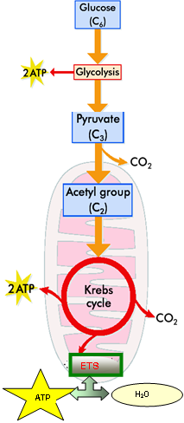
STAGE 1: GLYCOLYSIS

- The first stage process is referred to as Glycolysis
- Converts a six-carbon carbohydrate (glucose) to pyruvate with the generation of a small amount of ATP.

Under anaerobic conditions:
- the pyruvate molecule is converted or reduced to alcohol and carbon dioxide in most plant cells and yeast.
or
- the pyruvate molecule is reduced to lactic acid in most animal cells and
many bacteria

STAGE 2: KREBS CYCLE/ELECTRON TRANSPORT SYSTEM

In the second stage process under aerobic conditions, a series of reactions occurs:

- the pyruvate molecule enters the mitochondrion and is broken down to one molecule of carbon dioxide and a two-carbon acetyl group, acetyl Co-enzyme A.

- This Acetyl Co A enters a series called Krebs Cycle and leaves it later as CO₂ and H₂O.

- During this cycle an electron transport system operates to remove electrons from the substrate intermediates

- Electrons from the cycle are transferred through an electron transport chain (inner membrane of mitochondrion)

- Ultimately these are transferred to oxygen which combines with hydrogen to form water

- The energy released by these electrons through the chain is used in the production of ATP molecules (a large amount of energy is produced).

Note: The electron transport system cannot work in the absence of oxygen.

i) PREPARE AND (ii) SHOW THE PRODUCTION OF ALCOHOL BY YEAST

MATERIALS/EQUIPMENT
Yeast
Glucose
Sodium hypochlorite solution
Potassium iodide solution
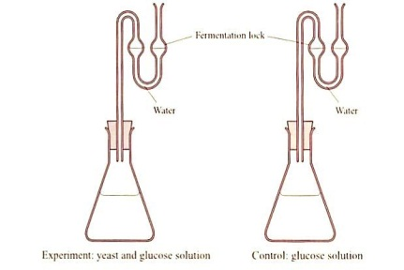Fermentation locks
DIAGRAM
(i) To prepare alcohol using yeast

Yeast and glucose
B
A
Glucose (control)

PROCEDURE
(i) To prepare alcohol using yeast
- Add yeast and glucose to conical flask A.
- Add glucose to flask B. This acts as a control .
- Attach a fermentation lock to each flask.
- Place both flasks in the incubator at 30 ºC overnight.

(ii) To show the presence of alcohol: Iodoform test for alcohol
- Filter the contents of each flask into test tubes.
- To each test tube, add potassium iodide solution
and sodium hypochlorite solution.
- Transfer to a water bath for 4-5 minutes.
- Allow to cool.
- Record and compare results.
- Replicate the investigation.

Results
Flask | Original colour of filtrate | Final colour filtrate
Yeast and glucose solution | Clear | Yellow crystals
Control (no yeast) | Clear | Clear

