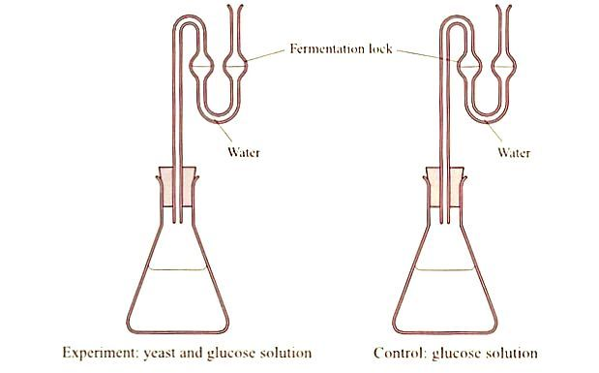

Procedure
To produce alcohol using yeast
- Prepare 500 cm³ of a 10% w/v glucose solution.
- Into each of the two conical flasks, add 250 cm³ of the 10% w/v glucose solution.
- To one, add 5g of yeast and swirl. Label this ‘yeast + glucose solution’
- The second flask acts as the control (has no yeast). Label as ‘control’.
- Attach a fermentation lock (half-filled with water) to each flask.
- Place both flasks in the incubator at 30 ºC overnight.

To show the presence of alcohol: Iodoform test for alcohol
- Remove both flasks from the incubator and filter the contents of each into separate beakers and label as before.
- Transfer 3 cm³ of the yeast and glucose filtrate into a test tube and label.
- Transfer 3 cm³ of the control filtrate into another test tube and label.
- To each test tube, add 3 cm³ of the potassium iodide solution and 5 cm³ of the hypochlorite solution.
- Warm gentlyfor 4-5 minutes in a water bath.
- Allow to cool and observe any change(s).
- Record and compare results.
- Replicate the investigations or cross reference your results with other groups.

Result
Flask | Original colour of filtrate | Final colour filtrate | Other changes
Yeast and glucose solution
Control (no yeast)

