Plant Responses

Q 2016 13 a
- (a) Growth regulators are important substances found in plants. They play a role in responses to environmental factors.

- What name is given to the regions of plants which secrete growth regulators?

- Give an example of a growth regulator which has a negative effect on plant growth.

- Explain the term thigmotropism.

MS 2016 13 a
(a) | (i) | Where growth regulators secreted: (Apical) meristems [Accept root tip or stem tip] |  | 3
 | (ii) | Negative regulator: Ethene or IAA (or any named growth regulator) |  | 3
 | (iii) | Thigmotropism: Growth response (of a plant) to touch |  | 3

Q 2015 8 c
(i) Describe how you carried out the investigation into the effect of IAA on plant tissue.

(ii) What were the results of your investigation?

MS 2015 8 c
(i) Some exposed to IAA and some not exposed to IAA

or tissue exposed to different concentrations of IAA

Leave for at least 2 days

Measure (or record) growth or compare growth

(ii) Description of how concentration (or IAA) changed growth (of tissue)

Q 2013 10 c
- State two ways in which growth regulators in plants are similar to hormones in animals.

- Name a plant growth regulator that promotes growth and give a precise location for a site of its action.

- Through which part of a stem are growth promoters transported?

- Outline two uses of growth promoters in horticulture.

- Give an example of a growth regulator that inhibits growth.

MS 2013 10 c
- Made at one site & function at another /  transport slow / in vascular tissue or in blood and phloem (or xylem) / chemical (nature)  - e.g. IAA (auxin)  Just behind shoot (or root) tip or meristem or zone of elongation  - Vascular bundles or vascular tissue or phloem or xylem  - (Encourage) rooting (in cuttings) / promote ripening / weed killer / seedless fruit / micro-propagation or tissue culture  - IAA / auxin / ethene (ethylene) / abscissic acid | 2(3)
 | 3
 | 3
 | 3
 | 2(3)
 | 3

Q 2011 11 a and b
(i) What do you understand by the term adverse external environment
(ii) Give two ways in which plants protect themselves from adverse external environments.
(b ) ( i) Name the group of substances in plants which control responses to external stimuli.
(ii) 1. What name is given to the regions in plants in which these substances are produced?
2. Give locations for two of these regions.
(iii) Most plant shoots are positively phototropic. Explain the underlined term.
- How does the plant benefit from this response?
- Explain the mechanism of response by a plant to a named external stimulus.

MS 2011 11 a and b

(a) | (i) | Surroundings that are harmful to organism(s) | 3
 | (ii) | Thick cuticle / changed transpiration (rate) / leaf fall / toxic parts / thorns / stings / dormancy / perennating organs / heat shock proteins Any 2 | 2(3)
(b) | (i) | (Plant) growth regulators or auxins (or other named group) | 3
 | (ii) | - Meristems  - Root tip / shoot (or stem) tip / bud / embryo (or named part) / fruit  / seed / between xylem and phloem (or vascular bundle) Any 2 | 3
 |  |  | 2(3)
 | (iii) | Growth towards light | 3
 | (iv) | Increased photosynthesis | 3
 | (v) | Named stimulus / diffusion of growth regulator / unequal distribution (of growth regulator) / one side grows faster / results in bending Any 3 | 3(3)

Q 2010 9
(a) (i) What is a tropism?
(ii) What is a plant growth regulator?
(b) Answer the following in relation to an investigation that you carried out into the effect of the growth regulator IAA on plant tissue.
(i) What plant tissue did you use?
(ii) Describe how you carried out the investigation.
(iii) Describe the control that you used.
(iv) Compare the results that you obtained in the experiment and in the control.

MS 2010 9

9. | (a) | (i) | Growth of a plant in response to a stimulus | 3
 |  | (ii) | Controls the growth (of a plant) | 3
 | (b) | (i) | Named plant tissue (or part) | 3
 |  | (ii) | Tissue or part(s) placed in apparatus / different concentrations / how IAA used / leave for time (min 2 days) / then measure (or observe) tissue or part(s) / replicates | 4(3)
 |  | (iii) | Water or no IAA | 3
 |  | (iv) | Test results described / control results described | 2(3)

Q 2009 2
2. The diagram shows a young plant growing in a tilted seed box.
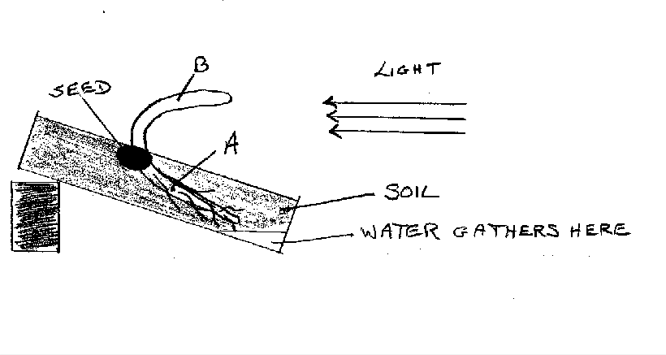
Seed
B
Light direction
A
Soil
Water gathers here
(a) From which structure in the seed did A develop?
(b) Name the growth response shown by A.
(c) Name the growth response shown by B.
(d) Suggest a benefit to the plant of the growth response shown by B.
(e) Give an example of a regulator in plants that inhibits growth.
(f) Give two uses of plant growth regulators in horticulture.

MS 2009 2
2. |  | 6(3) + 2
 | (a) | Radicle
 | (b) | Hydrotropism [accept geotropism]
 | (c) | Phototropism
 | (d) | Photosynthesis or described
 | (e) | Ethene or abscisic acid [accept other correct named]
 | (f) | Rooting powder / selective weedkiller / fruit ripening / seedless fruit / tissue culture (micro propagation) (Any two)

Q 2008 8
8. Growth regulators in plants can promote growth or inhibit it.
(a) Give an example of each of the following:
(i) A growth regulator that promotes growth
(ii) A growth regulator that inhibits growth
(b) In the course of your studies you investigated the effect of a growth regulator on plant tissue. Answer the following questions in relation to that investigation.
(i) Name the plant that you used
(ii) Describe how you carried out the investigation
(iii) Give a safety precaution that you took while carrying out the investigation
(iv) State the results that you obtained

MS 2008 8

8. | (a) | (i)  (ii) | auxin or IAA or NAA or ethylene (ethene)  auxin or IAA or NAA or abscisic acid or ethylene (ethene) | 3  3
 | (b) | (i) | name of plant | 3
 |  | (ii) | investigative procedure:  different concentrations / add regulator to / part of plant / how added / replicates described / control described / suitable time reference | 4(3)
 |  | (iii) | safety precaution | 3
 |  | (iv) | result of experiment and result of control or  result of two different concentrations (or plant parts) | 6, 0

Q 2005 14b
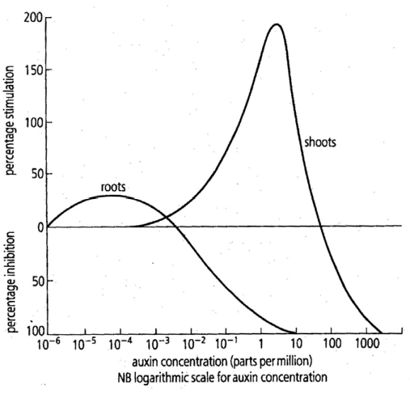
(b) The graph shows the effect of varying auxin concentration on the root and shoot of a plant.

(i) What is an auxin?
(ii) At what approximate auxin concentration does the root receive maximum stimulation?
(iii) At what approximate auxin concentration does the shoot receive maximum stimulation?
(iv) What is the effect on the root of an auxin concentration of 10^{–2} parts per million?
(v) Give two examples of uses of synthetic (man-made) auxins.
(vi) Describe three methods used by plants to protect themselves from adverse external environments.
Q 2005 14b
(b) (i) growth regulator / in plants or named plant or plant part | 2(3)
(ii) 10-3 - 10-3 | 3
(iii) 1 – 10 | 3
- Inhibition or explained  - Rooting powder / tissue culturing / weed killer / ripening of fruit / seedless fruits / other | 3  2(3)
(vi) Thorns/ modified leaves e.g. pine needles /stinging (cells)/deep roots / heat shock proteins/ phytoalexins e.g. production of antimicrobial chemicals / use of seeds / leaf fall / perennating organs or examples / dormancy / succulent tissues / toxins / other any three | 3(3)

