Oxygen bubbles

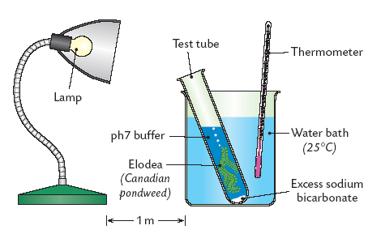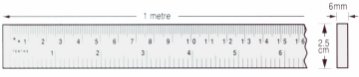

Elodea

Distance (cm)

**Procedure**

1. Obtain a fresh shoot of *Elodea.*
2. Cut the stem at an angle. Remove several leaves from around the cut end of the stem.
3. Fill a boiling tube with pond water.
4. Place the plant into the boiling tube, cut end pointing upwards.
5. Place this tube into the water bath.
6. Switch on the light source.
7. Place the boiling tube containing the pondweed at a measured distance from the light source e.g. 15 cm.
8. Allow the plant to adjust for at least 5 minutes and observe bubbles being released from the cut end of the stem.
9. Count and record the number of bubbles released per minute. Repeat twice.
10. Calculate and record the average number of bubbles released per minute.
11. Measure the light intensity at this distance using the light meter or calculate the the light intensity by using the formula: light intensity = 1/d2, where ‘d’ represents the distance from the light source. Record the result.
12. Repeat the procedure from step 9 at other measured distances e.g. at 30cm, 45cm, 60cm, 75 cm.
13. A graph should be drawn of the rate of bubble production against light intensity. Put light intensity on the horizontal axis.

**Result**

|  |  |  |  |  |  |
| --- | --- | --- | --- | --- | --- |
| Distance from light source (cm) | Light intensity  or 1/d2 | Trial 1 ( No. of bubbles /min) | Trial 2 ( No. of bubbles /min) | Trial 3 ( No. of bubbles /min) | Average ( No. of bubbles /min) |
|  |  |  |  |  |  |
|  |  |  |  |  |  |
|  |  |  |  |  |  |
|  |  |  |  |  |  |
|  |  |  |  |  |  |

**Graph**

Light Intensity

Rate of bubble production

(Rate of photosynthesis)

Note:

During this investigation only one factor (light intensity) should be varied – temperature and carbon dioxide concentration must be kept constant.

To keep the temperature constant, use a water bath @ 250C.

To keep the carbon dioxide concentration constant use pond water and complete the investigation over a short period of time.