|  |  |  |
| --- | --- | --- |
| **At the end of this section you should be able to ….** | **Y** | **N** |
| Define the term: photosynthesis. |  |  |
| Express photosynthesis as a balanced reaction. |  |  |
| Give the role of photosynthesis |  |  |
| Identify the sources of light , CO2 & water for photosynthesis. |  |  |
| State the role of chlorophyll in photosynthesis |  |  |
| Know the location of chlorophyll. |  |  |
| **Contemporary Issue**   * Human intervention: use of artificial light and   carbon dioxide enrichment to promote crop growth in greenhouses |  |  |
| **Mandatory Activity**   * Investigate the influence of light intensity on the rate of photosynthesis |  |  |

**KEY WORDS**

**Energised, photolysis, dark stage, light stage, ATP, NADP, NADPH,**

**H 2.2.9 Photosynthesis**

|  |  |  |
| --- | --- | --- |
| Know the 2 stage process of photosynthesis |  |  |
| Explain the Light Stage |  |  |
| State the two-pathway system of energised electrons. |  |  |
| Explain the role of NADP |  |  |
| Explain photolysis of water |  |  |
| Describe the fate of the products of photolysis |  |  |
| Explain the Dark Stage |  |  |
| Explain the role of ATP in the transfer of energy |  |  |
| Explain the production of ATP from ADP |  |  |
| Know that ADP and NADP+ returnto the light stage to be reused. |  |  |

**Key words**

**Photosynthesis, Nicotinamide Adenine Dinucleotide, Adenosine Triphosphate, photolysis, dark stage, light stage, reaction centre**

**Photosynthesis (Summary)**

**Photosynthesis**: Process by which green plants make food using energy from the sun.

**Balanced equation**

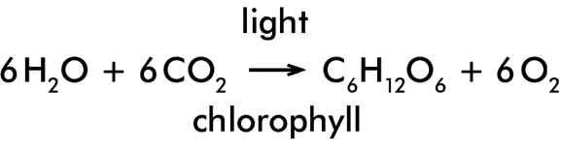

**Role of Photosynthesis:**

* Plants make food by photosynthesis.
* Animals eat plants.
* Plants produce oxygen gas by photosynthesis which is used in respiration.
* Plants and animals die and decay forming fossil fuels over millions of years.
* Removes carbon dioxide from the air.

**Location of chlorophyll within cells**: chloroplasts

**Sources of light, carbon dioxide and water for photosynthesis:**

* **Source of light**: Sun
* **Sources of carbon dioxide**:

Atmosphere

Respiration (in leaf)

* **Sources of water** : Absorbed from soil

**INVESTIGATE THE INFLUENCE OF LIGHT INTENSITY ON THE RATE OF PHOTOSYNTHESIS**

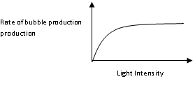

**MATERIALS/EQUIPMENT**

*Elodea (*Pondweed)

Light Intensity

Rate of bubble production production

Strong light source

Metre stick

Pond water

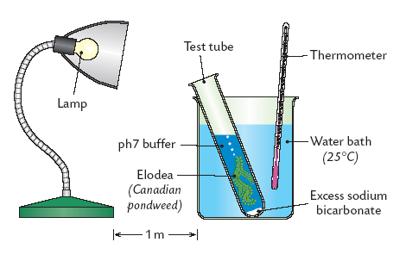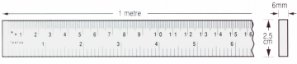

**PROCEDURE**

1. Place the *Elodea* into the boiling tube with pond water,

cut end pointing upwards.

1. Place this tube into the water bath and switch on lamp.
2. Place the boiling tube containing the pondweed at

a measured distance from the light source e.g. 15 cm.

1. Allow the plant to adjust for at least 5 minutes and count the bubbles

released from the cut end of the stem.

1. Record the number of bubbles released per minute. Repeat twice.
2. Calculate and record the average number of bubbles released per minute.
3. Measure the light intensity at this distance using the light meter
4. Record the result.
5. Repeat the procedure at other measured distances
6. Draw a graph of the rate of bubble production against light intensity.

Human intervention: use of artificial light and carbon dioxide enrichment to promote crop growth in greenhouses

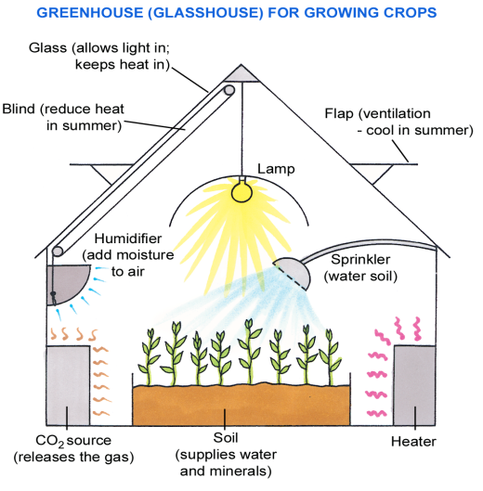

**Higher level only: H. 2.2.8**

**Role of ATP**

ATP ADP + P Energy released

ADP + P ATP Energy added

**Role of NAD**

* NADP supplies H+ ions and electrons (which are used to convert CO2 to carbohydrates, Cx(H2O)y in the dark phase)

**Two stages** involved in Photosynthesis:

* The **first stage,** driven by light energy, is called the **light stage** or light-dependent stage;
* The **second stage** is dependent upon the products of the light stage, does not require light and is called the **dark stage** or light–independent stage.

**In the light stage:**

* Light energy is absorbed and then passed on from one pigment molecule to other pigment molecules in the chloroplast until it reaches a **reaction centre chlorophyll molecule.**
* From here energised electrons enter **two pathways:**

**Pathway 1**

* The electrons return to chlorophyll releasing their surplus energy for the formation of ATP.

**Pathway 2**

* Two electrons leave chlorophyll move to an electron acceptor and are then trapped by NADP+ forming NADP-
* This leaves the chlorophyll molecules electron deficient.
* These electrons are replaced from the splitting of water into 2H+, electrons and oxygen.
* H+ ions from a pool of H+ ions are attracted to NADP- to form NADPH.

**In the dark stage**

* NADPH supplies H+ ions and electrons (reducing power) which are used to convert CO2 to carbohydrates, Cx(H2O)y.
* The energy to achieve this conversion comes from ATP.
* ATP and NADP+ return to the light stage to be reused