Q 2016 11(b)

Answer the following questions from your knowledge of photosynthesis.
(i) Where in plant cells does the process take place?
(ii) Name a substance which absorbs light energy for the process.
(iii) In which pathway of the light stage is oxygen produced?
(iv) Outline how this oxygen is produced.
(v) Give one fate of this oxygen.
(vi) What is the fate of the carbon in the carbon dioxide used in the dark stage?
(vii) Give one reason why a suitable temperature is necessary for the dark stage to occur.
(viii) Aquatic plants such as Elodea are particularly suitable for investigating photosynthesis. Suggest a reason for this.

Q 2016 11(b)

- Where: Chloroplast
- Substance: Chlorophyll
- Pathway: Pathway 2
- How oxygen produced: Water splits/using light (energy) or Photolysis of water
- Fate of oxygen: Released (into atmosphere) or (used in) respiration
- Fate of carbon: Makes carbohydrate (or named carbohydrate)
- Why suitable temperature: (Controlled by) enzymes
- Why elodea: Bubbles (visible for counting)

Q 2015 12

- (i) Write a balanced chemical equation for photosynthesis.
(ii) Where precisely in a plant cell does photosynthesis occur? (9)

- Researchers have taken an important step towards enhancing photosynthesis by creating genetically modified plants. These plants now contain genes from blue-green algae that code for a more efficient form of Rubisco, an enzyme used in the dark stage of photosynthesis. Rubisco can account for up to half of all the soluble protein found in a leaf.

- What is the energy source for the dark stage?
- Give the details of the dark stage of photosynthesis. Marks will not be given for a word diagram alone.
- Give two uses of the main product of the dark stage.
- Name two environmental factors on which the rate of photosynthesis depends.
- Suggest one advantage of using genetically modified crops. (27)

MS 2015 12
(a) (i) 6CO2 + 6H2O → C6H12O6 + 6O2
(ii) *Chloroplast(s)
(b) (i) *ATP
(ii) NADPH supplies H+ and e- (or NADPH supplies hydrogen or NADPH is reducing agent) / CO2 is reduced (or converted) / to form
carbohydrate (or named carbohydrate or 6C compound) / NADP (or ADP) regenerated
(iii) Respiration (or described)
Conversion to starch (or to other named carbohydrate) or provides food (for other organisms)
(iv) Temperature / light intensity / CO2 conc.

Q 2013 14 (a)

The scheme below summarises the process of photosynthesis.
{
FIRST STAGE
{
PATHWAY I
PHOTOSYNTHESIS:
}
SECOND STAGE
PATHWAY II
Give the name of the first stage.
In the first stage, pathways I and II relate to the passage of energised electrons.
- Explain what happens to these electrons in pathway I.
- Describe the events of pathway II.
- Give the name of the second stage.
- Explain why the second stage is given the name referred to in part (iii).
- Give one reason why the second stage cannot happen without the first stage.
- Outline the major events of the second stage.
- Name the compound D and give two functions of this compound in yeast cells.

MS 2013 14 (a)
(i) *Light (dependent stage)
(ii) 1. (electrons) picked up by acceptor / passed through carriers / back to chlorophyll / (electrons) lose energy
2. H2O split / protons to pool / NADP- formed / NADPH formed /
(electrons) picked up by acceptor / passed through carriers / O2 released / ATP produced
(iii) *Dark (stage) (or *light-independent stage)
(iv) Light not needed
(v) Product (or named product) (of 1st stage) required.
(vi) Sugar formed from CO2
(vii) ATP provides energy or NADPH provides hydrogen (or H)

Q 2012 12 (a) and (b)

(a) (i) From the following list, write into your answer book any term that describes the nutrition of a typical plant: parasitic; heterotrophic; saprophytic; autotrophic.
(ii) Identify, in your answer book, the cell organelles A and B.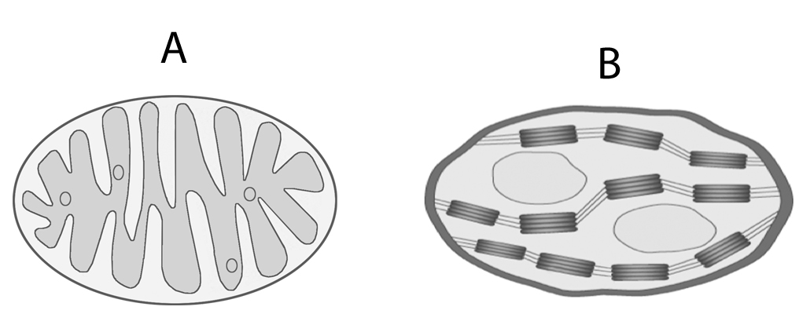

(b)
Chlorophyll is composed of various pigments.
Two of these pigments are chlorophyll a and chlorophyll b.
The graph below shows the amount of light of different colours absorbed by chlorophyll a and chlorophyll b.

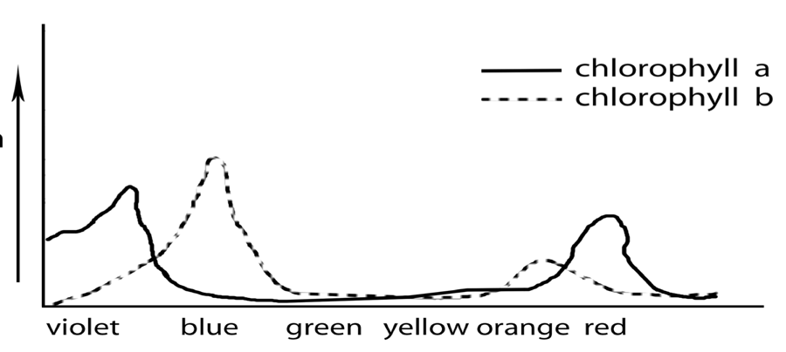
chlorophyll a
chlorophyll b
Absorption
of light
Colour of light
(i) 1. What colours of light are absorbed by most by chlorophyll a?
2. What colour of light is absorbed most by chlorophyll b?
(ii) What happens to yellow light when it strikes a leaf?
(iii) Suggest one possible benefit to plants of having more than one chlorophyll pigment.
(iv) From the information provided by the graph suggest how a commercial grower might try to increase crop yield in his glasshouses or tunnels.
(v) 1. What is the main source of carbon dioxide used by plants in the dark stage of photosynthesis?
2. State one role of NADP and one role of ATP in the dark stage of photosynthesis.

Q 2012 12 (a) and (b)
- (i) *Autotrophic 3
(ii) (A =) *mitochondrion 3
(B =) *chloroplast 3
(b) (i) 1. *Violet & *Red 3 +3
2. *Blue 3
(ii) Not absorbed or little absorption or it is reflected 3
(iii) Able to absorb more light (or energy) or able to absorb more (or different) colours (or wavelengths) or increased photosynthesis (or increased food production) 3
(iv) Use violet (or blue or orange or red) light 3
(v) 1. *Air (or atmosphere) or *respiration 3
2. NADP: to transport electrons / to transport energy / H-carrier ATP:Energy source or energy store 3

Q 2011 14 (a)

  - The graph shows the results of a classroom investigation into the factors affecting the rate of photosynthesis. The variable investigated was either light intensity or CO2 concentration.
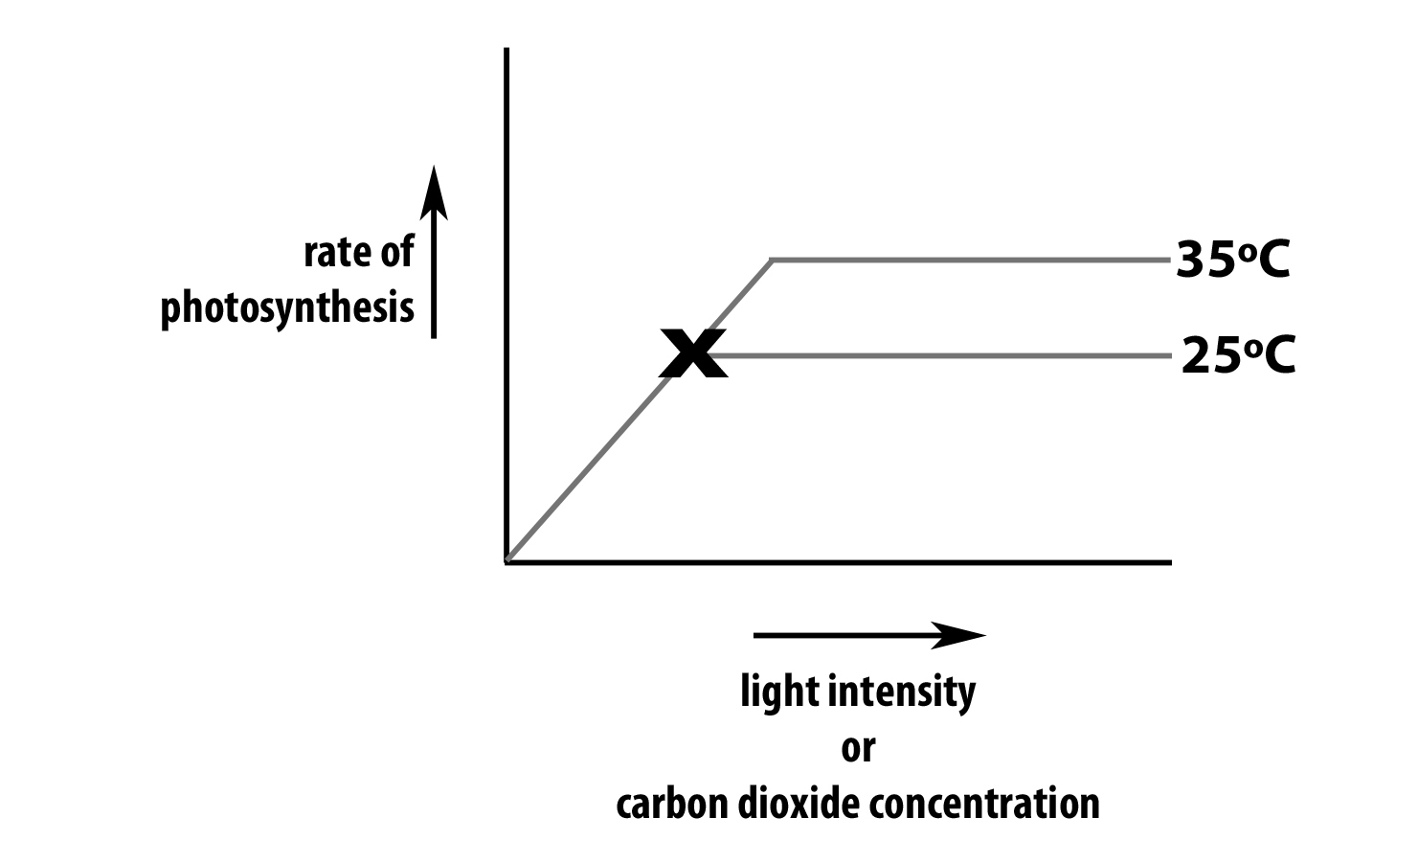

In your answer book, indicate clearly which factor you choose to address and answer the following questions:

    - Suggest a suitable plant for such an investigation.
    - How was the rate of photosynthesis measured?
    - Name a factor that must be kept constant during this investigation.
    - Explain how you would keep constant the factor referred to in (iii).
    - Why is it necessary to keep that factor constant?
    - 1. What happens to the rate of photosynthesis at X when the investigation is
      - carried out at 25oC?
      - carried out at 35oC?
2. Give a reason for each answer.

MS 2011 14 (a)

Aquatic plant or named (e.g. Elodea)
Counted bubbles (or measured volume) / per unit time
OR
datalogging / named sensor (or mention of time)
Light (if CO2 addressed) or CO2 (if light addressed) or temperature
Fixed lamp distance (or wattage) or NaHCO3 or water bath (or described)
To ensure that any change is not due to that factor
1. | A | It does not increase any further or levels off
 | B | It increases or does not level off
2. | A | Temperature is limiting or photosynthesis can not go any faster (at that temperature)
 | B | Temperature is not limiting or increased temperature allows greater rate

Q 2010 14 (a)
(i) Where in a plant cell does photosynthesis take place?
- Give the alternative name of the first stage of photosynthesis.
- During the first stage of photosynthesis energised electrons enter two pathways.
  - Where do the energised electrons come from?
  - Briefly describe the main events of each of these pathways.
- 1. In the second stage of photosynthesis compounds of the general formula Cx(H2O)y are formed. What name is given to this group of compounds?
2. From which simple compound does the plant obtain the H used to make compounds of general formula Cx(H2O)y?
- Name the simple compound that supplies the necessary energy for the second stage reactions.

MS 2010 14 (a)

(i) | Chloroplast | 3
(ii) | *Light (stage) | 3
(iii) | Chlorophy ll  (Energised electrons) release energy / ATP formed /  Pathway : (electrons) return to chlorophyll  Any two  Electrons taken up by NADP / photolysis (or water  Pathway : splits) / NADPH (formed) /electrons from water to chlorophyll /ATP formed  Any two | 3
 |  | 2(3)
 |  | 2(3)
(iv) | 1. *Carbohydrates | 3
 | 2. *Water (or H2O) | 3
(v) | *Adenosine Triphosphate (or ATP) | 3

Q 2009 12(c)

One laboratory activity that you carried out demonstrated the influence of light intensity or of carbon dioxide concentration on the rate of photosynthesis. Answer the following in relation to this activity:
  - Explain how you measured the rate of photosynthesis.
  - Explain how you varied light intensity or carbon dioxide concentration.
  - State how you kept another named factor constant.
  - Draw a graph with labelled axes to show the results that you obtained.
  - Briefly explain the trend in your graph.

MS 2009 12(c)

(i) | Counted bubbles (or measure volume) per unit time or use a (datalogging) sensor | 3
(ii) | Light source at different distances (from plant) or different wattages or  different concentrations of NaHCO3 solution | 3
(iii) | Temperature / how  OR light (if not given in (c) (ii)) / how  OR CO2 concentration (if not given in (c) (ii) ) / how | 2(3)

Q 2008 14 (a)
- Name the openings in the leaf which allow the entry of carbon dioxide for photosynthesis.
- State a factor which influences the diameter of these openings.
- During photosynthesis oxygen is produced. From what substance is oxygen produced?
- In which stage of photosynthesis is oxygen produced?
- Give two possible fates of oxygen following its production.
- Give an account of the role of each of the following in photosynthesis:
1: ATP,
2.NADP.

MS 2008 14 (a)

(i) | Stomata  light or CO2 or potassium ions (K+) or wind or turgidity of guard cells or water availability or high temperature | 3  3
(ii) | 1. water | 3
 | 2. light (dependent) stage | 3
 | 3. respiration | 3
 | 3. (diffuses) to atmosphere | 3
(iii) | provides or stores energy / reduction of CO2 or glucose formation or for dark stage  accepts electrons / hydrogen carrier / for the dark stage or  glucose formation or for dark stage | 2(3)
 |  | 2(3)

Q 2007 9

(a) State a precise role for each of the following in photosynthesis:
(i) Carbon dioxide
(ii) Water
  - Answer the following questions in relation to an activity that you carried out to investigate the influence of light intensity OR carbon dioxide concentration on the rate of photosynthesis.
    - Name the plant that you used.
    - How did you vary light intensity OR carbon dioxide concentration?
    - State a factor that you kept constant during the investigation.
    - How did you ensure that the factor that you mentioned in (iii) remained constant?
    - How did you measure the rate of photosynthesis?
    - Using labelled axes, sketch a graph to show how the rate of photosynthesis varied with the factor mentioned in (ii) above.

MS 2007 9

(a) | (i) | supplies carbon or correct comment related to CO2
 | (ii) | supplies hydrogen or protons (H+) or electrons or photolysis or described
 |  | [allow formation of carbohydrate or named once]
(b) | (i) | Elodea or other correctly named aquatic plant
 | (ii) | lamp distance or wattage or quantity of NaHCO3
 | (iii) | carbon dioxide or light or temperature
 | (iv)  (v) | water bath or described or lamp distance or wattage or NaHCO3 bubbles or volume / time
 |  | or data logger / sensor named
 | (vi) | vertical axis labelled rate + horizontal axis labelled [light or CO2]
 |  | curve matching axes labels

Q 2006 11

(a) (i) What is the primary role of chlorophyll in photosynthesis?
(ii) Write an equation to summarize photosynthesis. (9)

(b) The second stage of photosynthesis is called the dark stage or light-independent stage.
(i) Why is the dark stage given the alternative name of the light-independent stage?
(ii) Name a gas that is essential for the dark stage.
(iii) Two products of the light stage are vital for the dark stage. Name each of them.
(iv) State the precise role in the dark stage of each of the substances that you named in (iii).
  - To what group of biomolecules do the main products of the dark stage belong?

(c) Water is essential for photosynthesis.
(i) Briefly outline how water from the soil reaches the leaf.
(ii) What happens to water molecules when they reach the sites of photosynthesis?

MS 2006 11

(a) (i) traps or uses light or explained 3
(ii) balanced equation (one error = 3) 6, 3, 0

(b) | (i) | light not required | 3
 | (ii) | CO2 | 3
 | (iii) | NADPH(2) | 3
 |  | ATP | 3
 | (iv) | NADPH(2): supplies hydrogen or mention of reduction or e- | 3
 |  | ATP: supplies energy | 3
 | (v) | monosaccharides or polysaccharides or carbohydrates | 6

(c) (i) concentration gradient /root hair / osmosis / cell to cell / root pressure/
/ xylem / cohesion or explained / adhesion or capillarity or explained / Dixon and Joly / transpiration or evaporation [accept water loss] / tension any six 6(3)
(ii) photolysis or split 3
Protons or H+ / electrons / oxygen 2(3)

Q 2005 4
The following graph shows how the rate of photosynthesis varied when a plant was subjected to varying levels of light intensity or carbon dioxide concentration.

B
Rate of photosynthesis
A

Light intensity or carbon dioxide concentration

(a) What is happening at A?
(b) What is happening at B?
(c) Suggest a reason for your answer in (b)
(d) Where in a cell does photosynthesis take place?
(e) Give two sources of the carbon dioxide that is found in the atmosphere.
(f) Suggest one way in which the rate of photosynthesis of plants in a greenhouse could be increased.

MS 2005 4
- Rate (or photosynthesis) is increasing
- Rate (or photosynthesis) is levelling off (is not increasing)
- (Light or carbon dioxide) saturated or explained
- Chloroplast or chlorophyll
- Respiration / combustion or burning
- Increased (artificial) lighting/ increased carbon dioxide / heating

Q 2004 11
(a) ATP is an abbreviation. What does it stand for? Explain briefly the role of ATP in the energy exchanges of a cell.(9)
- (i)The first stage of photosynthesis is commonly known as the light-dependent stage. It involves the energising of electrons and their subsequent passage along two possible pathways. Give an account of what happens on each of these pathways.
(ii)What is the fate of each of the products of the light-dependent stage? (27)

- The effect of changing light intensity or carbon dioxide concentration on the rate of photosynthesis may be investigated by using the pondweed Elodea. Answer the following in relation to this investigation.
- Why is a water plant rather than a land plant used in this experiment?
- How is the temperature kept constant in this experiment?
- If pond water is used in the experiment, it is likely to contain dissolved carbon dioxide. Suggest two possible sources of carbon dioxide in pond water.
- Explain how light intensity or carbon dioxide concentration may be varied.
- Each time light intensity or carbon dioxide concentration is varied a precaution is necessary. What is this precaution and why is it necessary?

MS 2004 11

(a) Adenosine triphosphate 3
Role: P – P bond / holds or stores (energy) / passes on or releases (energy) or ATP ------ ADP + P / + energy (or the reverse reaction)any two 2(3)

(b) Pathway 1.
Light energising electrons or light into chlorophyll / (e-) from chlorophyll / ATP formed / (e-) returned to chlorophyll
Pathway 2.
(e-) to NADP / photolysis (or H2O split) / H+ (protons) to NADP / NADPH formed / ATP formed / O2 formed / different electrons / (e-) back to chlorophyll/ 6(3)
[maximum 4 points from either pathway]

(ii) Product Fate
ATP for dark phase or explained or any metabolic reaction
NADPH for dark phase or explained
O2 respired or released (into atmosphere)

(c) (i) Why Elodea?: ease of measurement of rate or explained 3
(ii) How temp constant: water bath or described 3
(iii) Sources of CO2 : animal respiration / plant respiration / from air / bacterial respiration or decomposition / 2(3) [Note: respiration alone = 1 point]
(iv) How varied: lamp / different distances (or different wattage) OR sodium hydrogen carbonate / different amounts 3 + 3
- Precaution at each change:
Allow time (before counting bubbles) 3
Reason: Plant adjusting or equilibration or explained 3

