Q 2015 5

- In an experiment, a student cut some potatoes into small, evenly-shaped pieces.
She divided them into groups of 10, weighed each group and placed them in sucrose solutions of different concentration, labelled A to F. Two hours later, she removed the potato pieces from the sucrose solutions, dried them and reweighed them. She plotted her results on a graph (change in mass versus % sucrose solution). The graph is shown below.
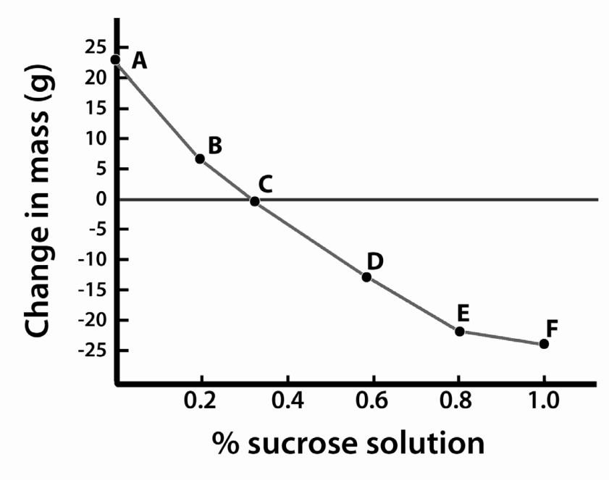

  - From the graph, determine the concentration of the contents of the potato cells.

  - Explain in detail why the pieces in solutions D to F lost mass.

  - Give one example of the use of the mechanism(s) described in (b) in food preservation.

  - Explain how plant cells remain turgid.

MS 2015 5

