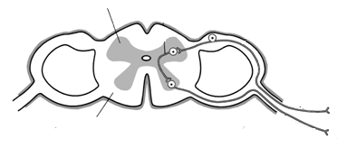
Q 2015 14 b
C
A
B

- Name the parts labelled A, B and C in the diagram of the cross section of the spinal cord.
- What is the main structural difference between A and B?
- 1. What is the function of the meninges?
2. How many layers are present in the meninges?
- Reflex actions are very important in animals.
  - What is a reflex action?
  - Outline the mechanism of a reflex action.
MS 2015 14 b
14. (b) | - A = *grey matter B = *white matter  C = *central canal or *cerebrospinal fluid (CSF)  - A: consists (mainly) of cell bodies or (mostly) no myelin  B: consists (mainly) of axons or (mostly) myelin  - 1. Protection (of CNS)  - *Three  - 1. Automatic (or involuntary) response to a stimulus  - Stimulus at receptor / (causes) impulse along sensory neuron / (impulse) through interneuron / (impulse) through  motor neuron / to effector (or muscle or gland) or effector reacts /  (another impulse is sent) to the brain. Any Two | 1
 |  | 1
 |  | 1
 |  | 3
 |  | 3
 |  | 3
 |  | 3
 |  | 3
 |  | 2(6)

Q 2014 11 b
Answer the following questions in relation to the human nervous system.

  - Name the type of particle whose movement in and out of neurons is an essential feature of nerve impulse transmission.

  - One of the roles of the particles referred to in (i) is the activation of neurotransmitters.

(iii) Give an account of how neurotransmitters work.
1. Distinguish between the position of the cerebellum and the position of the cerebrum in the human brain.

2.State three functions of the cerebrum. (27)

© Read the following extract and then answer the questions below.

Alzheimer’s disease (a degenerative brain condition), like many other degenerative illnesses, is driven by genes and recently scientists have identified a group of genes that are thought to be associated with this disease. The disease is thought to be caused by a build up of protein-based plaques in the brain, and investigators now believe they have an understanding of ways to interrupt that process. Technology is helping too, as researchers exploit new ways to scan the brain and detect the first signs of trouble, peering deeper into human and animal neural tissue to pinpoint the very molecules that give rise to the disease.
(Adapted from Alzheimer’s Unlocked, TIME, Volume 176, No. 17. 2010.)

- What do you think is meant by the term “degenerative illnesses”?
- Is Alzheimer’s disease driven by a single gene or by many genes?
- What is thought to cause the disease?
- Suggest a possible symptom of Alzheimer’ disease.
- How is the advance of technology helping in the fight against the disease?
- There are probably more people suffering from the disease now than ever before. Suggest a reason for this.
- Name another disorder of the nervous system and give a possible treatment for it. (24

MS 2014 11 b
(i) | *Ion |  | 3
(ii) | (Neurotransmitters are) secreted by the neuron / into (or crosses) the
 | synaptic cleft / react with receptors / (on) the next neuron / set up the
 | impulse in this neuron / inactivated by enzymes / reabsorbed by
 | (presynaptic neuron) |  | 4(3)
(iii) | 1. | The cerebellum – hind brain and cerebrum – forebrain | 3
 | 2. | Any three functions:
 |  | memory / learning / emotion / speech / vision / intelligence /
 |  | movement / language / smell / hearing / logic / personality / taste | 3(3)
(c)(i) | Getting worse |  | 3
(ii) | Many (or group) |  | 3
(iii) | A build up of protein plaques |  | 3
(iv) | e.g. memory loss |  | 3
(v) | Scans can examine the brain (for early detection) |  | 3
(vi) | Larger population or more people living into old age |  | 3
(vii) | Name / treatment |  | 2(3)

Q 2012 13
(a) (i) Distinguish between the central nervous system and the peripheral nervous system. Include a clear reference to each in your answer.
(ii) Give one way in which a nervous response differs from a hormonal response. (9)

(b) (i) Draw a large labelled diagram of a motor neuron.
(ii) Give one function each of any two parts found only in neurons.
(iii) Place an arrow on or near your diagram to indicate the direction of impulse transmission.
(iv) Name and state the role of any two types of neuron, other than the motor neuron. (27)

(c) (i) State one function for each of the following parts of the human brain.
Cerebrum; Hypothalamus; Cerebellum; Medulla oblongata.
(ii) In relation to the nervous system, distinguish between grey matter and white matter. Include a clear reference to each in your answer.
(iii) In the case of either paralysis or Parkinson’s disease state:
1. a possible cause, other than accident;
2. a method of treatment. (24)

MS 2012 13
13. (a) (i) CNS: brain and spinal cord | 3
PNS: nerves leading to and from CNS or nerves not in CNS | 3
(ii) Faster or shorter-lived or electrical | 3
(b) (i) Diagram: cell body with dendrites + axon + terminal dendrites shown  Diagram of a sensory neuron gets 0 marks | 6, 3, 0
Labels: Cell body / dendrites / axon / myelin sheath / Schwann cells / (neurotransmitter) vesicles (or swellings) | 6(1)
(ii) Function first named part | 3
Function of second named part | 3
(iii) *Arrow | 3
(iv) Sensory neuron carry impulses to CNS (or to named part of CNS) | 3
Interneuron carry impulses within CNS or Interneuron carry impulses
from sensory to motor neuron or connect sensory and motor neurons | 3
(c) (i) Cerebrum: language or reason or consciousness or senses or  memory or intelligence or emotions or other  Hypothalamus: homeostasis or example of homeostasis or  endocrine function or other  Cerebellum: movement or balance or coordination or example  Medulla oblongata: involuntary muscle control or example | 3
 | 3
 | 3
 | 3
(ii) Grey: few axons or little myelin or mostly cell bodies | 3
White: many axons or much myelin or few cell bodies | 3
(iii) 1. Cause: Parkinson‟s – lack of dopamine or genetic or toxins  OR  Paralysis – damage to spinal cord or other | 3
2. Treatment: Parkinson‟s - levodopa or drugs that mimic dopamine  or physiotherapy or exercise OR  Paralysis – surgery or psysiotherapy | 3

Q 2010 11 a and b
(a) (i) Name a disorder of the human nervous system.
- In the case of the disorder referred to in part (i) state:
  - A possible cause.
  - A means of prevention or a treatment. (9)

- (i) What is a reflex action?
- Give one example of a reflex action.
- Suggest an advantage of reflex actions.
- The parts of the nervous system involved in a reflex action make up a reflex arc.
  - Draw a large labelled diagram to show the structures involved in a reflex arc.
  - Place arrows on your diagram to show the direction of impulse transmission in the reflex arc. (27)

MS 2010 11 a and b

(a) | (i) | Paralysis or Parkinson’s . . . | 3
 | (ii) | 1. Relevant cause | 3
 |  | 2. Relevant means of prevention or treatment | 3
(b) | (i) | automatic / response to a stimulus / involuntary (or not controlled by brain)  Any two | 2(3)
 | (ii) | e.g. coughing, blinking, sneezing etc. | 3
 | (iii) | Protection or fast (response) | 3
 | (iv) | - Diagram  (sensory neuron, motor neuron, spinal cord and correct position of cell bodies for 6 marks)  Labels:  receptor (or named), sensory neuron, inter neuron,  motor neuron, cell body, effector (or named) Any  three  - Arrow in (dorsal) + arrow out (ventral) | 6, 3, 0
 |  |  | 3(2)
 |  |  | 3

Q 2008 4
The diagram shows a motor neuron.
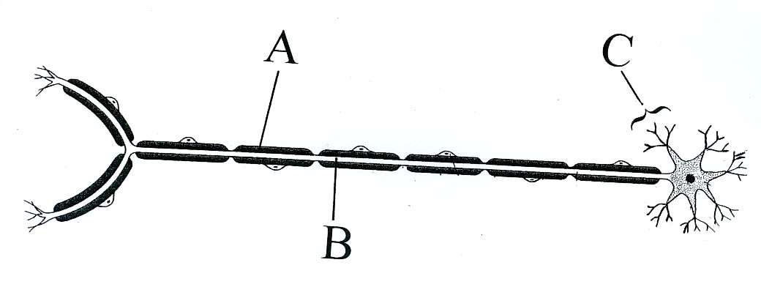

(a) Identify parts A, B and C.
(b) Give a function of A
(c) Place an arrow on the diagram to show the direction of the impulse.
(d) Give a function of C
(e) Place an X on the diagram at a point at which a neurotransmitter substance is secreted.
(f) What is the role of the motor neuron?

MS 2008 4
4. | (a) | A = myelin sheath or Schwann cell B = myelin sheath or axon C = dendrite | 3(1)
 | (b) | A: (myelin sheath) insulates or protection or speeds up impulse (message)
 |  | A: (schwann cell) produces myelin (or sheath) or insulates or protection or  speeds up impulse (message) | 3
 | (c) | arrow (right to left) or from dendrites towards cell body | 3
 | (d) | receives impulse or carries impulse (message) to cell body | 3
 | (e) | X on terminal dendrites on left | 3
 | (f) | receive or carry impulse (message) and to muscle or gland or effector or from CNS | 5, 0

Q 2006 14 b
- (i) What is a neuron?
- Distinguish between sensory, motor and interneurons (association neurons).
- Briefly explain the role of neurotransmitter substances.
- State a function for 1. Schwann cells, 2. Myelin sheath.
- In relation to Parkinson’s disease or paralysis give;
  - A possible cause,
  - A method of treatment.

MS 2006 14 b
(i) nerve cell | 3
(ii) sensory: towards CNS or named part or from receptor or  structural feature | 3
motor: away from CNS or named part or to effector or  structural feature | 3
inter: links two neurons | 3
(iii) carries impulse / across synaptic cleft /  triggers impulse in next neuron any two | 2(3)
(iv) Schwann cell: produces myelin (sheath) | 3
Myelin sheath: insulation or protection or speeds impulse  (v) Disorder:  Cause: injury / genetic / disease / lack of dopamine / | 3  3
Treatment: physiotherapy / stem cell / dopamine or
drugs qualified 3

Q 2004 15a
  - (i) Draw and label sufficient of two neurons to show a synaptic cleft.
- Describe the sequence of events that allows an impulse to be transmitted across a synapse from one neuron to the next.
- Suggest a possible role for a drug in relation to the events that you have outlined in (ii).

MS 2004 15a
- Diagram of synaptic cleft: 6, 3, 0 3 labels 3(2)

- Transmission of impulse: arrival of impulse / synaptic bulbs (or vesicles) /
(secretes) transmitter (substance) / passage of neurotransmitter /
impulse starts in next neuron / neurotransmitter broken down / by enzymes
any five 5(3)

- A drug may be used to inhibit or enhance transmission of impulse or
similar comment

