Q 2013 4
The diagram shows a strawberry plant from which a runner has given rise to a daughter plant.
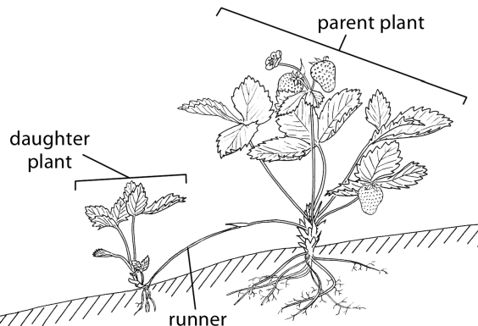

(a) The runner is a modified stem. How could you tell this from
1. external observation?
2. viewing a thin section of it under the microscope?
(b) What term is used for the type of asexual reproduction that produced the daughter plant?
(c) Would you expect the daughter plant to be haploid or diploid? Explain your answer.
(d) What evidence is there in the diagram that sexual reproduction has also taken place
(e) Give one method, other than runners, and not involving seeds, that is used by horticulturists to produce new plants.

MS 2013 4
- 1. Bud(s) or node(s) or leaf

2. Vascular bundles [plural only]

- Vegetative propagation

- Diploid

Product of mitosis or genetically identical (to parent) or clone

- Fruit or (straw)berries or seeds

- Cuttings or layering or grafting or micro-propagation or tissue culture

Q 2004 4 b
In some species of flowering plants the leaves are modified for the storage of food.
(i) Name a plant in which the leaves are modified for food storage ………………………………..…
(ii) Name a carbohydrate that you would expect to find in the modified leaves of the plant that you named above…………………………………………………………………………………………
(iii) Name a type of modified stem that functions in food storage….…………………………………

MS 2004 4 b
- Onion or tulip or daffodil or cabbage other correctly named plant

(ii) Starch or sucrose or cellulose or fructose or glucose [not ‘sugar’]
(iii) Rhizome or corm or tuber [allow stolon]

