Q 2014 3
The diagram shows a region of tissue that includes body cells and parts of the circulatory and lymphatic systems.

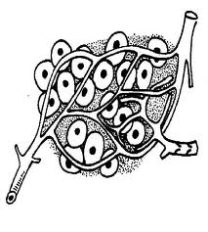
Direction of blood flow
Body Cells
A
C
B

  - Name part C.

  - What type of blood vessel is A?

  - If a transverse section of A were viewed under the microscope state one way in which it would differ from a transverse section through B.

  - Give two functions of the lymphatic system.

1.

2.

  - Give one way in which lymph differs from blood.

  - Name a major blood vessel that returns the blood in B to the heart.

MS 2014 3
3. | 8 + 7 + 5(1)
(a) | C = Lymph vessel
(b) | Arteriole [accept artery]
(c) | Narrow(er) lumen or thick(er) wall or no valves
(d) | Maintains a constant level of ECF or drains fluid or returns fluid to blood / manufacture of
 | lymphocytes or maturation of lymphocytes / filtering bacteria / fighting infection /
 | transport of named material
(e) | No red blood cells or no haemoglobin / no platelets / no clotting (proteins) /
 | higher fat level [accept correct colour difference]
(f) | Vena cava

