Unit 1

FOOD TESTS

CONDUCT A QUALITATIVE TEST FOR (a) STARCH, (b) FAT, (c) REDUCING SUGAR, (d) PROTEIN

- Qualitative test for STARCH

CHEMICALS
DIAGRAM
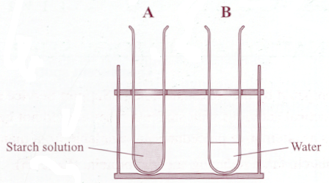
Starch solution
Iodine
Water
PROCEDURE
- I added starch solution into tube A.
- I added water into tube B. This acted as a control.
- I added 2-3 drops of iodine solution to each tube.
- I recorded my result.

RESULT

Sample | Initial colour | Final colour
A – Starch solution | Brown | Blue black
B - Water | Brown | Brown

Test for Starch
Starch + Iodine = Blue black

(b) Qualitative test for FAT

CHEMICALS /MATERIALS

Vegetable oil
DIAGRAM

Brown paper

Water
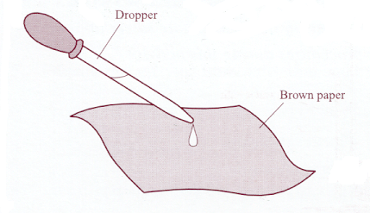
PROCEDURE
- I placed a drop of oil on one piece of brown paper
- I placed a drop of water on the other piece of paper.
This acted as a control.
- I left both aside to dry.
- I held both pieces up to the light.
- I recorded my result.

RESULT

Sample | Presence of Translucent spot
Sample | Before drying | After drying
Oil | No | Yes
Water | No | No

Test for Fat
Fat + Brown paper = Translucent spot

Unit 1

FOOD TESTS (cont)

(c) Qualitative test for A REDUCING SUGAR e.g. glucose
DIAGRAM

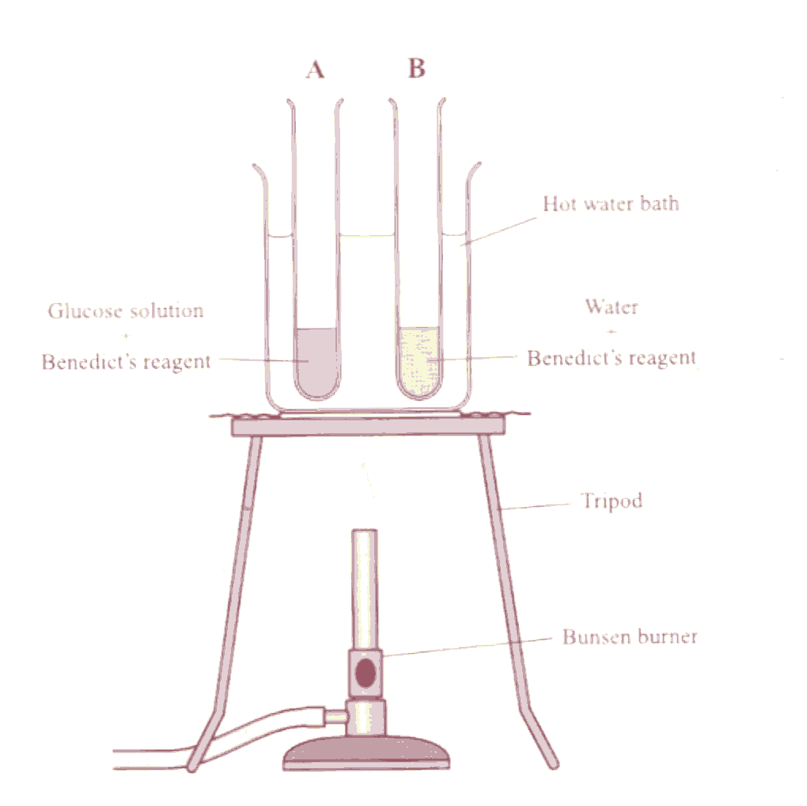
CHEMICALS

Glucose solution

Benedict’s reagent

Water
PROCEDURE

- I placed glucose solution into tube A.
- I placed water into tube B. This acted as a control.
- I added Benedict’s reagent to each tube.
- I placed both tubes in the hot water bath and heated for 5 minutes.
- I recorded my result.

RESULT

Sample | Initial colour | Final colour
A – Glucose solution | Blue | Brick red
B - Water | Blue | Blue

Test for reducing sugar
Glucose + Benedicts = Brick red

(d) Qualitative test for PROTEIN
DIAGRAM
CHEMICALS

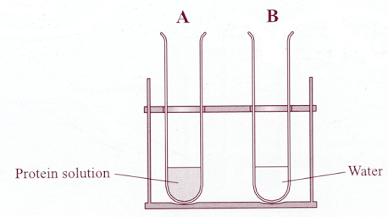
Protein solution e.g. milk

Biuret reagent

Water

PROCEDURE

- I placed the milk into tube A.
- I placed water into tube B. This acted as a control.
- I added Biuret reagent to each tube
- I recorded my results.

RESULT

Sample | Initial colour | Final colour
A – Protein solution | Blue | Lilac
B - Water | Blue | Blue

RESULT

Test for Protein
Protein + Biuret = Lilac

Unit 1

ECOLOGY

(a) (i) IDENTIFY ANY 5 FAUNA AND ANY FIVE FLORA USING SIMPLE KEYS (ii) IDENTIFY A VARIETY OF HABITATS WITHIN THE SELECTED ECOSYSTEM

MATERIALS/EQUIPMENT

Identification keys

PROCEDURE
- I used a key consisting of a series of questions relating to the organism I was trying to identify
- I answered ‘yes’ or ‘no’ to pairs of questions relating to the selected organism
- I then looked to the right of the set of questions, and using the number indicated, moved down to the correct set of alternatives.
- I continued to do this until a name was reached.
- I noted the habitat of the organism.
- I repeated this procedure to identify 5 flora and 5 fauna.
- I recorded my results.

RESULT

Organism name | Habitat | Adaptation feature
Crab | Under rock – lower shore | Hard shell - protection
Bladder wrack | Attached to rocks –middle shore | Air bladders – buoyancy for photosynthesis

(b) IDENTIFY AND USE VARIOUS APPARATUS REQUIRED FOR COLLECTION METHODS IN AN ECOLOGICAL STUDY

MATERIALS
DIAGRAM
PROCEDURE
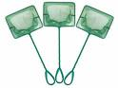
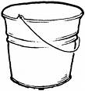
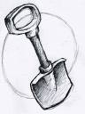
net
bucket
spade
- I used a net to catch butterfish by sweeping the net through the water.
- I transferred the butterfish to a bucket
- I used a spade to collect crabs and transferred them to a bucket
Fish net
Bucket
Spade

Unit 1

ECOLOGY (cont.)

(c) CONDUCT A QUANTITATIVE STUDY OF PLANTS AND ANIMALS OF A SAMPLE AREA OF THE SELECTED ECOSYSTEM

EQUIPMENT

DIAGRAM

PROCEDURE

- I threw a quadrat randomly in the sample area of the selected ecosystem.
- I recorded the presence or absence of the named plants and animals within each quadrat.
- I repeated for a number of throws
- I recorded my results

Quadrat

Quadrat

RESULT

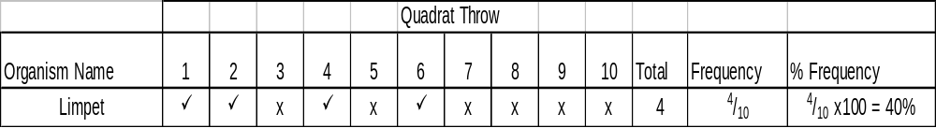
Frequency = No. of quadrats containing organism
No. of quadrats thrown

If percent is required multiply frequency by 100

(d) (i) INVESTIGATE ANY THREE ABIOTIC FACTORS PRESENT IN THE SELECTED ECOSYSTEM, AS LISTED
(ii) RELATE RESULTS TO CHOICE OF HABITAT SELECTED BY EACH ORGANISM IDENTIFIED IN THIS STUDY
DIAGRAM
MATERIALS/EQUIPMENT

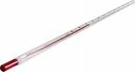
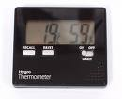
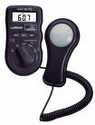
Thermometer
Digital Hygrometer
Digital Light meter
Thermometer
Light meter
Hygrometer

PROCEDURE
- I choose three abiotic factors present in my selected ecosystem to measure e.g. temperature, humidity and light intensity.
- I placed the thermometer in the habitat of the identified organism.
- I switched on the hygrometer and light meter and placed them in the habitat of the identified organism.
- I recorded my results.

RESULTS
 |  | Abiotic factors and measurements
Organism Name | Suitability of Habitat | Temperature (⁰C) | Humidity (%) | Light Intensity (Lux)
Lichen | Yes | 12 | 70 | 1005

Unit 1

ECOLOGY (cont.)

(e) CONSTRUCT A (i) FOOD CHAIN, (ii) A FOOD WEB AND (iii) A PYRAMID OF NUMBERS

(i) FOOD CHAIN

Seaweed Shrimp Sea anemone Gull

(ii) FOOD WEB

Algae
Periwinkle
Crab
Shrimp
Mussels
Limpet
Plankton
Sea Anenome
Goby
Dog Whelk
Sea Slug
Gull

(iii) PYRAMID OF NUMBERS
Seaweed
Shrimp

Sea anenome
Gull

Unit 1

MICROSCOPE

(a) BE FAMILIAR WITH AND USE THE LIGHT MICROSCOPE

MATERIALS
Magnification
= Magnification of objective lens X magnification of eyepiece
Microscope
Prepared microscope slides

PROCEDURE
- I switched on the light source.
- I rotated the nosepiece so that the low power lens was used.
- I put a prepared microscope slide on the stage of the microscope above the hole.
- I used the stage clips to hold the slide in place.
- I used the coarse adjustment wheel, to ensure that the low power lens is at the closest setting to the slide.
- I looked down the eyepiece and adjusted the iris diaphragm for correct illumination.
- I used the coarse adjustment wheel to focus the object as sharply as possible and then used the fine adjustment wheel to sharpen the focus.
- I repeated steps 6-7 using the other objective lenses.
- I drew diagrams of my observations under L.P. and H.P.

RESULTS

DIAGRAM

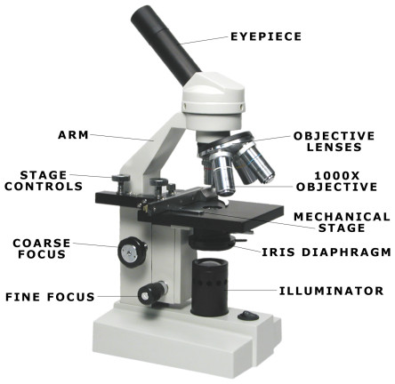
NOSE PIECE

STAGE CLIPS

RESULTS

L.P.
H.P
LIGHT SOURCE

(b) PREPARE AND EXAMINE ONE ANIMAL CELL (i) UNSTAINED AND (ii) STAINED USING THE LIGHT MICROSCOPE (X100, X400)

- PREPARE AND EXAMINE UNSTAINED ANIMAL CELL

MATERIALS/EQUIPMENT
Microscope
Microscope slides
Cover slips
RESULTS

X 100
X 400

PROCEDURE
      - I set up the microscope.
      - I swabbed the inside of my cheek surface and transferred the sample to the slide
3. I covered the sample with a drop of water.

4. I applied the coverslip as follows:
    - I placed the coverslip at the edge of the water at an angle of 45⁰ to the slide.
    - I lowered the coverslip onto the water, supporting it with a mounted needle, until it was in place. This helps to avoid trapping air bubbles.
- I examined the slide and I drew labelled diagrams of what I saw under x100 and at x400.

Unit 1

MICROSCOPE (cont.)

(ii) PREPARE AND EXAMINE STAINED ANIMAL CELL

MATERIALS/EQUIPMENT
Microscope
Microscope slides
Cover slips
Methylene blue stain

RESULTS

X 100
X 400

PROCEDURE
- I swabbed my inside cheek surface and transferred the sample onto a second slide.
- I covered the sample with one drop of methylene blue solution.
- I allowed it to stand for one minute.
- Using a wash bottle, I washed excess stain from the slide.
- I applied a cover slip.
- I examined it under the microscope and drew labelled diagrams
of what I saw at x100 and at x400.

- PREPARE AND EXAMINE ONE PLANT CELL (i) UNSTAINED AND (ii) STAINED USING THE LIGHT MICROSCOPE (X100, X400)

(i) PREPARE AND EXAMINE UNSTAINED PLANT CELL

MATERIALS/EQUIPMENT
RESULTS

X 100
X 400
Microscope
2 Microscope slides
2 Cover slips

PROCEDURE
- I set up the microscope.
- I cut the onion and located the epidermis.
- I cut the epidermis into small pieces and put these pieces into water.
- I transferred one piece into the drop of water on the slide.
- I applied the cover slip.
- I examined the slide under the microscope and I drew labelled diagrams
of what I saw at x100 and x400

(ii) PREPARE AND EXAMINE STAINED PLANT CELL
RESULTS

X 100
X 400
Microscope, 2 slides, 2 Cover slips , Iodine stain

MATERIALS/EQUIPMENT

PROCEDURE
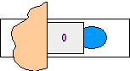
1. I set up the microscope.
Filter paper
Stain
2. I cut the onion and located the epidermis.
3. I cut the epidermis into small pieces and placed them in water.
4. I transferred one piece onto a slide.
5. I applied a coverslip.
6. I applied the stain as follows:
I placed a drop of iodine solution at one end
of the cover slip and drew it across the plant tissue
by placing the edge of the filter paper at the opposite side of the cover slip.
- I examined the slide under the microscope and I drew labelled diagrams of
what I saw at x100, x400

UNIT 2

ENZYMES

- INVESTIGATE THE EFFECT OF pH ON THE RATE OF CATALASE ACTIVITY.
MATERIALS: Enzyme source (Yeast) , Hydrogen peroxide (substrate)
Range of buffer solutions (vary pH), Water bath (temp constant)

PROCEDURE
- Add yeast and water and one of the buffers to the cylinder.
- Add hydrogen peroxide to a boiling tube.
- Stand the cylinder and boiling tube in the beaker of water at 25⁰C
- Add the hydrogen peroxide to the cylinder.
- Note the volume in the cylinder immediately and record.
- Read the volume again after a set time and record.
- Calculate the height of foam (activity of enzyme).
- Repeat the procedure for different pH buffers.
- Record results

.Control: Used boiled yeast

Boiling Tube
H₂O₂ ₋ substrate
Water bath: to keep temperature
constant
Graduated Cylinder
Buffer – to vary pH
Yeast + water – enzyme source

Thermometer

Hot plate: to keep temp constant

RESULTS
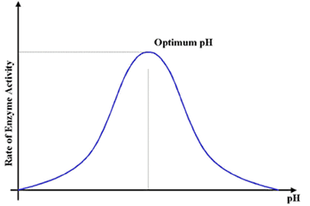
GRAPH
pH of buffer | Initial volume (cm3) | Final volume (cm3) | Volume of foam produced
9 | 20 | 30 | 10

2 H₂O₂ 2 H₂O + O₂
catalase

(b) INVESTIGATE THE EFFECT OF TEMPERATURE ON THE RATE OF CATALASE ACTIVITY.
Enzyme source (yeast), Hydrogen peroxide ,(substrate),Buffer pH 9 (constant pH), Water bath (vary temp)
MATERIALS:

Thermometer
– to monitor temperature
Hot Plate: to vary temperature
PROCEDURE
- Add yeast, water and pH 9 buffer to the cylinder.
- Add hydrogen peroxide to a boiling tube.
- Stand the cylinder and boiling tube in an ice-cold water bath until the desired temperature (0⁰C) is reached.
- Add the hydrogen peroxide into the cylinder.
- Note the volume in the cylinder immediately and record.
- Read the volume again after 2 minutes and record.
- Calculate the height of foam (activity of enzyme).
- Repeat the procedure for other temperatures.
- Record results
Control: Used boiled yeast

Boiling Tube
H₂O₂ ₋ substrate
Water bath: to vary temperature
Graduated Cylinder
Buffer –to keep pH constant
Yeast + water – enzyme source

DIAGRAM

GRAPH
RESULTS
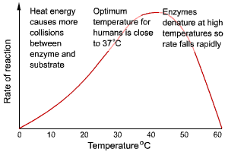
Temperature | Initial volume (cm3) | Final volume (cm3) | Volume of foam produced
0 | 20 | 20 | 0

UNIT 2

ENZYMES (cont.)

(c) PREPARE ONE (i) ENZYME IMMOBILISATION AND (ii) EXAMINE ITS APPLICATION

MATERIALS
Sodium alginate and yeast
Calcium chloride – forms beads
Bead containing immobilised yeast
NOTE:
Easy to recover and reuse immobilised enzymes
Yeast
(i) Prepare enzyme immobilisation
Sodium alginate
Calcium chloride
Sucrose
Sodium alginate traps enzyme

PROCEDURE
((i) Prepare enzyme immobilisation
- Mix sodium alginate and water and yeast in a beaker.
- Draw the mixture into a syringe.
- Release the mixture from the syringe, one drop at a time,
into the calcium chloride solution. Beads containing yeast cells will form.
- Leave the beads to harden.
- Filter the beads through a sieve and rinse with distilled water.

(ii) Application of the immobilised enzyme – production of glucose from sucrose
(ii) Application of the immobilised enzyme
- Mix yeast and water and pour into a separating funnel (Free yeast).
- Place the beads into another separating funnel (Immobilised yeast).
Free yeast + sucrose
Immobilised yeast
+ sucrose
- Pour sucrose solution into each of the separating funnels.
- Using Clinistix, immediately test samples from each funnel for glucose.
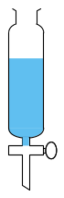
- Repeat the test at intervals until glucose appears in both.
- Record result.
- Run off the remaining product from each funnel into the beakers.
- Compare the turbidity of the solutions from both funnels.

RESULTS

Time (minutes) | Free yeast – presence of glucose | Immobilised yeast – presence of glucose
0 | Yes | No
2 | Yes | Yes

 | Free yeast | Immobilised yeast
Turbidity of solution | Cloudy | Clear

(d) INVESTIGATE THE EFFECT OF HEAT DENATURATION ON THE RATE OF CATALASE ACTIVITY
Enzyme source (yeast), Hydrogen peroxide (substrate),Buffer pH 9 (constant pH), Water bath

MATERIALS

PROCEDURE
DIAGRAM
Thermometer
- Place yeast in a boiling tube and place into the water bath at 100⁰C.
- Add the heated yeast and the buffer to the graduated cylinder.
Graduated Cylinder
Buffer –to keep pH constant
Boiled Yeast + water – enzyme source

- Add hydrogen peroxide to a boiling tube.
- Stand the cylinder and boiling tube in the water bath until the desired
temperature (25⁰C) is reached.
- Add the hydrogen peroxide into the cylinder.
- Note the presence or absence of foam formation and record.
- Repeat the procedure using an unheated yeast sample.
Boiling Tube
H₂O₂ ₋ substrate
Water bath

RESULTS
 | Unheated enzyme | Heated enzyme
Foam formation | Foam produced | No foam produced

UNIT 2

PHOTOSYNTHESIS

INVESTIGATE THE INFLUENCE OF LIGHT INTENSITY ON THE RATE OF PHOTOSYNTHESIS

MATERIALS/EQUIPMENT
Elodea (Pondweed)
Strong light source
Metre stick
Pond water

PROCEDURE
- Place the Elodea into the boiling tube with pond water,
cut end pointing upwards.
- Place this tube into the water bath and switch on lamp.
- Place the boiling tube containing the pondweed at
a measured distance from the light source e.g. 15 cm.
- Allow the plant to adjust for at least 5 minutes and count the bubbles
released from the cut end of the stem.
- Record the number of bubbles released per minute. Repeat twice.
- Calculate and record the average number of bubbles released per minute.
- Measure the light intensity at this distance using the light meter
- Record the result.
- Repeat the procedure at other measured distances
- Draw a graph of the rate of bubble production against light intensity.

DIAGRAM

Elodea

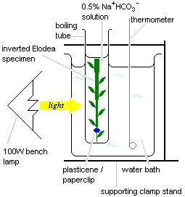
Lamp

Pondwater

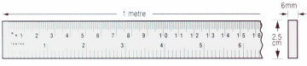
Water bath
Meter stick

GRAPH
RESULT
Light Intensity
Rate of bubble production production

Distance from light source (cm) | Average number of bobbles produced / min
15 | 20
30 | 10

Note:
During this investigation only one factor (light intensity) should be varied – temperature and carbon dioxide concentration must be kept constant.

To keep the temperature constant, use a water bath @ 25⁰C.

To keep the carbon dioxide concentration constant use pond water and complete the investigation over a short period of time or add Sodium Hydrogen carbonate .

UNIT 2

RESPIRATION

(i) PREPARE AND (ii) SHOW THE PRODUCTION OF ALCOHOL BY YEAST

MATERIALS/EQUIPMENT
Yeast
Glucose
Sodium hypochlorite solution
Potassium iodide solution
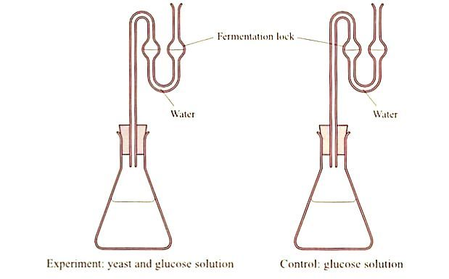
Fermentation locks
DIAGRAM
(i) To prepare alcohol using yeast

Yeast and glucose
B
A
Glucose (control)

PROCEDURE
(i) To perpare alcohol using yeast
- Add yeast and glucose to conical flask A.
- Add glucose to flask B. This acts as a control .
- Attach a fermentation lock to each flask.
- Place both flasks in the incubator at 30 ºC overnight.

(ii) To show the presence of alcohol: Iodoform test for alcohol
- Filter the contents of each flask into test tubes.
- To each test tube, add potassium iodide solution
and sodium hypochlorite solution.
- Transfer to a water bath for 4-5 minutes.
- Allow to cool.
- Record and compare results.
- Replicate the investigation.

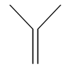
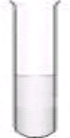
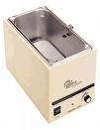
DIAGRAM (Summary)
(ii) To show the presence of alcohol: Iodoform test for alcohol

Add potassium iodide and sodium hypochlorite solution
Filter contents of each flask
Transfer to water bath for 4 – 5 min

RESULTS

Flask | Original colour of filtrate | Final colour filtrate
Yeast and glucose solution | Clear | Yellow crystals
Control (no yeast) | Clear | Clear

UNIT 2

GENETICS

ISOLATE DNA FROM PLANT TISSUE

CHEMICALS/MATERIALS
Onion
Washing up liquid
Table salt
Protease enzyme
Ice cold ethanol

PROCEDURE
- Chop the onions into small pieces.
- Add the chopped onion to the beaker with the salt and washing up liquid solution and stir.
- Put the beaker in the water bath at 60⁰C for exactly 15 minutes.
- Cool the mixture by standing the beaker in the ice-water bath for 5 minutes.
- Pour the mixture into the blender and blend it for no more than 3 seconds.
- Carefully filter the mixture into the second beaker.
- Transfer some of this filtrate into the boiling tube.
- Add 2-3 drops of protease.
- Trickle the ice cold alcohol down the side of the boiling tube
- Observe any changes that take place at the interface of the alcohol and the filtrate.
- Using the glass rod, gently draw the DNA out from the alcohol.
- Record the result.

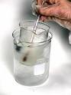
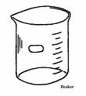
SUMMARY
Salt, washing up liquid chopped onion

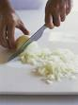

Add
Chopped onion
Salt
Washing up liquid

Breaks open cell membranes
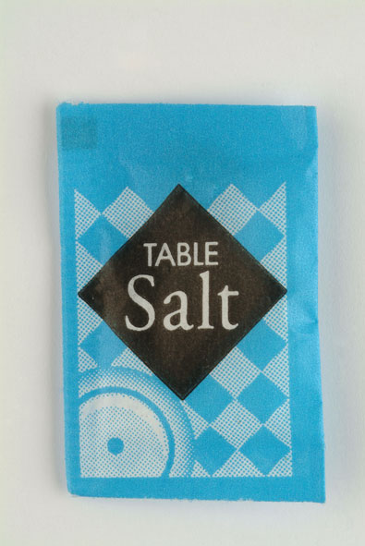
Ice water bath
for 5 min – slows down action of enzymes
Hot water bath @ 60ºC 15 min – denatures enzymes which breakdown DNA
Breaks open cell walls
Clumps DNA

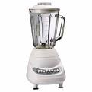
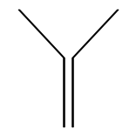
Transfer filtrate

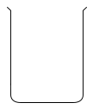

Add ice cold ethanol – DNA insoluble in ice cold ethanol
Blend for 3 sec – destroys cell walls and membranes
Filtrate containing DNA and protein
Add protease enzyme
– breaks down proteins associated with DNA

Filter – removes cellular debris

UNIT 2

MOVEMENT THROUGH CELL MEMBRANES

CONDUCT ANY ACTIVITY TO DEMONSTRATE OSMOSIS

MATERIALS/EQUIPMENT
Distilled water
Sucrose solution
Visking tubing

PROCEDURE
- I softened 2 strips of visking tubing by soaking them in water.
- I tied a knot at one end of each strip.
- I half-filedl one piece of tubing with the sucrose solution and the other with distilled water (Control).
- I eliminated air from the tubes and tie a knot at the open end.
- I washed off any sucrose solution from the outside of the tubes and dried.
- I recorded the turgidity of each tube.
- I recorded the mass of each tube .
- I suspended each tube in a beaker of distilled water.
- After 20 min I removed the tubes and dried.
- I recorded the turgidity of each tube.
- I recorded the mass of each tube .
- 12. I repeated the investigation.

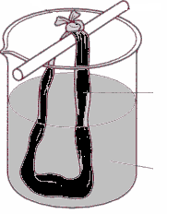
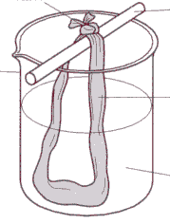
Distilled Water
Beaker
Visking tubing with sucrose solution
Glass rod
Knot
Knot
Glass rod
Visking tubing with distilled water
Distilled water
Control
Experiment
DIAGRAM

RESULTS

Tube contents | Turgidity at start | Turgidity after test period | Mass at start (g) | Mass after test period (g)
Sucrose solution | No | Yes | 10 | 40
Distilled  water | No | No | 10 | 10

UNIT 3

FUNGI

INVESTIGATE THE GROWTH OF LEAF YEAST USING AGAR PLATES AND CONTROLS

MATERIALS/EQUIPMENT

Fresh leaves
2 Sterile malt agar plates

PROCEDURE
- I swabbed the laboratory bench with disinfectant. (Kills microorganisms)
- I left one sterile malt agar plate unopened. (This acted as a control.)
- I sterilised the scissors, cork borer and forceps by flaming and allowed to cool.
- I carefully cut a leaf (e.g. Ash) using the sterile scissors and transferred it to the lab using a sterile forceps. (I was careful not to dislodge the yeast)
- I cut some discs from the leaf using a sterile cork borer..
- I opened the lid of one of the plates slightly and using the forceps, smeared small blobs of vaseline on the inside of the lid.
- I replaced the lid and reflamed the forceps.
- I again opened the lid slightly and using the forceps, attached a leaf disc to each of the blobs of vaseline.
- I closed and sealed the plate.
- I left the plates for approximately 24 hours. ( Spores can drop onto agar from the leaf discs).
- After 24 hours I inverted the plates.and incubated them at 18⁰C – 20⁰C , for three days .(Allow the leaf yeast to grow)
- I recorded the result. (Leaf yeast will grow as pink glistening colonies.)
- I repeated the investigation.

RESULTS

Agar plate | Appearance of colonies
Control | No
Experiment | Pink colonies

SUMMARY

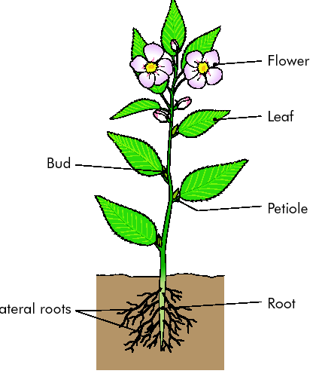
Cut leaf using sterile scissors
Cut discs using sterile cork borer
Attach discs to vaseline on lid of plate
Leave plates for 24 hours to allow spores fall onto agar
Invert and Incubate the plates @18⁰C – 20ºC for 3 days to allow yeast grow
Leaf disc
Malt agar

UNIT 3

ANIMAL BIOLOGY
sitting
running
Pulse rate (b.p.m.)
GRAPH
(a) INVESIGATE THE EFFECT OF EXERCISE ON THE PULSE OF A HUMAN

MATERIALS/EQUIPMENT
Timer

PROCEDURE
- I sat on a chair. I took 5 minutes to settle.
- I counted the number of pulses per minute and recorded.
- I repeated twice and calculated the average number of pulses per minute
and recorded (This is my resting heart rate).
- I ran for 5 minutes. I immediately measured my pulse rate and recorded.
(This is my pulse rate after exercise)
- I compared the pulse rates before and after exercise.
- I drew a bar chart of my results.

RESULT
 | Average
Resting pulse rate (bpm) | 72
Pulse rate after exercise (bpm_ | 100

(b) DISSECT, DISPLAY AND IDENTIFY A SHEEPS HEART

MATERIALS/EQUIPMENT
Sheep's heart
Dissecting board
Scalpel

PROCEDURE
- I placed the heart on the dissecting board so that the front (ventral) side is facing up.
- To identify the front side:
(i) I felt the sidewalls - The left side will feel much firmer than the right side.
(ii) I found a groove that extends from the right side of the heart downward.
- I located the four chambers chambers of the heart and the main blood vessels .
- I drew a labeled sketch of the external structure of the heart.
- I made a shallow cut in the left ventricle and left atrium (See diagram)
- I opened the heart at the cut to examine the internal structure.
- I observed the different sizes of the chambers and recorded my results.
- I located the bicuspid valve between the left atrium and left ventricle. ( I looked for two flaps).
- I inserted my finger under the chordae tendinae and notice that they extend from the valve, to the papillary muscles.
- I made a shallow cut on the right side of heart (See diagram)
- I located the tricuspid valve between she right atrium and the right ventricle. ( I looked for three flaps).
- I found the septum, a thick muscular wall, which separates the right and left ventricles.
- I used the scalpel to cut open the aorta and observed the semi-lunar valve. (I looked for the three half-moon shaped flaps of this valve)
- I found two small openings at the base of the aorta just above the semi-lunar valve. These lead into the coronary arteries. I inserted a seeker into a coronary artery to trace its pathway.
- I drew a labelled diagram of the internal structure of the heart.
- I washed and sterilised the dissecting instruments after use.

UNIT 3

ANIMAL BIOLOGY (cont.)

(b) DISSECT, DISPLAY AND IDENTIFY A SHEEPS HEART (cont.)

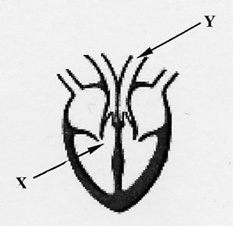
Internal structure
R.A.
R.V.
L.A.
L.V.
Vena cava
Pulmonary artery
Aorta
Pulmonary vein
Septum
Bicuspid valve
Tricuspid valve
Semi lunar
valve
DIAGRAM

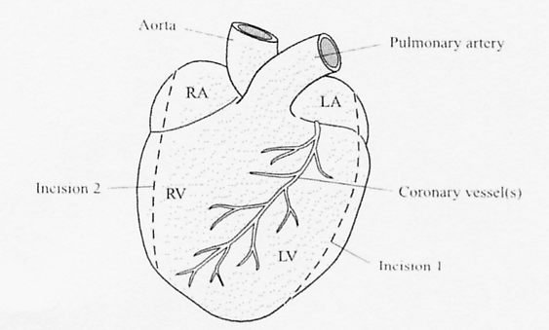

Groove: location of coronary vessel

External structure

RESULTS
Chamber | Wall – thick/thin
Left atrium | thin
Right atrium | thin
Left ventricle | thick
Right ventricle | thin
Valve type | Number of flaps
Biscupid | 2
Tricuspid | 3
Semi-lunar | 3
UNIT 3

PLANT BIOLOGY

(a) PREPARE AND EXAMINE MICROSCOPICALLY THE TRANSVERSE SECTION OF A DICOTYLEDENOUS STEM (X100, X400)

MATERIALS/EQUIPMENT
Dicotyledenous stems
Microscope slides
Cover slips
Microscope

RESULTS
PROCEDURE
X 100
- I cut a number of short lengths of wet stem using the blade.
( Cut at the node, at right angles to the stem,
away from the body, to get a very thin transverse section).
- I placed the cut sections in a petri dish of water (Prevents drying out).
- I removed the thinnest section from the water and placed it
on a microscope slide in a drop of water.
X 400
- I added a coverslip.
- I examined under the microscope.
- I drew labelled diagrams of what I saw.

SUMMARY

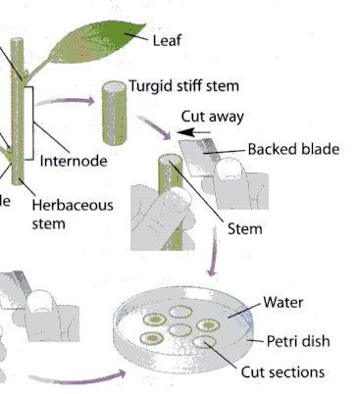
Fig 1.1 T.S dicot stem


Node

cut

UNIT 3

PLANT BIOLOGY (cont.)

(b) INVESTIGATE THE EFFECT OF I.A.A. GROWTH REGULATOR ON PLANT TISSUE.
(OPTION 1)

MATERIALS/EQUIPMENT
Radish seeds
IAA solution

PROCEDURE
- I labelled 8 petri dishes and 8 bottles as in diagram.
- I added 10 cm³ of the IAA solution to the first bottle.
- I added 9 cm³ of distilled water to each of the next seven bottles.
- I removed 1cm³ of the IAA solution from the first bottle and add it to the second bottle.
- I removed 1 cm³ of solution from the second bottle and add it to the third bottle
- I repeated this serial dilution procedure for the fourth fifth, sixth and seventh bottles (using a different dropper each time).
- I discarded 1cm³ of solution from the seventh bottle so that each bottle now contains 9 cm³ of solution.
- I fitted a circular acetate grid inside the lid of each dish.
NOTE
The 8th bottle acted as a control
- I placed five radish seeds in each dish as shown in diagram.
- I placed a filter paper and cotton wool on top of the seeds in each dish.
- I added each solution to its matching dish
- I stood the dishes vertically on their edge,(to ensure the roots grow down).
- I placed the dishes in the incubator for 2-3 days @ 25⁰C. (allow germination).
- I measured the length of the roots and shoots of the seedlings in each dish and recorded
- I calculated the percentage stimulation or inhibition of root and shoot growth in each dish using the following formula:
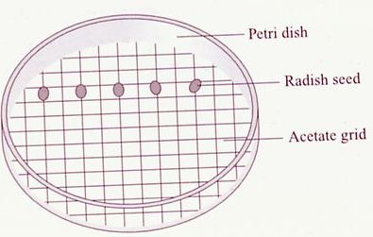
Percentage stimulation/inhibition

= (Average length – average length of control) x 100
Average length of control

- I drew a graph of percentage stimulation and inhibition of root and shoot growth against IAA concentration

RESULTS

Conc IAA (ppm) | Length root/shoot (mm) |  |  |  |  |  |  |  |  |  | Total lenght | Average length | % stimulation/inhibition
Conc IAA (ppm) | Seed 1 |  | Seed 2 |  | Seed 3 |  | Seed 4 |  | Seed 5 |  | Total lenght | Average length | % stimulation/inhibition
Conc IAA (ppm) | Root | Shoot | Root | Shoot | Root | Shoot | Root | Shoot | Root | Shoot | Total lenght | Average length | % stimulation/inhibition
0
10⁻⁴
10⁻³
10⁻²
10⁻¹
1
10
10²

UNIT 3

PLANT BIOLOGY (cont.)

(b) INVESTIGATE THE EFFECT OF I.A.A. GROWTH REGULATOR ON PLANT TISSUE
(Option 1 cont.)

GRAPH

Root:
low auxin concentration stimulates growth
high auxin concentration inhibits growth
Shoot
low auxin concentration inhibits growth
high auxin concentration stimulates growth
Percentage stimulation

Percentage inhibition
10⁻⁴
10⁻⁶
10⁻²
1
10²
10⁴

Growth response
UNIT 3

PLANT BIOLOGY (cont)

(b) INVESTIGATE THE EFFECT OF I.A.A. GROWTH REGULATOR ON PLANT TISSUE.
(Option 2)

MATERIALS/EQUIPMENT
Radish seeds
IAA solution

PROCEDURE

- I labelled 8 petri dishes: 10² ppm, 10 ppm, 1 ppm, 10⁻¹ ppm, 10⁻² ppm, 10⁻³ ppm, 10⁻⁴ ppm, distilled water

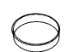

Distilled

10²
10
1
10⁻³
10⁻¹
10⁻²
10⁻⁴
Distilled
Water

2. I labelled 8 bottles in the same way
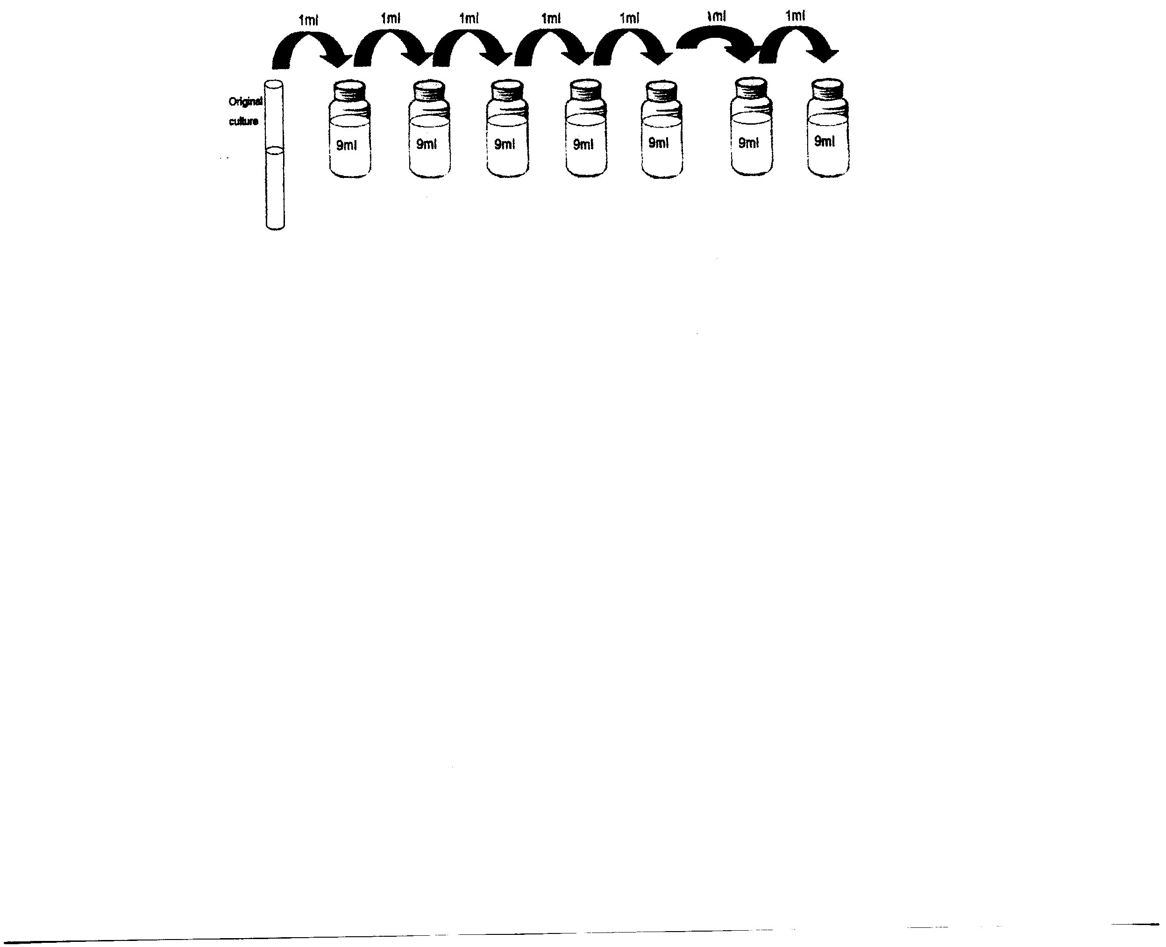
10²
10
1
10⁻¹
10⁻²
10⁻³
10⁻⁴
Distilled water

3. I added 10 cm³ of IAA solution to first bottle and added 9 cm³ of dist. water to each of the next 7 bottles

10²
10
1
10⁻¹
10⁻²
10⁻³
10⁻⁴
10cm³
9cm³
9cm³
9cm³
9cm³
9cm³
9cm³
9cm³
Dist .water
IAA
DISTILLED WATER

4. I removed 1 cm³ from 1st bottle and added to second bottle and mixed

5. I removed 1 cm³ from 2nd and added to 3rd and mixed.

- I repeated the serial dilution for each of remaining bottles
1 cm³
Discard from 7th bottle into sink
1 cm³
1 cm³
1 cm³
1 cm³
1 cm³
1 cm³
1 cm³
10²
10
1
10⁻¹
10⁻²
10⁻³
10⁻⁴
^{Dist. Water}
9 cm³
9cm³
9cm³
9cm³
9cm³
9cm3
9cm³
9cm³

Leave 8th bottle untouched . This is the CONTROL

UNIT 3

PLANT BIOLOGY (cont.)

INVESTIGATE THE EFFECT OF I.A.A. GROWTH REGULATOR ON PLANT TISSUE.
(Option 2 cont.)

7. I discarded 1 cm³ from 7th bottle and left the 8th bottle untouched as a control. Note: Each bottle now contains 9 cm³

8. I fitted a circular acetate grid inside the lid of each dish and place 5 radish seeds in each dish

9. I placed a filter paper and cotton wool on top of the seeds on each dish.

10. I added each solution in the bottle to its matching dish
10⁻², 10, 1, 10⁻¹, 10⁻², 10⁻³, 10^{-4 D. water}
9 cm³
9 cm³
9 cm³
9 cm³
9 cm³
9 cm³
9 cm³
9 cm³

11. I stood the dishes vertically on their edges (to allow roots grow down)

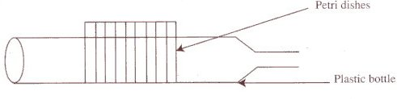

12. I incubated for a few days @ 25⁰C. (to allow germination)
13.I measured the length of the roots and shoots of the seedlings in each dish and recorded
14 .I estimated the percentage stimulation or inhibition of root and shoot growth in each dish using the following formula:
Percentage stimulation/inhibition

= (Average length – average length of control) x 100
Average length of control

  - I drew a graph of percentage stimulation and inhibition of root and shoot growth against IAA concentration

UNIT 3

PLANT BIOLOGY (cont.)

(b) INVESTIGATE THE EFFECT OF I.A.A. GROWTH REGULATOR ON PLANT TISSUE.
(Option 2 cont.)
RESULTS

Conc IAA (ppm) | Length root/shoot (mm) |  |  |  |  |  |  |  |  |  | Total lenght | Average length | % stimulation/inhibition
Conc IAA (ppm) | Seed 1 |  | Seed 2 |  | Seed 3 |  | Seed 4 |  | Seed 5 |  | Total lenght | Average length | % stimulation/inhibition
Conc IAA (ppm) | Root | Shoot | Root | Shoot | Root | Shoot | Root | Shoot | Root | Shoot | Total lenght | Average length | % stimulation/inhibition
0
10⁻⁴
10⁻³
10⁻²
10⁻¹
1
10
10²

GRAPH
Root:
low auxin concentration stimulates growth
high auxin concentration inhibits growth
Shoot
low auxin concentration inhibits growth
high auxin concentration stimulates growth
Percentage stimulation

Percentage inhibition
10⁻⁴
10⁻⁶
10⁻²
1
10²
10⁴

Growth response

Auxin concentration (ppm)

10⁻⁴
10⁻²
1
10²
10⁴
10⁻⁶

UNIT 3

PLANT BIOLOGY (cont)

(c) INVESTIGATE THE EFFECT OF WATER, OXYGEN AND TEMPERATURE ON GERMINATION.

MATERIALS/EQUIPMENT
Seeds e.g. radish
Anaerobic jar/GasPack
4 Petri dishes

PROCEDURE
  - I set up the four Petri dishes with cotton wool in each.
  - I labelled the dishes A,B,C,D.
  - In dish A, I left the cotton wool dry – seeds lacking water.
  - I wet the cotton wool in each of the other dishes.
  - I placed10 seeds in each dish.
  - I placed dish D in the fridge – seeds lacking a suitable temperature.
  - I placed C in the anaerobic jar with a GasPack to create an anaerobic environment– seeds lacking oxygen.
  - I placed dishes A,B and C, in the incubator at 25ºC for a few days. (Dish B acts as a control – all conditions for germination present.)
  - I recorded the results.
  - Replicated the investigation

RESULT
Dish | Germination
A- with oxygen and suitable temperature (no water) | NO
B- with water, oxygen, and a suitable temperature. | NO
C- with water and suitable temperature (no oxygen) | NO
D- with water and oxygen (unsuitable temperature) | YES

DIAGRAM
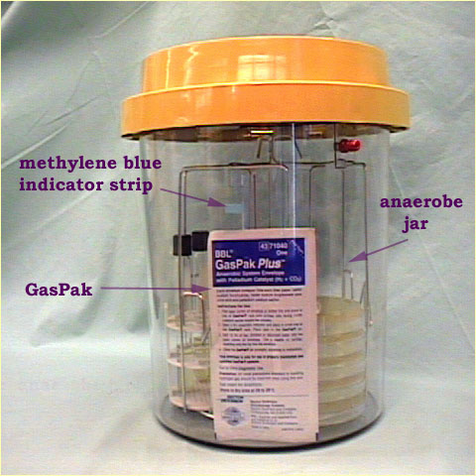
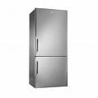
Anaerobic jar
GasPack
A
dry cotton
wool
B
wet cotton wool

C
wet cotton wool
D
Wet cotton wool
Fridge
Incubate @ 25⁰C

Fit a circular acetate grid inside the lid of each dish.
Place 5 radish seeds along a grid line in each dish
Place a filter paper on top of the seeds on each dish

UNIT 3

PLANT BIOLOGY (cont)

(d) USE STARCH AGAR OR SKIMMED MILK PLATES TO SHOW DIGESTIVE ACTIVITY DURING GERMINATION

MATERIALS/EQUIPMENT
Soaked broad bean seeds
Sterile starch agar plates
Iodine solution

PROCEDURE
DIAGRAM
- I cleaned the lab bench with disinfectant (kill microorganisms).
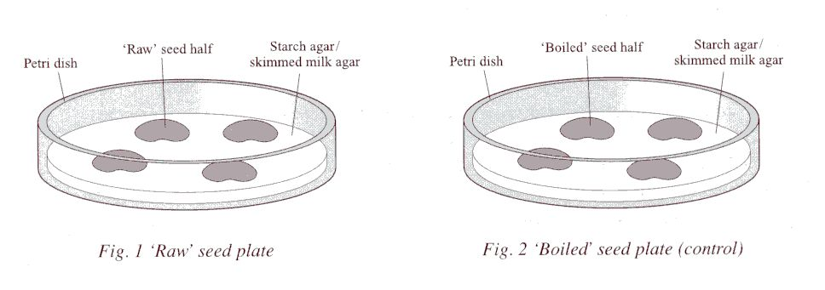
- I got 2 sterile starch agar plates and labelled them unboiled and boiled.
- I got 4 soaked seeds.
- I boiled 2 of the seeds. These acted as controls.
- I split each seed in half( to separate the cotyledons).
- I sterilised all seeds by soaking them in disinfectant and then rinsed them
( kills microorganisms on surface of seed)
- I sterilised the forceps by flaming it in a Bunsen flame..
Unboiled
- With minimal opening, I placed all the seed halves
facing down on the agar plates (minimises contamination).
- I incubated the plates upright at 18ºC-20ºC for 48 hours (allow germination).
- I removed the seeds from the plates.
- I flooded the plates with iodine solution (to test for starch)
- I poured off the iodine solution.
- I recorded my results.
Boiled

Unboiled: Test with iodine | Boiled: Test with iodine
Blue black  clear areas under seed where starch digestion took place | All blue black – no clear areas

RESULTS

Unboiled: clear areas under seeds indicating starch digestion
Boiled: All blue black indicating no starch digestion

