Q 2016 15 b
Answer the following questions in relation to the typical human female menstrual cycle.

    - State one change that occurs, and the approximate day(s) of the cycle on which it occurs
      - in the endometrium.
      - in the ovary.

    - FSH and LH each plays a role in the cycle. Where in the body are these hormones produced?

    - State one role of each of these hormones in the cycle.

    - Name two other hormones that play a role in the cycle.

    - Stating clearly which of the two hormones you have chosen from (iv), give a function in the cycle of that hormone.

MS 2016 15 b
15 | (b) | (i) | 1. Endometrium: |  | Breaks down (shed) | (Days) 1 – 5
 |  |  |  |  | or  Thickens | (Days) 6 – 28 | 3 + 3
 |  |  | 2. Ovary: |  | Follicle (or ovum or egg) matures | (Days) 1 – 14
 |  |  |  |  | or  Ovulation | (Days) 13 – 15 | 3 + 3
 |  |  |  |  | or  Corpus luteum develops | (Days) 15 – 28
 |  | (ii) | Where FSH and LH produced: *Pituitary (gland) |  |  |  | 3
 |  | (iii) | FSH: | Stimulates follicle (egg) to develop (in ovary) or stimulates (ovary) to
 |  |  |  | produce oestrogen or stimulates LH (production) |  |  | 3
 |  |  | LH: | Stimulates ovulation or described or causes (Graafian follicle) to develop
 |  |  |  | into corpus luteum or stimulates progesterone (production) |  |  | 3
 |  | (iv) | Other hormones: Oestrogen/ progesterone |  |  |  | 2(3)
 |  | (v) | Fn oestrogen: |  | Causes endometrium to build up or inhibits FSH or stimulates LH
 |  |  |  |  | OR |  | 3
 |  |  | Fn progesterone: |  | Maintains endometrium or inhibits LH or inhibits FSH

Q 2015 14 c
(i) Draw a labelled diagram of the human male reproductive system and its associated glands.

- Put X on the diagram where meiosis occurs.

- Give a function of one named gland.

- The diagram shows the structure of a human sperm cell. Part B contains many mitochondria.

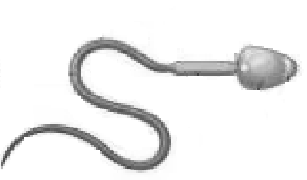
B
  - Suggest why a sperm cell needs so many mitochondria.

  - Mitochondria are inherited exclusively from the mother. Suggest why this is the case.

  - State the survival times of the egg and sperm in the female body

Q 2015 14 c
14. (c) | - Diagram: testis + prostate (or seminal vesicles or Cowper’s gland)  + sperm duct & urethra + penis  Labels: testis, epididymis, sperm duct, seminal vesicle,  Cowper’s gland, prostate gland, urethra, penis, scrotum  - X on testes  - Named gland + function  - 1. (Sperm cells) need a lot of energy or (sperm cells) need to swim long distances (or described) (compared to their size) Mitochondria produce energy or mitochondria carry out (aerobic) respiration  2. Only the head (of the sperm) enters the egg  or no sperm mitochondria enter the egg  - Egg: 12 – 48 hours  Sperm: 0 – 7 days | 6, 3, 0
 |  | 3 + 2
 |  | 1
 |  | 3
 |  | 3
 |  | 3
 |  | 3
 |  | 3
 |  | 3

Q 2013 Q 13

(a) (i) In humans, widening of the female hips is one example of physical changes that distinguish the sexes but are not essential for reproduction.
To what term does the definition in italics refer?

  - What term is used for the time in a young person’s life when such changes take place?

  - Name the hormone that maintains such changes throughout the life of a male.

    - The diagram shows the reproductive system of the human female.
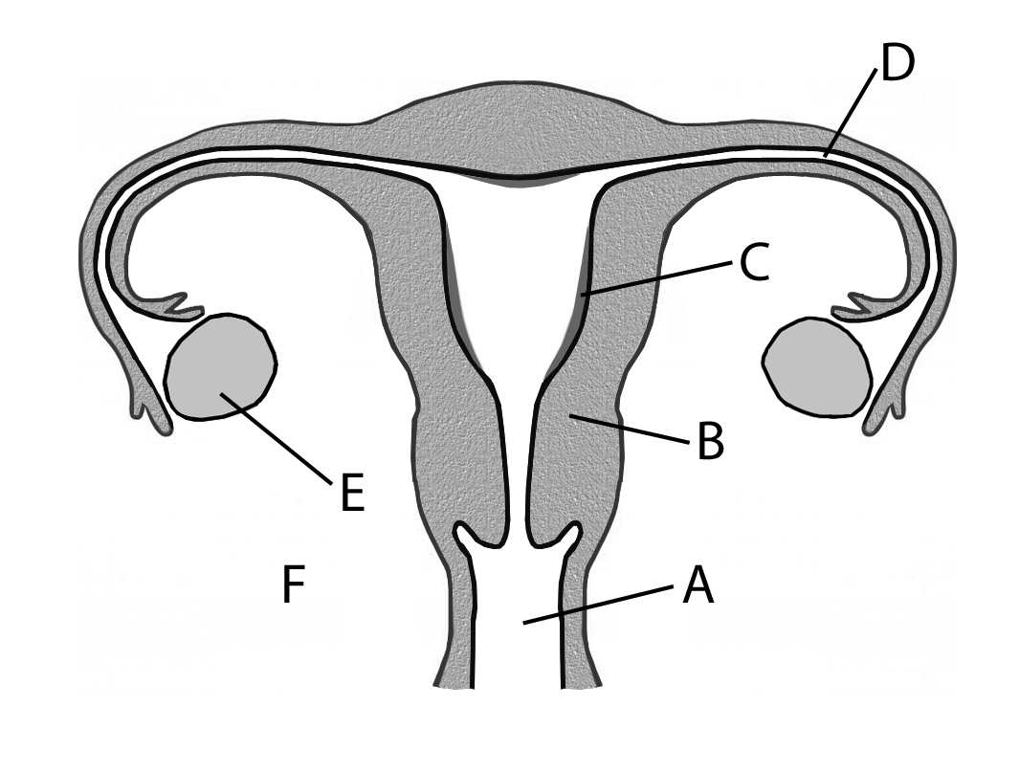
      - Name the parts labelled A, B, C, D, E and F.

      - Using the letters from part (i), identify the following locations:
        - Where meiosis occurs.
        - Where zygote formation occurs.
        - Where implantation occurs.

      - Describe the role of oestrogen and progesterone in the control of the events of the menstrual cycle.

(c) Answer the following questions in relation to the development of a human zygote.
      - By which type of cell division does the zygote divide?

      - Further divisions result in the formation of a morula. What is the next developmental stage after the morula?

      - The placenta forms from tissues of the mother and the foetus. Give two roles of the placenta.

      - Give one change experienced by the mother that indicates to her that the birth process is starting.

      - Give a short account of the birth process.

MS 2013 Q 13

- (a) (i) *Secondary sexual characteristics  - *Puberty  - *Testosterone | 3  3  3
- (i) A. Vagina  - Uterus (or womb)  - Endometrium (or lining of uterus or lining of womb)  - Fallopian tube (or oviduct)  - Ovary  - Cervix  - 1. *E  - *D  - *C  - Oestrogen: Endometrium repair / stimulates LH / inhibits FSH  Progesterone: Endometrium maintenance / inhibits LH / inhibits FSH | 6(1)  3  3  3  2(3)  2(3)
- (i) *Mitosis  - *Blastocyst  - Makes progesterone / barrier or one (barrier) example / material transfer or one (transfer) example  - (Mucus) show or contractions or waters break  - Contractions or amniotic sac breaks or cervix dilates Baby delivered  Afterbirth delivered | 3  3  2(3)  3  3  3  3

Q 2012 14 b
Answer the following questions from your knowledge of early human development in the womb.
    - 1. Name the three germ layers in the early human embryo.
2. For each germ layer name a structure in the adult body that develops from it.
    - From which tissues does the placenta develop?
    - 1. What is the amnion?
2. Explain the importance of the amnion for the foetus

MS 2012 14 b
14. (b) | (i) | - ectoderm mesoderm endoderm  - ectoderm: e.g nervous system mesoderm: e.g skeletal system endoderm: e.g. digestive system
 | (ii) | Embryonic
 |  | Uterine or endometrium
 | (iii) | 1. A membrane (or sac) that surrounds the embryo (or foetus)
 |  | 2. It contains (or secretes) (amniotic) fluid or protects embryo

Q 2009 14 a
(a) | (i)  (ii) | Draw a diagram of the reproductive system of the human female. On your diagram indicate where the following occur:  - Meiosis.  - Fertilisation.  - Implantation.  Give an account of the role of either oestrogen or progesterone in the menstrual cycle.
 | (iii) | Name a human female menstrual disorder. In the case of this disorder give:  - A possible cause.  - A method of treatment.

MS 2009 14 a

14. | (a) | (i) | Diagram | 6, 3, 0
 |  |  | Indicate sites of:
 |  |  | Meiosis: (Ovary) indicated on diagram | 3
 |  |  | Fertilisation: (Fallopian) tube indicated on diagram | 3
 |  |  | Implantation: (Uterus) indicated on diagram | 3
 |  | (ii) | Oestrogen: repairs endometrium / inhibits FSH / stimulates LH  OR  Progesterone: thickening (or maintenance of) endometrium / inhibits FSH / inhibits LH production | 2(3)
 |  | (iii) | Named menstrual disorder: | 3
 |  |  | 1. Cause | 3
 |  |  | 2. Treatment | 3

Q 2008 6

The diagram shows the female reproductive system.

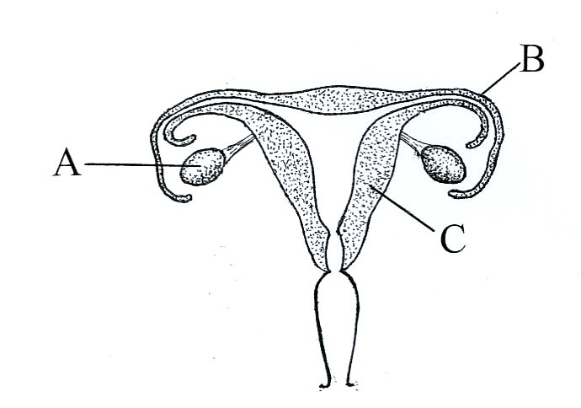

  - Identify parts A, B and C.
  - Using the letters X, Y and Z and arrows, identify each of the following on the diagram: endometrium (X), where fertilization normally occurs (Y), where meiosis occurs (Z).
  - Which part of the system is influenced by both FSH and LH?
  - Give two biological advantages of breastfeeding.

MS 2008 6

6. | (a) | A = ovary B = Fallopian tube (oviduct) C = uterus (womb) | 3(2)
 | (b) | locations of X, Y, Z | 3(2)
 | (c) | Ovary or A or follicle | 2
 | (d) | (transfer of) antibodies / balanced diet / bonding / contraception / correct temperature/ milk sterile / uterus recovers more quickly / reduced cancer risk / psychological wellbeing | 2(3)

Q 2007 15 a
  - (i) Draw a detailed diagram of the reproductive system of the human male. Label the following parts on your diagram: testis, seminal vesicle, urethra, sperm duct (vas deferens), epididymis, prostate gland.
- Place an X on your diagram where meiosis occurs.
- Place a Y on your diagram where sperm are stored.
- State two functions of testosterone.
- Give a cause of male infertility and suggest a corrective measure.

MS 2007 15 (a)
(a) | (i) | diagram [penis, urethra, sperm duct, testis] | 6, 3, 0
 |  | labels | 6(1)
 | (ii) | X on testis | 3
 | (iii)  (iv) | Y on epididymis  growth / development of primary sex characteristics or example / development of secondary sex characteristics or example / sperm | 3
 | (v) | production / comment on male behaviour  low sperm count or low sperm motility or hormonal imbalance or explained or named chemical or smoking or drug abuse or erectile | 2(3)
 |  | dysfunction [accept unsuitable temperature (of testes) or cause described] | 3
 |  | corrective measure matched | 3

Q 2006 15
- Write notes on three of the following.

  - Menstruation and a disorder of menstruation.
  - Biological benefits of breastfeeding.
  - Survival times for sperm and ova.
  - Formation and functions of the placenta.

MS 2006 15

    - menstruation: shedding of endometrium / in absence of fertilisation or
low level of progesterone
disorder: Endometriosis or fibroids / comment 4 + 2(3)

    - Antibodies or immunity / less danger of infection/ uterus contracts / may reduce risk of breast cancer / bonding / correct nutrients or easier to digest / suitable temperature / delayed ovulation
any three 4 + 2(3)
    - sperm: up to 7 days
ova: up to 2 days
one valid comment e.g. sperm nourished in female tract or
longer survival time means greater chance of fertilisation 4 + 2(3)
    - formation: (placenta) formed from embryonic and uterine tissues 4
functions: connected to embryo by umbilical cord / (placenta) produces hormones /example of transfer / example of a barrier
any two 2(3)

Q 2005 13
13. (a) | (i)  (ii) | Where is testosterone secreted in the body of the human male? Give a brief account of the role of testosterone. | (9)
(b) | (i)  (ii)  (iii)  (iv)  (v) | Draw a large labelled diagram of the reproductive system of the human male. Where are sperm produced?  State two ways in which sperm differ from ova (eggs). Name a gland that secretes seminal fluid.  State a function of seminal fluid. | (27)

(c) (i) What is meant by contraception?
- Give an example of a surgical method of male contraception. Suggest an advantage and a disadvantage of the method that you have named.
- List three methods of contraception other than surgical. In your answer you may refer to either or both sexes.
- Suggest a possible effect on a human population that may result from an increased availability of contraception.

MS 2005 13

13. (a) | (i)  (ii) | Testis  Development of secondary sexual characteristics or example named /  / development of sex organs /sperm production any two | 3  2(3)
(b) | (i) | Diagram (testis, associated duct, penis) | 6, 3, 0
 |  | labels | 2(3)
 | (ii)  (iii) | Testis  Size comment / shape or structural comment / motile (only if ‘tail or ‘flagellum’’ not given)/ chromosomal difference / does not (usually) | 3
 |  | contribute mitochondrial DNA to zygote any two | 2(3)
 | (iv) | Cowper’s gland / seminal vesicle / prostate gland | 3
 | (v) | Allows sperm to swim / provides nutrients / lubricant / protects sperm | 3
(c) | (i) | Prevention of fertilisation (conception) or implantation or pregnancy | 3
 | (ii) | Vasectomy or described  Advantage – simple operation/ avoids side effects of hormonal contraception / effective / single procedure | 3  3
 |  | Disadvantage – not easily reversed / medical complications / no protection against STIs | 3
 | (iii)  (iv) | Any three examples  Decrease (no increase) in population / demographic imbalance/ improved conditions /comment on STIs / health issues | 3(3)  social  3

Q 2004 14 c
Answer the following questions from your knowledge of human embryology.
    - What is a germ layer? List the three germ layers.
    - Relate each of the germ layers that you have listed in (i) to an organ or system in the adult body.
    - From what structures does the placenta develop? State three functions of the placenta.
    - Name a hormone associated with the maintenance of the placenta.
    - Describe the amnion and state its role.

MS 2004 14 c
(i) Germ layer:
Layer of cells / in the blastula (embryo) / (potential to) give rise to
(specific) tissues (or organs) any two |  | 2(2)
Name 3 germ layers: ectoderm |  | 2
endoderm |  | 2
mesoderm |  | 2
(ii) Fate of 3 germ layers:  ectoderm – skin or nails or hair or nervous system | 2
endoderm – (inner lining of) gut or named part of
or liver or pancreas | 2
mesoderm – muscles or skeleton or excretory system
or respiratory system or circulatory system (or blood) | 2
(iii) Placenta origin: uterine tissue and embryonic tissue
[allow from mother and baby] | 2
3 Functions:
produces hormones (or named) / allows passage of food (or named) /
/ and oxygen / antibodies / waste (or named) / acts as a barrier or explained
 |  | any three | 3 (2 )
(iv) | Progesterone |  | 2
(v) | Amnion: | sac or membrane | 2
 | holds or produces fluid or protects | embryo (or foetus) | 2

