At the end of this section you should be able to …. | Y | N
Describe pollen grain development
Describe embryo sac development:

Pollen grain development in the anther

Inside pollen sac:
- Microspore mother cells meiotic division, Tetrad (4 haploid microspores)

These will separate to form

- 4 haploid pollen grains (microspores)

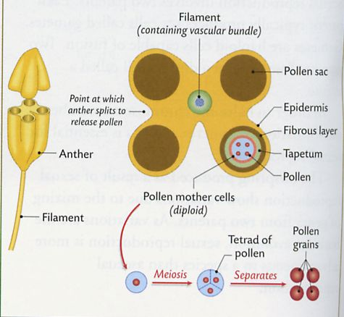
- Each pollen grain mitotic division, 2 nuclei ( generative and tube nuclei )
Food supply

Embryo sac development:
Inside the ovule
x3 mitosis
Megaspore Mother Cell
4 haploid cells
3 disintegrate
Embryo Sac
1 meiotic division

8 cells of which one is the Egg Cell

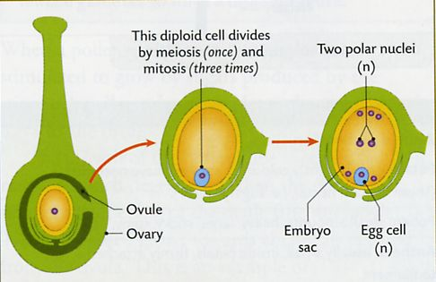

Practical Activities
- Investigate the effect of water, oxygen and temperature on germination.

Materials/Equipment
2 Thermometers
Incubator (25ºC)
Fridge (4ºC)
Absorbent cotton wool
Labels
Seeds e.g. radish
Distilled water
Gas generating kit sachets
Anaerobic jar
4 Petri dishes

Procedure
  - Set up the four Petri dishes with a wad of absorbent cotton wool in each.
  - Label the dishes A,B,C,D.
  - In dish A, leave the cotton wool dry – seeds lacking water.
  - Wet the cotton wool in each iof the other dishes.
  - Place 10 seeds in each dish.
  - Place dish B in the fridge – seeds lacking a suitable temperature.
  - Plac C in the anaerobic jar, activate and seal – seeds lacking oxygen.
  - Place dishes A,C (in the anaerobic jar0 and D, in the incubator at 25ºC.
  - Dish D has seeds with water, oxygen and a suitable temperature.
  - Check the dishes daily for 2-3 days.
  - Record the results.
  - Replcate the investigations or cross reference your results with other groups.

Result
Dish | Germination
A- with oxygen and suitable temperature (no water)
B- with water and oxygen (unsuitable temperature)
C- with water and suitable temperature (no oxygen)
D- with water, oxygen, and a suitable temperature.

Background
Water is required to activate the biochemical reactions associated with germination which take place in an aqueous solution.
Temperature: A suitable soil temperature (5ºC – 40ºC) is necessary to activate enzyme-controlled reactions.
Oxygen is required for aerobic respiration, releasing energy for the growth of the embryo.

Questions
In dish A why was the cotton wool left dry?
Why were 10 seeds used?
Why was dish B placed in the fridge?
Why was dish C placed in an anaerobic jar?
Why were all plates placed in an incubator at 25ºC?
What is the purpose of plate D?

TITLE: Use starch agar plates to show digestive activity during germination.

Materials/Equipment

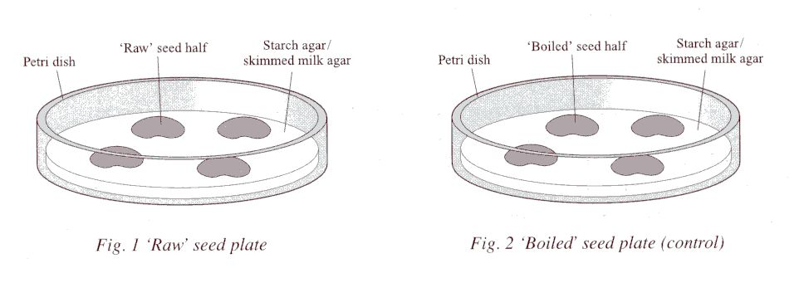
Procedure
- Swab the laboratory bench with disinfectant.
- Label one of the sterile plates ‘UNBOILED’.
- Label the other plate ‘BOILED’.
- Obtain 4 broad bean seeds.
- Boil two of the seeds for five minutes. These will act as controls.
- Split each of the four seeds in half, to separate the cotyledons.
- Sterilise all seeds by soaking them in the disinfectant solution for 10 minutes.
- Rinse the seeds twice using distilled water.
- Sterilise the forceps by flaming it in a Bunsen flame. Allow to cool.
- With minimal opening, use the forceps to place all the seed halves facing down on the agar in the appropriate plates ( boiled seeds on plate labelled boiled and unboiled seeds on plate labelled unboiled.)
- Re-flame the forceps and re-swab the bench.
- Incubate the plates upright at 18ºC-20ºC for 48 hours.
- After 48 hours, remove the seeds from the plates.
- Flood the plates with iodine solution and leave for two minutes.
- Pour off the iodine solution.
- Observe the pattern of starch digestion by holding the plate up to the light.
- Observe the pattern of protein digestion by holding the plate up to the light.
- Record the result.
- Replicate the investigation or cross reference your results with other groups.

Background

Unboiled
In the Starch agar plates which contained the unboiled seeds: starch in the agar is digested by amylase produced in the seeds.
These plates, when flooded with iodine solution will predominantly stain blue black due to the presence of starch in the agar.
However, where starch digestion has occurred (under the seeds) the areas will be clear.

Boiled
In the Starch agar plates which contained the boiled seeds: the enzymes (Amylases) in the seed have been denatured. The starch in the agar is not digested by amylase produced in the seeds.
These plates, when flooded with iodine solution will stain blue black due to the presence of starch in the agar.
No starch digestion has occurred (under the seeds) these areas will also stain blue black.

Blue black  clear areas under seed where starch digestion took place | All blue black – no clear areas

RESULTS

Unboiled: clear areas under seeds indicating starch digestion
Boiled: All blue black indicating no starch digestion

Questions
- Why was the lab bench swabbed with disinfectant?
- Explain your answer.
- Why are the agar plates sterile?
- Explain your answer.
- Why were one set of seeds boiled?
- Why is this necessary?
- Why were the seeds split in half?
- Why were the seeds sterilised?
- Why were the lids of the agar plates minimally opened?
- Why is this important?
- Why was the forceps flamed?
- Why were the seeds incubated at 18-20ºC for 48 hours?
- After 48 hours why were the seeds removed from the plates?
- Why were the plates flooded with iodine solution/
- How do you know starch has been digested?
- What happened to the digested starch?
- Why would you replicate the investigation?

