At the end of this section you should be able to … | Y | N
Detailed study of the menstrual cycle and hormonal control.
Contemporary Issue
Menstrual disorders:
One example of a menstrual disorder from the following: endometriosis and fibroids; one possible cause, prevention and treatment.
KEY WORDS
Follicle stimulating hormone, luteinising hormone, Humanchorionic gonadotropin hormone, fibroids

H. 3.6.5 Sexual Reproduction in the Human (Summary)
Menstrual cycle is controlled by hormones produced by the pituitary gland and the ovary.
- Pituitary secretes FSH (follicle stimulating hormone) and the LH (luteinising hormone).
- The ovary produces oestrogen and progesterone.
- The menstrual cycle is an example of feedback mechanism of hormone control: When the level of a hormone controls the production of another hormone or of itself.

Menstrual cycle when fertilisation does not occur:
Day 1
First day of menstruation
- Corpus luteum from the previous cycle has degenerated.
- Levels of oestrogen and progesterone fall.
- Menstruation occurs
- The low levels of oestrogen and progesterone stimulate the pituitary gland to secrete the hormone FSH.
- The level of FSH rises quickly.
- The high level of FSH stimulates follicles to develop in the ovary. Follicles secrete oestrogen.
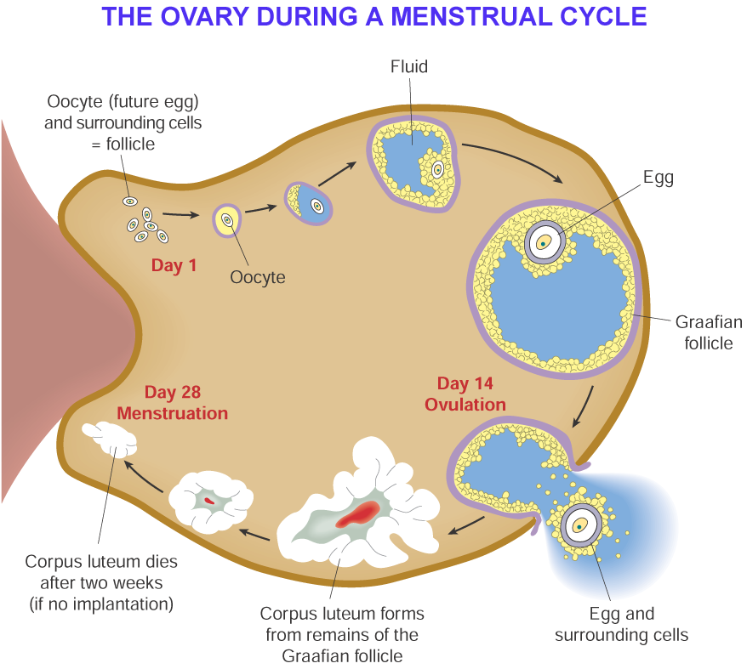
Days 6-13
- High levels of FSH stimulate maturation of a Graafian follicle.
- Graafian follicle secretes oestrogen. Level of oestrogen rises.
High levels of oestrogen causes
  - Repair and thickening of endometrium.
  - Inhibits further secretion of FSH.
  - Stimulates production of LH.
  - Prevents any more follicles from maturing.
Day 14
Ovulation
- LH secreted by the pituitary.
- Level builds up.
- High level stimulates ovulation.
Days 15 – 26
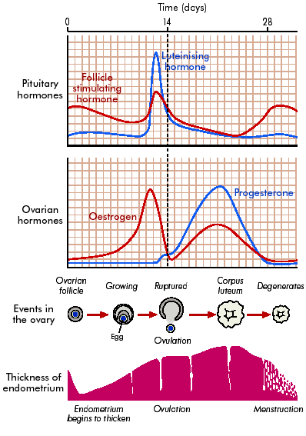
- High levels of LH causes the remains of the Graafian follicle to form the corpus luteum.
- Corpus luteum secretes oestrogen and progesterone.
- The high levels of oestrogen and progesterone inhibit secretion of FSH and LH from the pituitary.
- Low levels of FSH prevents graafian follicle development
- Low levels of LH
- prevent further ovulation.
- Causes the Corpus luteum to degenerate
- High level of progesterone stimulates further thickening of the endometrium for implantation of the embryo.

Days 26 – 28
If implantation has not occurred by day 26
- The corpus luteum degenerates.
- Oestrogen and progesterone levels fall dramatically.
- Fall in progesterone causes endometrium to break down. Menstruation occurs.
- Low levels of oestrogen and progesterone stimulate the pituitary to produce to produce FSH and LH.
- Cycle begins again.

Pregnancy
If fertilisation occurs the menstrual cycle is interrupted.

- Implantation of embryo releases a hormone hCG (Humanchorionic gonadotropin hormone)
- Prevents corpus luteum from degenerating.
- Progesterone and oestrogen continue to be secreted by the corpus luteum
- The endometrium remains intact.
- High levels of progesterone prevent production of FSH
- Low levels of FSH prevent more follicles being produced and prevents ovulation
- Menstruation does not take place.
- After 3-4 months corpus luteum breaks down.
- Placenta takes over production of oestrogen and progesterone.
- Placental progesterone prevents contractions of the uterus.

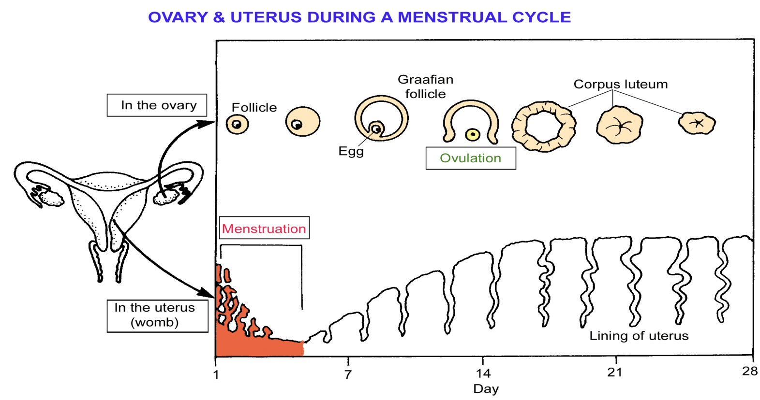
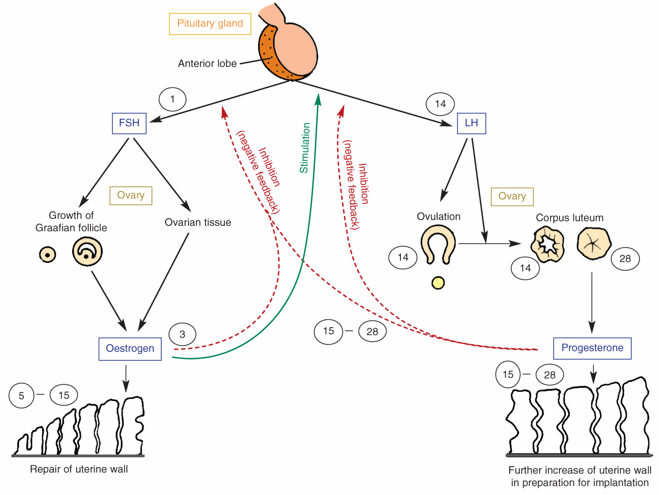

Menstrual disorder e.g. Fibroids
- Fibroids are tumours of the uterus
- They are the result of the overproduction of cells
- They do not invade other tissues and do not spread (benign)
- Slow growing and range from the size of a pea to the size of a melon
- Common between ages of 35 and 45
- Small fibroids often produce no symptoms
- As they enlarge they produce heavy and prolonged menstrual bleeding (this can lead to anaemia, pain, miscarriage or infertility)

Cause
- Cause is uncertain
- May be an abnormal response to oestrogen
- Can occur in women taking the contraceptive pill

Prevention and Treatment
- Small fibroids require no treatment just monitoring to check their growth
- Large fibroids can be removed by surgery
- If many large fibroids are present a Hysterectomy may be necessary. This is where the uterus is removed

