H. 3.6.5 Sexual Reproduction in the Human (Extended study)

(Menstrual Cycle and Hormonal Control)

Detailed study of the menstrual cycle and hormonal control.

Contemporary Issue
Menstrual disorders:
One example of a menstrual disorder from the following: endometriosis and fibroids; one possible cause, prevention and treatment.

NOTES
Detailed study of the menstrual cycle and hormonal control.

Menstrual cycle is controlled by hormones produced by the pituitary gland and the ovary.
Pituitary secretes FSH (follicle stimulating hormone) and the LH (luteinising hormone).
The ovary produces oestrogen and progesterone.

Menstrual cycle when fertilisation does not occur:
Day 1
First day of menstruation

- Corpus luteum from the previous cycle has degenerated.
- Levels of oestrogen and progesterone fall.
- Menstruation occurs
- The low levels of oestrogen and progesterone stimulate the pituitary gland to secrete the hormone FSH.
- The level of FSH rises quickly.
- The high level of FSH stimulates follicles to develop in the ovary. Follicles secrete oestrogen.

Days 6-13
- High levels of FSH stimulate maturation of a Graafian follicle.
- Graafian follicle secretes oestrogen. Level of oestrogen rises.
High levels of oestrogen causes
  - Repair and thickening of endometrium.
  - Inhibits further secretion of FSH.
  - Stimulates production of LH.
  - Prevents any more follicles from maturing.

Day 14
Ovulation

- LH secreted by the pituitary.
- Level builds up.
- High level stimulates ovulation.

Days 15 – 26
- High levels of LH causes the remains of the Graafian follicle to form the corpus luteum.
- Corpus luteum secretes oestrogen and progesterone.
- The high levels of oestrogen and progesterone inhibit secretion of FSH and LH from the pituitary.
- Low levels of FSH prevents graafian follicle development
- Low levels of LH
- prevent further ovulation.
- Causes the Corpus luteum to degenerate
- High level of progesterone stimulates further thickening of the endometrium for implantation of the embryo.

Days 26 – 28
If implantation has not occurred by day 26
- The corpus luteum degenerates.
- Oestrogen and progesterone levels fall dramatically.
- Fall in progesterone causes endometrium to break down. Menstruation occurs.
- Low levels of oestrogen and progesterone stimulate the pituitary to produce to produce FSH and LH.
- Cycle begins again.

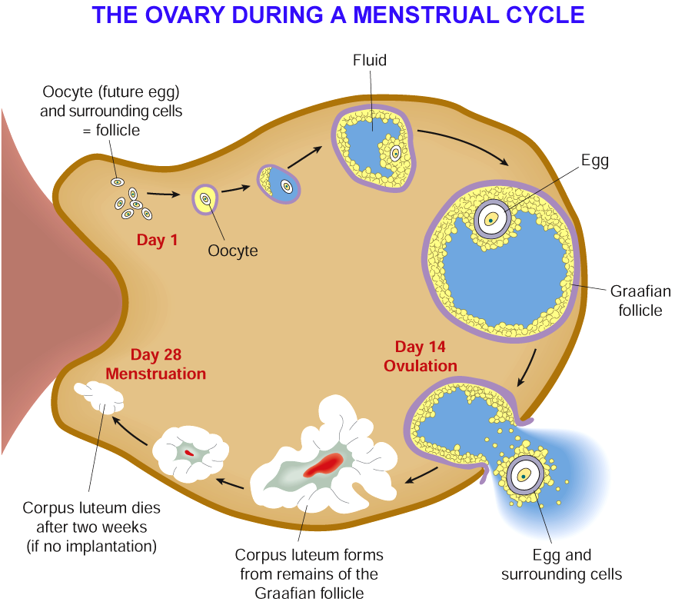

Pregnancy
If fertilisation occurs the menstrual cycle is interrupted.

- Implantation of embryo releases a hormone hCG (Humanchorionic gonadotropin hormone)
- Prevents corpus luteum from degenerating.
- Progesterone and oestrogen continue to be secreted by the corpus luteum
- The endometrium remains intact.
- High levels of progesterone prevent production of FSH
- Low levels of FSH prevent more follicles being produced and prevents ovulation
- Menstruation does not take place.
- After 3-4 months corpus luteum breaks down.
- Placenta takes over production of oestrogen and progesterone.
- Placental progesterone prevents contractions of the uterus.

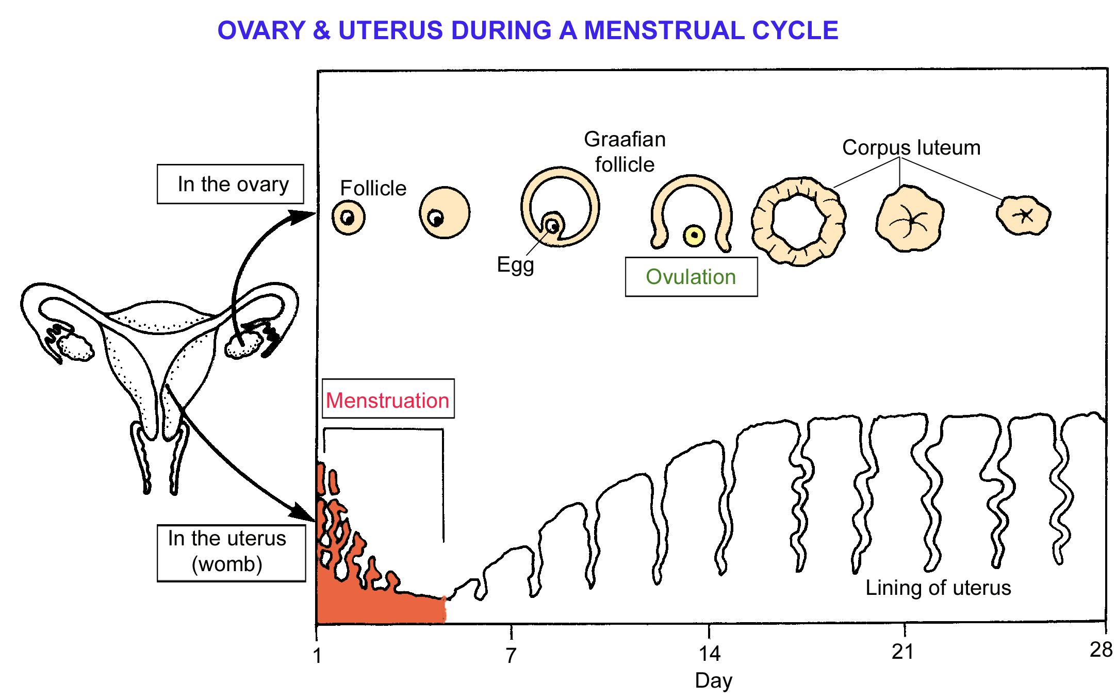
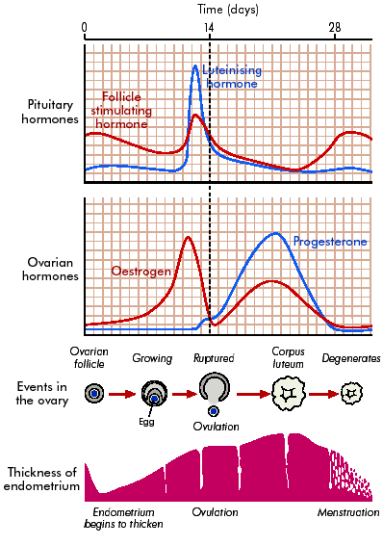

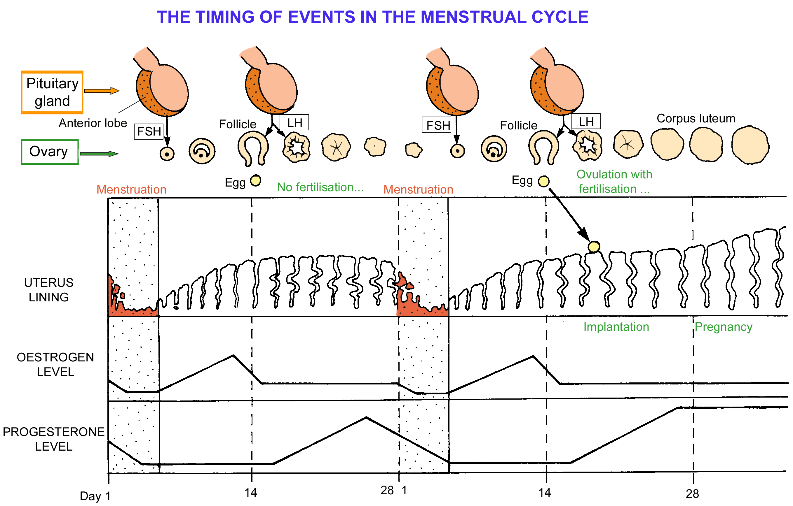

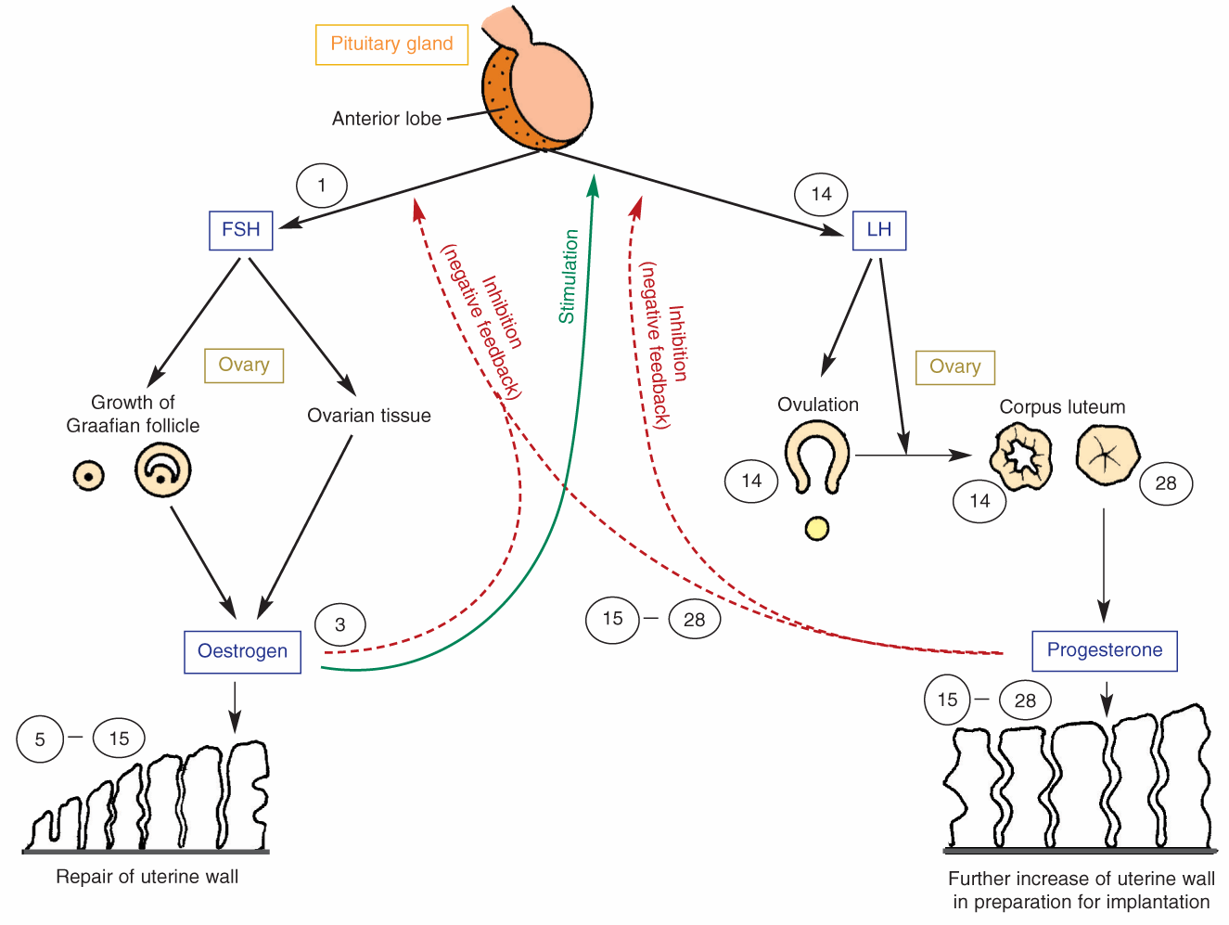
Contemporary issues
Menstrual disorders:
One example of a menstrual disorder from the following: endometriosis and fibroids; one possible cause, prevention and treatment.

Endometriosis
Occurs in 10% – 15% of fertile menstruating women.
Patches of the uterine lining (endometrium) grow outside the uterus e.g. lining of abdominal cavity and surface of the abdominal regions..
Respond to changes in the ovarian hormones during the menstrual cycle.
May cause abdominal swelling, menstrual irregularities, infertility and severe pain in the lower abdomen.

Cause
May be due to backflow of endometrial cells from the uterus along the fallopian tube into the abdominal cavity during menstruation.
May be a genetic component.

Prevention
No known prevention

Treatment
Remove the displaced endometrium during surgery.
Drugs for relief of pain.
Uterus removed (hysterectomy)

Fibroids
Non-cancerous growths of muscle and fibrous tissue in the wall of the uterus (benign tumours)
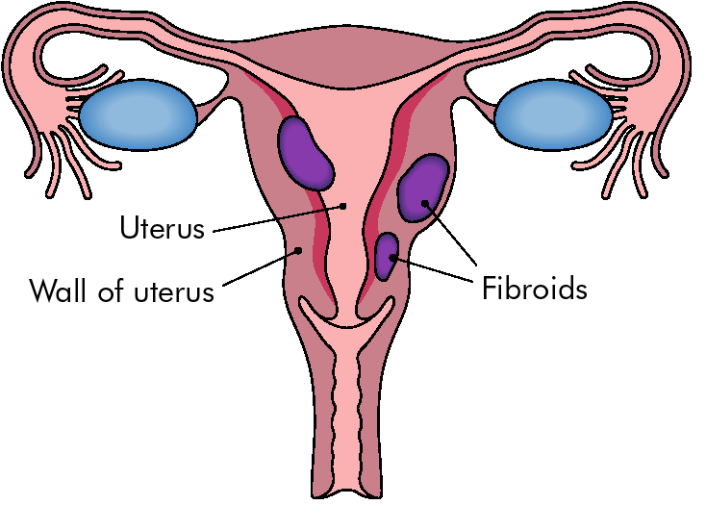
Occur in 20% of woman > 35 yrs.
May cause
- heavy or prolonged menstruation.
- infertility due to blockage of fallopian tubes
- miscarriage
- early labor or pain
- swelling in the abdomen

Cause
Not known.
May be induced by oestrogen.
Grow larger during pregnancy and shrink after menopause.

Prevention
No known prevention

Treatment
Hormone treatment used to shrink fibroids.
Removed surgically if symptoms severe.

