**Whitaker’s Five Kingdom classification** : Monera, Protista, Fungi, Plant and Animal.

S**pecies:**  A group of organisms capable of interbreeding and producing fertile offspring.

**Heredity:**  The transmission of traits from parents to offspring. **Examples**: inheritance of eye colour, hitchhikers thumb, curly/straight hair/ dimples/freckles

G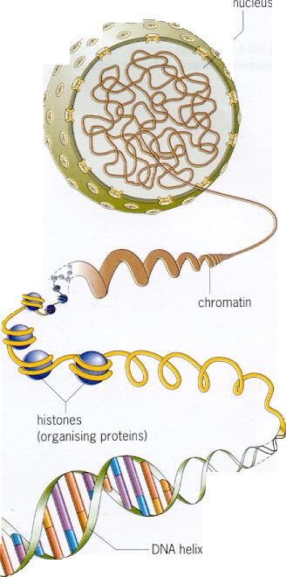**ene:**

* Unit of inheritance
* A length of DNA
* Carries information for specific proteins

**Role of gene**: Carries information for making specific proteins

G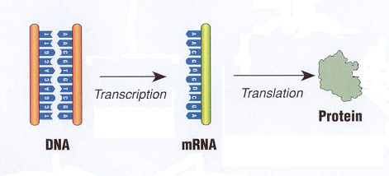**ene expression:** The genetic information, encoded in a gene, is transferred to its functional product (protein). **Examples**: (skin colour, hair colour, :protein melanin), (protein: haemoglobin)

C**hromosome:** A thread-like structure found in the nuclei of dividing cells, and composed of a super-coiled arrangement of DNA and protein Chromosome structurThread of DNAWrapped around proteinsSupercoiled

C**hromosome structure**

* Thread of DNA
* Supercoiled
* Wrapped around proteins

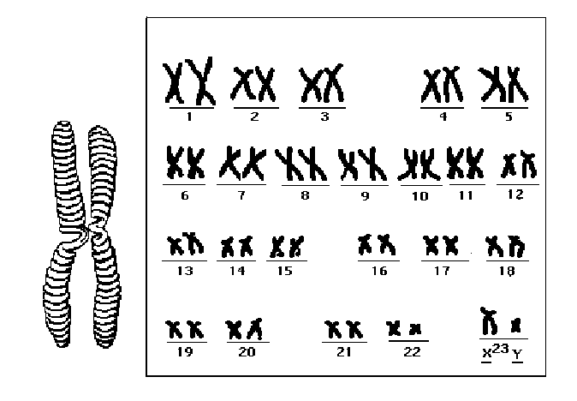

Human Chromosomes

DNA double helix structure as proposed by Watson and Crick

**DNA structure**

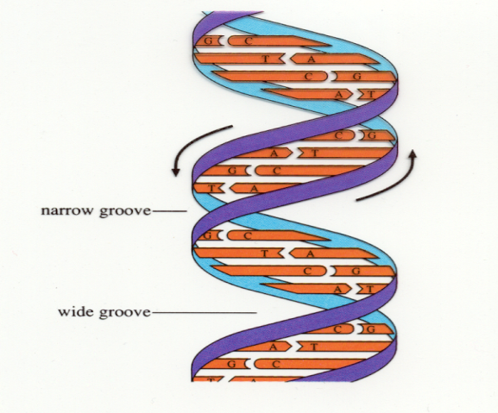

* DNA is a very long molecule.( Over 2m in each cell)
* It consists of 2 strands. The 2 strands are linked together by paired bases.
* There are 4 different bases: Adenine (A), Thymine (T), Guanine (G), Cytosine (C) . Each base can only link with one other type, A with T and C with G.
* A molecule of DNA consists of a **double helical structure**
* The double stranded DNA molecule is held together by **hydrogen bonds** between chemical components called bases.
* **Adenine bonds with Thymine, Cytosine bonds with Guanine.**
* These specific base pairing couples are called complementary base pairs.
* There are **two hydrogen bonds between A & T and three between C & G.**
* These letters form the code of life.
* There are some 3bn base pairs in the entire human genome.
* The order in which the nitrogenous bases of DNA are arranged in a molecule, determine the type and amount of protein synthesised in the cell and is known as the **genetic code.**
* The four bases are arranged in groups of **three, called triplets** .
* Each triplet acting as a unit (codon) which specifies a particular amino acid

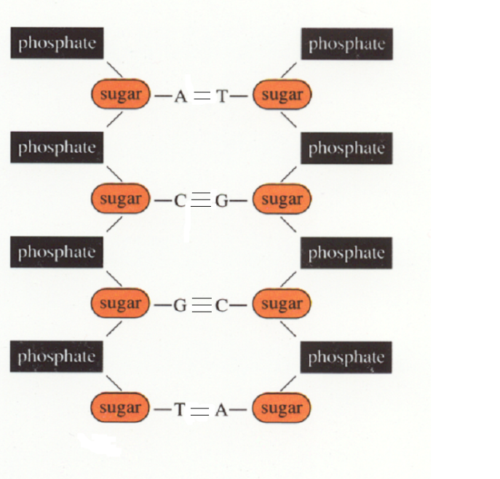

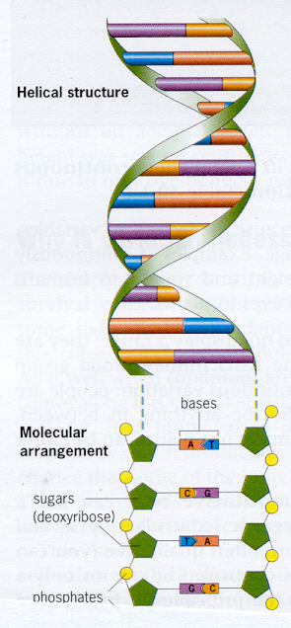

Note: The structure of DNA can be compared to a spiral staircase.

* The sides (handrails) are formed by alternating sugar phosphate units.
* The base pairs form the steps.



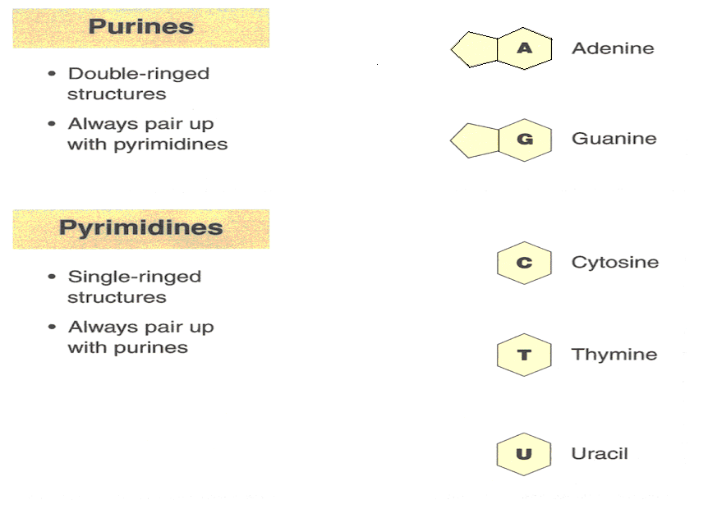**Purines and Pyramidines**

**Genetic code:** 3 bases code for one amino acid

**Coding structures**: Genes which code for proteins

**Non coding structures:** Also known as “ junk DNA”. Do not code for proteins.

**mRNA**

mRNA exists as a complementary strand to DNA except that the base thymine is replaced by uracil.

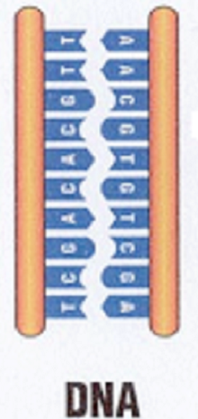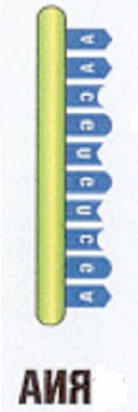

**Comparing DNA and RNA**

**DNA RNA**

Thymine v Uracil

Double strand v Single strand

Deoxyribose v Ribose

**RNA**

Function of mRNA: Protein synthesis

**DNA replication (makes a copy of DNA)**



Replication of DNA involves:

* the opening of the helix
* the synthesis of complementary nucleic acid chains alongside the existing chains
* two identical new copies of the DNA double helix are produced.

**Genetic screening:** Genetic Screening is a screening test diagnosis for changed genes.

**DNA profiling**

**Definition:** A process or technique of analysisrevealing unique patterns of an individual’s DNA involving non-coding regions

**Stages involved:**

* 1. Cells broken down to release DNA
  2. DNA strands are cut into fragments using enzymes
  3. Fragments are separated on the basis of size
  4. The pattern of fragment distribution is analysed

**Applications** e.g. forensic and medical.

* Forensic Science
* Confirming animal pedigrees
* Monitoring bone marrow transplants
* Detecting inherited diseases

**Protein Synthesis**

* The code is **translated** and the amino acids are assembled in the correct sequence to synthesise the protein
* The protein folds into its functional shape

S**teps involved:**

* DNA contains the code for proteins
* This code is **transcribed** to mRNA
* The transcribed code goes to a ribosome

**H.2.5.15 Protein Synthesis (Extended Study)**

**Location of protein synthesis**: Ribosome

**Process of protein synthesis** : involves 2 stages: **1. Transcription and 2. Translation**

1. **Translation (takes place in the ribosome**

**Steps involved**

* Free floating **tRNAs** with their attached amino acids, within the cytoplasm, are attracted by their binding sites (**anticodons**) to complementary mRNA (codons) already attached to the ribosome.
* This ensures the amino acids are aligned in a sequence determined by the codons of the mRNA.
* Aligned amino acids bond to form links of the new protein molecule.
* tRNAs continue to move to the ribosome, until a stop codon on the mRNA is reached.
* The protein is released when the mRNA code sequence is complete and the protein folds into its functional shape.

1. **Transcription (takes place in the Nucleus)**

**Steps involved**

* Enzymes unwind the DNA double helix.
* RNA nucleotide bases bond with one strand of exposed DNA
* The enzyme **RNA polymerase** assembles these bases to form mRNA.
* mRNA, therefore, has a series of bases that are complementary to those in DNA.

.

**Next ……..**

mRNA moves into the cytoplasm.

* Each 3 base sequence of mRNA carries a genetic code or **codon** that specifies a starting codon, a particular amino acid or a stop codon
* Ribosomal sub-units (rRNA) attach to the mRNA . These sub units form the ribosome

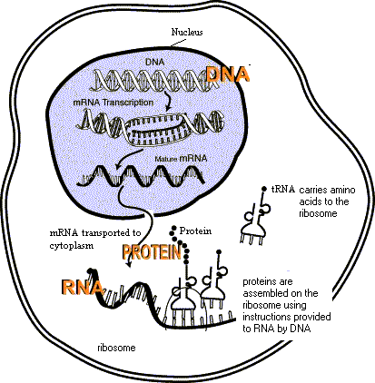

Summary diagram protein synthesis

**2.5.6 Genetic Inheritance**

**Gamete:** A haploid sex cell

**Role of gametes**

* In sexual reproduction cells that transmit genes from one generation to another are called sex cells or gametes.
* During meiosis the diploid number of chromosomes (2n) is reduced to one set and gametes are formed. This single set is called the haploid number (n)

**Definitions:** Fertilisation, Allele, Homozygous, heterozygous, Genotype, Phenotype, Dominance, Recessive, Incomplete dominance. **Please refer to definition sheet**

**Monohybrid crosses**

Single unlinked trait in a cross involving:

1. ***Homozygous parents***

t

t

T

T

Parents

t

T

X

Gametes

T

t

F1 generation Genotype

F1 generation Phenotype All Tall

**Single unlinked trait in a cross involving:**

1. ***Heterozygous parents***

T

t

T

t

Parents

T

T

T

t

X

t

t

T

t

T

T

t

Gametes

F1 Genotype

t

**Punnet Square**

|  |  |  |
| --- | --- | --- |
| ***Gametes*** | ***T*** | ***t*** |
| ***T*** | *TT* | *Tt* |
| ***t*** | *Tt* | *tt* |

|  |  |  |  |  |
| --- | --- | --- | --- | --- |
| ***Genotype*** | ***TT*** | ***Tt*** | ***Tt*** | ***tt*** |
| ***Phenotype*** | ***Tall*** | ***Tall*** | ***Tall*** | ***Small*** |

***Ratio 3:1***

* ***Sex determination***
* The control of maleness and femaleness by genes located on sex chromosomes designated X and Y.
* A human male body cell has one X and one Y chromosome.
* A human female body cell XX

**Punnett Square**

Parents

Gametes

**F1 Genotype**

Female

Male

Female

Male

**F1 Phenotype**

|  |  |
| --- | --- |
| **Genotype** | **Phenotype** |
| XX | Female |
| XY | Male |

|  |  |  |
| --- | --- | --- |
| ***Gametes*** | ***X*** | ***X*** |
| ***X*** | ***XX*** | ***XX*** |
| ***Y*** | ***XY*** | ***XY*** |

Prediction: 50% chance Male or Female

**H 2.5.10 Mendels work and laws**

Mendel worked with pea plants.

**Monohybrid crosses**

* He crossed the parents to get F1 generation.
* To get the F2 generation the F1 generation was self crossed:

|  |  |
| --- | --- |
| Tall stem x | Dwarf stem |
| Coloured testa x | White testa |
| Axial flowers x | Terminal flowers |
| Inflated pods x | Constricted pods |
| Green pods x | Yellow pods |
| Round seeds x | Wrinkled seeds |
| Yellow cotyledons x | Green cotyledons |

Mendel concluded that:

* Characteristics controlled by pairs of factors called **genes** and contrasting characteristics are controlled by separate genes.
* Mendel gave the gene which controlled the **dominant** trait a capital letter e.g. T for tall and the **recessive** trait the small letter of the dominant e.g. t for dwarf.
* T and t are contrasting genes for the same characteristics called **alleles**.
* When two members of the pair of alleles are identical the organism is known as **homozygous** for that character e.g. TT or tt.
* When the alleles are different the organism is said to be **heterozygous** for the characteristic.
* When **gametes** are formed the pairs of genes separate , each member of the pair going into a different gamete.
* At fertilisation the gametes fuse, which restores the pair of genes.

From these conclusions Mendel derived his 1st law known as the **Law of Segregation**

**Dihybrid crosses**

A Dihybrid cross involves the inheritance of two pairs of contrasting characteristics e.g.

**tall plants with yellow cotyledons crossed with dwarf pea plants having green cotyledons**.

In this cross all plants are pure breeding. Mendel crossed tall plants with yellow cotyledons crossed with dwarf pea plants having green cotyledons

**P:** TTYY x ttyy

**G:** TY ty

**F1 Genotype:** TtYy

**F1 Phenotype:** Tall Yellow

He then selfed the F1 generation to get the F2 generation (i.e. crossed with itself):

**P:** TtYy x TtYy

**G:** TY Ty tY ty TY Ty tY ty

**F2 genotypes**

|  |  |  |  |  |
| --- | --- | --- | --- | --- |
| **Gametes** | **TY** | **Ty** | **tY** | **ty** |
| **TY** | TTYY | TTYy | TtYY | TtYy |
| **Ty** | TTYY | TTyy | TtYy | Ttyy |
| **tY** | TtYY | TtYy | ttYY | ttYy |
| **ty** | TtYy | Ttyy | ttYy | ttyy |

From these results he formulated his **2nd Law of Independent Assortment**

**Linkage**

Recall in an Unlinked Cross:

P: Dihybrid heterozygote x dihybrid recessive organism

**P:** TtYy x ttyy

**G:** TY Ty tY ty ty

**F1 Genotype:**

|  |  |  |  |  |
| --- | --- | --- | --- | --- |
| **Gametes** | TY | Ty | tY | ty |
| ty | TtYy | Ttyy | ttYy | ttyy |

* + **1:1:1:1 ratio due to independent assortment**
  + Recombinants formed i.e. variation occurs due to independent assortment

***But***

**In a linked cross:**

**P:** TtYy x ttyy

**G:** TY ty ty

**F1 Genotype**: TtYy ttyy

**F1 Phenotype:** Tall Yellow Small Green

* Independent assortment of alleles at gamete formation does not occur
* **Linked genes stay together and 1:1:1:1 ratio changes.**
* No recombinants formed; only original parental types. There is no variation

**ISOLATE DNA FROM PLANT TISSUE**

**CHEMICALS/MATERIALS**

Onion

Washing up liquid

Table salt

Protease enzyme

Ice cold ethanol

**PROCEDURE**

1. Chop the onions into small pieces.
2. Add the chopped onion to the beaker with the salt and washing up liquid solution and stir.
3. Put the beaker in the water bath at 600C for exactly 15 minutes.
4. Cool the mixture by standing the beaker in the ice-water bath for 5 minutes.
5. Pour the mixture into the blender and blend it for no more than 3 seconds.
6. Carefully filter the mixture into the second beaker.
7. Transfer some of this filtrate into the boiling tube.
8. Add 2-3 drops of protease.
9. Trickle the ice cold alcohol down the side of the boiling tube
10. Observe any changes that take place at the interface of the alcohol and the filtrate.
11. Using the glass rod, gently draw the DNA out from the alcohol.
12. Record the result.

**Reasons for steps:**

* ***Chopping the onions***

The physical chopping breaks the cell walls and allows the cytoplasm to leak out.

* ***Adding the washing up liquid***

Breaks down the lipids in the phospholipids bilayer and causes the protein in the membrabes to break apart. This results in the release of the nuclear material from the cell.

* ***Adding the salt***

Once the cell is destrpyed the ion levels within the cell change. The proteins in the membranes, which have been exposed by the detergent, are now positively charged. These naturally attract the negatively charged phosphate groups in DNA. The salt minimises the attractive forces between the DNA and protein by shielding the DNA molecules, causing them to clump together.

* ***Heating the mixture to 60oC for exactly 15 minutes***

Causes DNAases released from the lysosomes, to be broken down. After 15 minutes DNA itself will be broken down.

* ***Cooling the mixture***

Decreases the rate ofchemical reactions, slowing down the action of any remaining enzymes before they destroy the DNA.

* ***Blending***

Further destroys cell walls and membranes. Causes DNA to be released. Blending for more than 3 seconds shears the fragile DNA strands.

* ***Adding protease***

Breaks down the proteins associated with DNA.

* ***Filtering***

Strains all the large cellular debris out of the mixture. DNA passes through the filter with the liquid.

* ***Using ice cold ethanol***

Ethanol forms a layer on top of the onion filtrate. The alcohol tends to draw the water out of the DNA molecule, making it less dense. It is now found at the interface of the two liquids. DNA is insoluble in freezing cold ethanol but soluble in alcohol at room temperature.

**Sex Linkage**

* The sex chromosomes also carry genes which determine other traits in addition to the genes which determine sex.
* Such genes are said to be **Sex-linked**.
* Genes which are carried on that part of the x chromosome for which there is no corresponding portion on the Y chromosome are said to be **completely sex linked (X linked)**
* Genes carried on the portion of the X chromosome for which there is a corresponding section on the Y chromosome are said to be **partially sex linked.** e.g.total colour blindness
* Examples of x linked conditions in humans: haemophilia, red green colour blindness, spinal ataxia

**Sex Linked Condition: Haemophilia**

* Inability of blood to clot properly
* Results in heavy bleeding after injury, bleeding at the joints
* Caused by recessive gene on the X chromosome
* Females with both X chromosomes carrying the recessive gene do not survive beyond the first four months of life in the womb.
* Females with one X chromosome carrying the recessive gene do not suffer from the disease but act as **carriers**.
* If a male X chromosome carries the recessive gene then the male will suffer the symptoms of the disease

**Because**

* Males have only one X chromosome and since there is no corresponding allele on the Y chromosome.

**Cross demonstrating inheritance of Haemophilia;**

**P**: **Normal Male** X **Carier Female**

XYN- X XX Nn

**G:** XN Y- XN Xn

**F1 Genotypes: XXNN XXNn XYN- XYn-**

**F1 Phenotypes:**

Normalfemale

Haemophiliac

male

Normal male

Carrier female

* Each son has a 50:50 chance of inheriting the recessive gene and suffering from the disease.
* Each daughter has an equal chance of being a carrier (unaffected by the disease but capable of transmitting it to her sons.
* There is no male to male transmission of an X linked trait

**Because**

* Father cannot pass the disease to his son because the male always passes his X chromosome to his daughters.

**Pedigree Studies**

* A pedigree is a diagram showing the occurrence and appearance of a particular genetic trait from one generation to the next in a family.

Q.The ability to roll ones tongue is controlled by a dominant gene R, the recessive being a non roller r.

The diagram shows part of a family tree. Answer the following:

What combination of tongue rolling genes is possessed by A,B,C.?

D marries a man homozygous for tongue rolling. Work out the possible genotypes and phenotypes of their children.

* **Males:**
* **Females:**
* **Homozygous recessive:**
* **At least one dominant trait:**
* Individuals usually numbered or given a letter.
* Each generation represented by a Roman numeral.

Male non-roller

**1**

Male roller

Female roller

**11**

Female non- roller

**111**

Tongue –Rolling Pedigree

**Q.**Freckles on the skin is an inherited characteristic in humans. It is controlled by a dominant gene. If a man whose parents are both non-freckled, marries a freckled girl whose mother and grandparents are freckled and whose father and sister are non freckled, what are the chances that the first child will be freckled.?

In, fact their first child, a girl, turns out to be freckled. She eventually marries another freckled individual and they have two sons, neither of whom have freckles, and three daughters, two of whom have freckles, whilst the third is non freckled. Express the transmission of freckles through all five generations, in the form of a pedigree chart.

**Non Nuclear DNA: (mitochondrial DNA** (mtDNA) and chloroplast DNA**(cpDNA)** )

**(mtDNA)**

* Mitochondria are found in the cytoplasm of every cell.
* Number of mitochondria per cell varies.
* Mitochondria contain their own DNA (a small amount- 39 genes).
* Known as mtDNA
* Code for some of the enzymes and other materials e.g. RNA required for respiration.
* Mutations in mtDNA may lead to mitochondrial disorders.
* (mtDNA) is inherited from the female only.
* This is because during fertilisation only the male nucleus is transferred to the female cell**.**
* Mitochondrial disease dies out if a woman has no children or all male children.
* When a cell replicates it makes copies of the mitochondria including the DNA contained inside them.
* This results in some parts of the offspring cells getting all of their genetic information from the maternal parent only.
* This is described as **non nuclear inheritance.**
* Mitochondrial and chloroplast DNA are self replicating and their DNA has an independent existence from nDNA.

**Disease and mtDNA**

* Tissues with high demand for energy e.g. muscles,heart,brain vulnerable.
* Mother will pass on her mtDNA mutations to 100% of her children.
* Mother passes mutated and normal mtDNA randomly and so each zygote will receive a different amount of mutated mtDNA.
* Severity of disease will be different for each child.

**Chloroplast DNA (cpDNA)**

* Chloroplasts in plant tissue also have own DNA.
* Also circular but contains more genes than mtDNA.
* Codes for some of the proteins required to make the pigments in a plant cell.
* Mutations can lead to leaf colour variation.