At the end of this section you should be able to …. | Y |  | N
Define Genetic engineering
Describe the process of genetic engineering to include some or all of the following:
Isolation, cutting (restriction ), transformation (ligation), introduction of base sequence changes, expression
Contemporary issues
Give 3 applications of genetic engineering: one plant, one animal, one microorganism

Genetic engineering – Summary

Genetic Engineering is a process of manipulating and altering the genetic material.

Genetic engineering also known as recombinant DNA technology involves removing a specific piece of DNA (gene) from one organism and joining this DNA to the DNA in another organism.
Example:
A gene for the production of insulin can be removed from a human cell and inserted into a bacterial cell. The bacterial cell containing the human gene can now produce human insulin.

Genetic Engineering involves some or all of the following steps:
- Isolation,
- Cutting (restriction ),
- Transformation (ligation)
- Introduction of base sequence changes,
- Expression

Production of human insulin

- Isolation of a specific gene:
- The specific length of DNA (gene) is first identified and located in the human cell e.g. gene for insulin production.

A plasmid is removed from a bacterial cell.

- Cutting (Restriction)
- Enzymes are used to cut the human DNA containing the desired gene.
- Enzymes are also used to cut open the plasmid

- Transformation
- The human gene is taken up by the plasmid.

- Ligation
- Enzymes join the lengths of human DNA and plasmid DNA together.

- Introduction of base sequence changes
The
The
tT
- The plasmid containing the human DNA is placed back into a bacterial cell
- The order of bases in the bacterial plasmid is now changed and contains recombinant DNA. The bacterial cell has been genetically modified and is known as a Genetically Modified Organism (GMO)

- Expression
Each time the bacterial cell divides the inserted human gene is activated to produce its protein product

Applications:
- Microorganism:
  - Humulin, human insulin produced by genetically modified bacteria, was the first recombinant DNA drug approved for use in humans.
- Plant
  - Genetically modified corn.
The corn plants carry a bacterial gene that enables them to resist infestation by an insect.

- Animal:
  - Genetically modified sheep produce human clotting factor in their milk.
DNA removed from human cell (first organism)
Plasmid removed from bacterial cell (second organism)
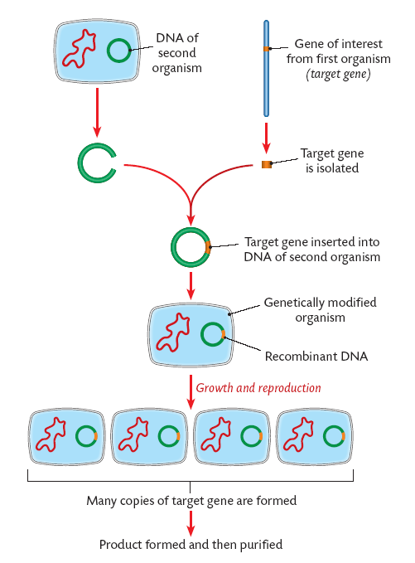

Plasmid
Removed from bacterial cell

