Excretion in the Human
Urinary System

Q 2016 12 a and b
(a) Distinguish between the terms excretion and egestion by writing a sentence about each term.
(ii) Suggest how excretion may occur in simple organisms such as Amoeba.
(b)(i) Name two excretory products, other than water, of mammals
(ii) For each product referred to in (i), give a location in the body in which it is produced.
(iii) Describe the role of ADH (vasopressin) in human excretion.
(iv) Suggest two structures in flowering plants which play a role in excretion.
MS 2016 12 a and b
12. | (a) | (i) | Excretion: |  | Removal of metabolic waste | 3
 |  |  | Egestion: |  | Removal of undigested (or unabsorbed) material | 3
 |  | (ii) | Simple excretion: Diffusion or contractile vacuole |  |  | 3
 | (b) | (i) | Excretory products: Carbon dioxide/ urea/ salt(s) |  |  | 2(3)
 |  | (ii) | Excretory product production locations: First product + matching location |  |  | 3
 |  |  |  |  | Second product + matching location | 3
 |  | (iii) | ADH: (Produced in response to) high salt levels or low water levels or dehydration/
 |  |  | (acts on) collecting ducts or (acts on) distal convoluted tubules/ more permeable/
 |  |  | more water reabsorbed (into blood)/ urine volume lowered (or urine more conc.) |  |  | 3(3)
 |  | (iv) | Plant structures: Stomata/ lenticels/ leaves |  |  | 2(3)

Q 2011 12
12. (a) | (i)  (ii) | What is meant by the term excretion?  Mention one method of excretion in flowering plants. | (9)

(b)
(i)  (ii) | Draw a large labelled diagram of a vertical section through a human kidney. Label the following parts of your diagram: cortex, medulla, pelvis.  Indicate clearly on your diagram where re-absorption takes place.
(iii)  (iv) | - Name the blood vessel that supplies blood to a kidney.  - From which blood vessel does the blood vessel referred to in (iii)1 arise? In which cavity of the body are the kidneys located?
(v)  (vi) | Name one substance, other than water, excreted in the urine.  Give a feature of the kidney which indicates that it is an exocrine gland.
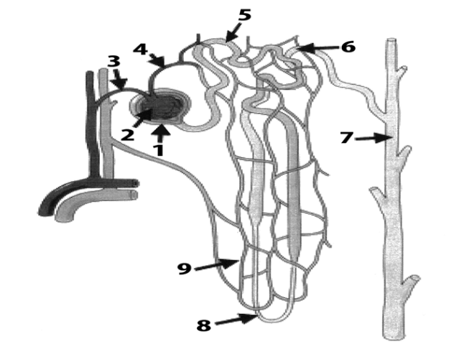

- The diagram above shows the structure of a nephron and its associated blood supply.
  - Name the parts numbered 1 to 6.
  - Indicate clearly by number where filtration takes place.
  - Name the hormone associated with changing the permeability of the structure at 7.
- A sample of urine was found to contain protein.
  - Would you consider this to be normal?
  - Explain your answer.
- A sample of urine was found to contain glucose.
  - Would you consider this to be normal?
  - Explain your answer. (24)

MS 2011 12 b
 | (b) | (i) | Diagram: | 3, 0
 |  |  | Labels: cortex, medulla, pelvis | 3(2)
 |  | (ii) | Position of reabsorption indicated | 3
 |  | (iii) | 1. *Renal artery | 3
 |  |  | 2. *Aorta | 3
 |  | (iv) | *Abdominal (cavity) or *Abdomen | 3
 |  | (v) | Urea or salt or uric acid | 3
 |  | (vi) | Has ducts or does not produce hormones | 3
 | (c) | (i) | 1. 1 = Bowman’s capsule; 2 = glomerulus;  3 = afferent arteriole; 4 = efferent arteriole;  5 = proximal (convoluted) tubule; 6 = distal (convoluted) tubule  2. *1 or *2 or *1 and 2*  3. Anti-diuretic hormone or ADH or vasopressin
 |  |  | Has ducts or does not produce hormones | 6(1)
 |  |  |  | 3
 |  |  | 1. 1 = Bowman’s capsule; 2 = glomerulus;  3 = afferent arteriole; 4 = efferent arteriole;  5 = proximal (convoluted) tubule; 6 = distal (convoluted) tubule  2. *1 or *2 or *1 and 2*  3. Anti-diuretic hormone or ADH or vasopressin  - *No  - Protein molecules too big (to pass into the filtrate)  Note: ‘Yes’ correctly qualified (e.g. low level or pregnancy) for 6m  1. *No | 3
 |  | (ii) |  | 3
 |  |  |  | 3
 |  | (iii) |  | 3
 |  |  | 2. Glucose (in the filtrate should have been) reabsorbed | 3

Q 2008 13
13. (a) | (i) | What is meant by excretion?
 | (ii) | Urea and carbon dioxide are excretory products of the human body. In the case of each
 |  | product name a substance from which it is derived. (9)

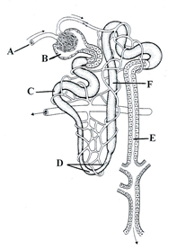
The diagram shows the structure of a nephron and its associated blood supply
(i) Name the parts A, B, C, D, E and F.
(ii) From which blood vessel is A derived?
(iii) Where in the kidney is B located?
(iv) Give the part of the nephron in which each of the following takes place:
1. filtration, 2. reabsorption of amino acids.
(v) Give two features of the nephron that aid filtration.
(vi) Name a group of biomolecules in the blood which are too large to pass through the filtration system of the nephron.

MS 2008 13
13. | (a) | (i) | elimination of waste products of metabolism or explained | 3
 |  | (ii) | Urea: protein or amino acid  carbon dioxide: carbohydrate or named example or fat or named example of fat or fatty acids | 3
 |  |  |  | 3
 | (b) | (i) | A = arteriole B = Bowman’s capsule C = proximal tubule  D = Loop of Henle E = collecting duct F = distal tubule or Loop of Henle | 6(1)
 |  | (ii) | renal artery or renal arteriole | 3
 |  | (iii) | *cortex | 3
 |  | (iv) | 1. Bowman’s capsule or glomerulus or B | 3
 |  |  | 2. proximal tubule or C | 3
 |  | (v) | large surface area / porous capillary walls/ (lining) one cell thick / efferent arteriole narrower than afferent arteriole or arterioles in arteriole out or arteriole to capillary network  NB not more than one arteriole point. | 2(3)
 |  | (vi) | proteins or named group of proteins | 3
 | (c) | (i) | infection / hot conditions or perspiration or exercise / high salt intake / low water intake / diuretic(s) | 2(3)
 |  | (ii) | *ADH (vasopressin) | 3
 |  |  | *pituitary | 3
 |  | (iii) | distal tubule or collecting duct | 3
 |  |  | in the blood | 3
 |  | (iv) | (makes walls) more permeable (resulting in) more absorption of water | 6

Q 2004 12 a and b
12. (a) What is homeostasis? State the role of the kidneys in homeostasis. (9)
(b) (i) Draw a labelled diagram of a nephron. Include blood vessels in your diagram.
(ii) Filtration and reabsorption are vital processes that take place in the nephron. Describe how each of these processes occurs.

Q 12 (a) Maintaining (a constant) internal environment or described 3
Role of kidneys: Maintaining salt balance or explained / 3
Maintaining water balance or explained / 3
[Note: Osmoregulation = 2 points]

(b) (i) Diagram of nephron3,0
Diagram of blood supply 3,0

labels 3(1)

(ii) Filtration:
Blood in arteriole / under pressure/ plasma (accept blood) or small molecules or named from (or in) glomerulus /in or into (Bowman’s) capsule /large molecules or named or cells or named cells cannot pass
any three 3(3)

Reabsorption:
Substance (or named) from (or in) tubule (or named part or from filtrate) /
/ into blood / active transport / diffusion / osmosis / mention of hormonal control
any three 3(3)

