At the end of this section you should be able to … | Y | N
Define a hormone
Compare hormone and nerve action
Distinguish between exocrine and endocrine glands
Give examples of each type of gland
Locate the principle endocrine glands in the human
Name one hormone from each gland
Give a function of each hormone
Describe deficiency symptoms, excess symptoms and corrective measures for any one hormone
Contemporary issue:
Give two examples of the use of hormone supplements
H. 3.5.6.
Describe the feedback mechanism of any one hormonal system

Key Words
Hormone, endocrine, exocrine,
Endocrine System (Summary)
Definition of a hormone.
- Hormones are chemical messengers produced by the endocrine glands
- Travel in the blood stream
- Bring about a reaction in another part of the body.
- Many hormones are proteins e.g. insulin
- They regulate activities of the various systems of the body.

Distinguish between exocrine and endocrine glands (with examples).

Exocrine Gland | Endocrine Gland
Ducted gland | Ductless gland
Produce chemicals e.g. salivary gland | Produce hormones e.g. Pituitary gland

Comparison with nerve action:
The general slow and sustained nature of hormone action as compared with
nerve action.

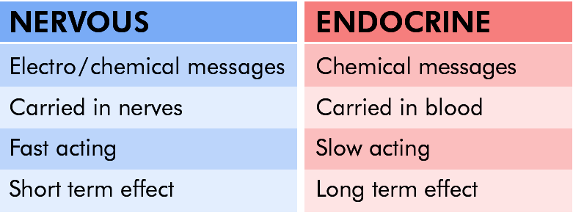

Location of the principle endocrine glands in the human.

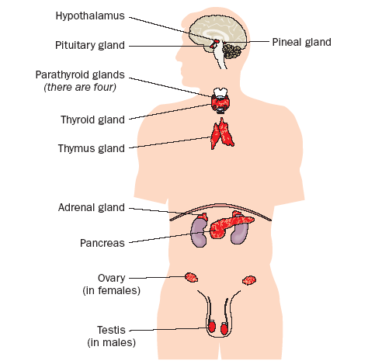

For each of the glands name one hormone and give its function

Gland | Hormone | Function
Hypothalmus | A.D.H. (Antidiuretic hormone) | Reabsorption of water from the distal convoluted tubule in the kidney leading to the production of a lower volume of urine
Thyroid | Thyroxine | Controls the metabolic rate
Pineal | Melatonin | Controls sleep patterns
Thymus | Thymosin | Causes lymphocytes (white blood cels) to mature
Parathyroid | Parathormone | Controls calcium levels in the blood
Adrenals | Adrenaline | Prepares the body for emergency response (flight, fright)
Pancreas | Insulin | Regulates blood sugar levels
Ovaries | Oestrogen/Progesterone | Controls sexual development
Testes | Testosterone | Controls sexual development
Pituitary  (Master gland) | HGH (Human Growth Hormone)

For one hormone give a description of its deficiency symptoms, excess symptoms, and corrective measures.

Gland | Hormone | Function | Deficiency symptoms | Corrective measure | Excess symptoms | Corrective measures
Pancreas  (Islets of Langheran) | Insulin | Lowers glucose levels in the blood  by converting glucose to glycogen  for storage in the liver. | Diabetes  High blood sugar levels(hyperglycaemia).  Glucose not converted to glycogen.  Excretion of large amounts of sugary urine (glycosuria).  Lack of energy.  Craving for sweet food.  Persistent thirst.  Weight loss.  Muscle wasting. | Insulin injections.  Insulin cannot be taken orally because, being a protein, it would digest in the alimentary canal. | Low blood sugar levels (hypoglycaemia).  Unconsciousness.  Coma | Take sugar.

Point of information
Insulin used to be only available from non-human sources e.g. pigs
Recombinant DNA technology has made human insulin available to diabetics (see notes 2.5.9 Genetic engineering).
Prolonged use of Insulin from non-human sources may lead to immunological reactions. The immune system identifies the non-human insulin as foreign and attacks it with antibodies.

Contemporary Issue:
Hormone supplements: two examples of their use.
- Use of insulin as a hormone supplement when sugar levels are high (see table above).
- Fertility and contraception:

Fertility:
FSH and LH are used in fertility pills
They stimulate the production and release of eggs during the menstrual cycle.
Contraception:
In oral contraceptives ( the pill) carefully balanced quantities of oestrogen and progesterone are taken for 21 days of the menstrual cycle in order to prevent ovulation and, hence, pregnancy.
Oxytocin administered to speed up labor.
Hormone Replacement Therapy (HRT) used to reduce the symptoms of menopause and to maintain bone strength.

H.3.5.6 Feedback mechanism

Feedback mechanism: When the level of a hormone (in the blood) controls (the production) of itself or another hormone.e.g. the hormone oestrogen controls its own production

- When levels of oestrogen are low
- Pituitary produces FSH. Follicle stimulating hormone stimulates eggs to develop in the ovary.
- High levels of FSH stimulates the eggs to produce oestrogen
- Level of oestrogen rises
- High oestrogen levels inhibit the Pituitary
- No more FSH produced
- Oestrogen levels fall
stimulates
Feedback Mechanism
High levels FSH
Stimulates ovary to produce oestrogen
Pituitary gland
Oestrogen levels rise
Oestrogen levels fall
inhibits
No FSH
produced

Feedback mechanisms helps to maintain a constant internal environment (homeostasis).
Maintaining blood glucose levels is also controlled by a feedback mechanism
- Insulin controls blood glucose concentrations and is secreted when blood glucose levels rise above a normal level.
- Insulin results in an increase in the uptake of glucose into the cells, an increase in cellular respiration, and an increase in the rate of conversion of glucose to glycogen in the liver.
- This causes a fall in the blood glucose level and so insulin secretion is stopped.
- If glucose level falls below the norm another hormone called Glucagon is secreted
e.g. after a heavy meal
High blood glucose level
Normal blood glucose levels
Detected by the Islets of Langerhans
in the Pancreas
Insulin withdrawn
Lowers blood glucose level
Insulin secreted
Feedback Mechanism

