**Q 201613 b**

(i) Draw a large diagram to show the structure of the human ear, labelling each of the following parts:

### pinna semi-circular canals stirrup ear drum cochlea Eustachian tube

(ii) 1. Briefly outline the function of the pinna.

1. To which part of the body does the Eustachian tube link the ear?
2. What is the role of the Eustachian tube?
3. Name another part of the ear that has a function similar to that of the stirrup.
4. The semi-circular canals play a role in balance.

Suggest why there are three semi-circular canals in each ear.

**MS 2016 13 b**

|  |  |  |  |  |  |  |  |  |  |
| --- | --- | --- | --- | --- | --- | --- | --- | --- | --- |
| (b) | (i) | *Diagram:* with correctly located labelled parts | | | | |  |  | **6(2)** |
|  |  | **pinna** | | **semi-circular canals** | **stirrup** | **eardrum** | **cochlea** | **Eustachian tube** |  |
|  | (ii) | 1. | *Function of pinna:* Collects sound | | | |  |  | **3** |
|  |  | 2. | *Eustachian tube connected to:* Throat **or** pharyn | | | | x |  | **3** |
|  |  | 3. | *Role of Eustachian tube:* To equalise pressure **or** to relieve (or prevent) pressure | | | | | | **3** |
|  |  | 4. | *Other ossicle:* Hammer **or** anvil | | |  |  |  | **3** |
|  |  | 5. | *Why three semi-circular canals:* To control (balance) in three planes  (or dimensions or axes) | | | | | | **3** |

**Q 2011 15 a**

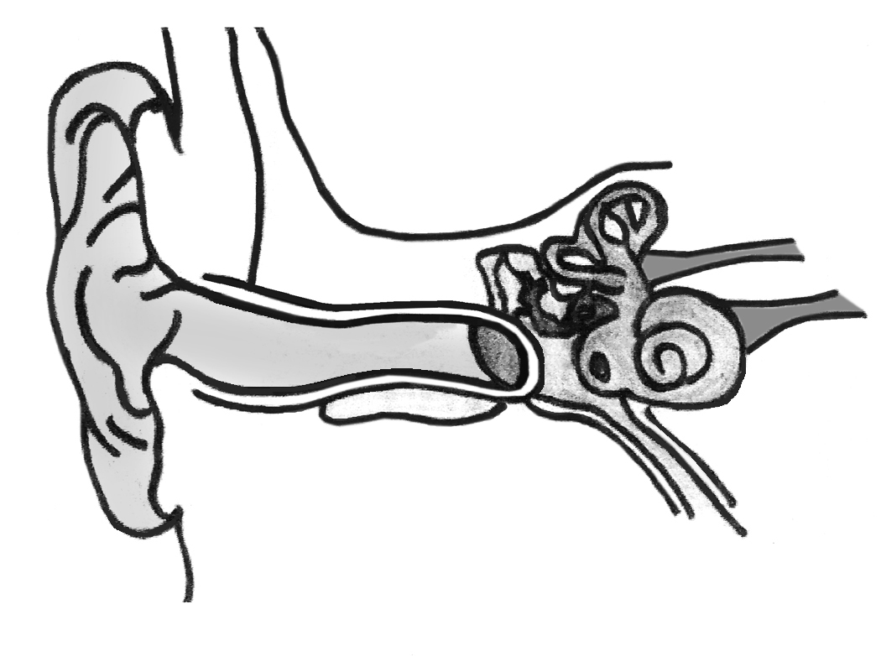

D

A

B

F

E

* 1. (i) The diagram above shows the internal structure of the human ear.

1. Name the structures labelled A, B, C.
2. Give the functions of parts D and E.
3. Which letters denote the parts of the ear in which nerve impulses are generated?
   1. In what part of *the eye* are nerve impulses generated?
   2. Suggest **one** way by which the ear may be protected.
   3. Explain how a corrective measure for a **named** defect of hearing **or** vision work

**MS 2011 15 a**

