DNA

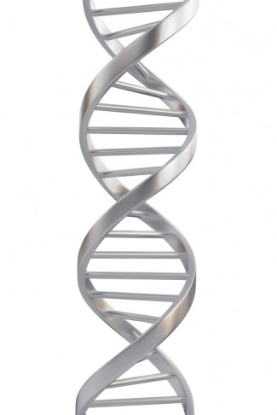DNA is a long molecule consisting of **Deoxyribose**, **Phosphate**, and a **nitrogenous base**. One of each of these components bonded together correctly forms a **nucleotide**. The whole DNA molecule has **two** **strands**, and twists together to form a __________ _____________.

There are __ different nitrogenous bases, __________, ___________, ___________, _________________.

These are shortened to their respective letters, ___, ____, ___, ___.

The bases form hydrogen bonds between the two strands, which holds the whole structure together. There are very strict rules governing which base bonds with which base:

**Adenine** will always bond with _____________

**Guanine** will always bind with ______________

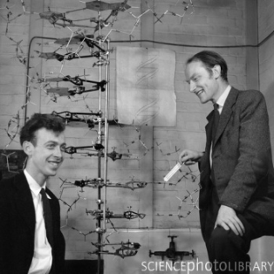

**James Watson (left) and Francis Crick**, with their model showing the structure of DNA

With your knowledge of base pairing, correctly work out the complementary strand for the given DNA molecules:

