Asexual Reproduction

Q 2009 15 a
- What is meant by vegetative propagation?
- Horticulturists use a number of methods to artificially propagate plants. Suggest one advantage of artificial propagation.
- Describe two methods used by horticulturists to artificially propagate plants.
- Give two differences between vegetative propagation and propagation involving seeds.

MS 2009 15 a

(a) | (i) | Production of new plant from root or from stem or from leaf or  plant asexual reproduction (or described) | 3
 | (ii) | Fast or preserves desirable features or cheap or more reliable | 3
 | (iii) | Cuttings (or described) / layering (or described) / grafting (or described) / micro propagation (or described) | 2(3)
 | (iv) | No gametes (or one parent) / identical plants or example / rapid production / no outside agent | 2(3)

Q 2013 4
- The diagram shows a strawberry plant from which a runner has given rise to a daughter plant.

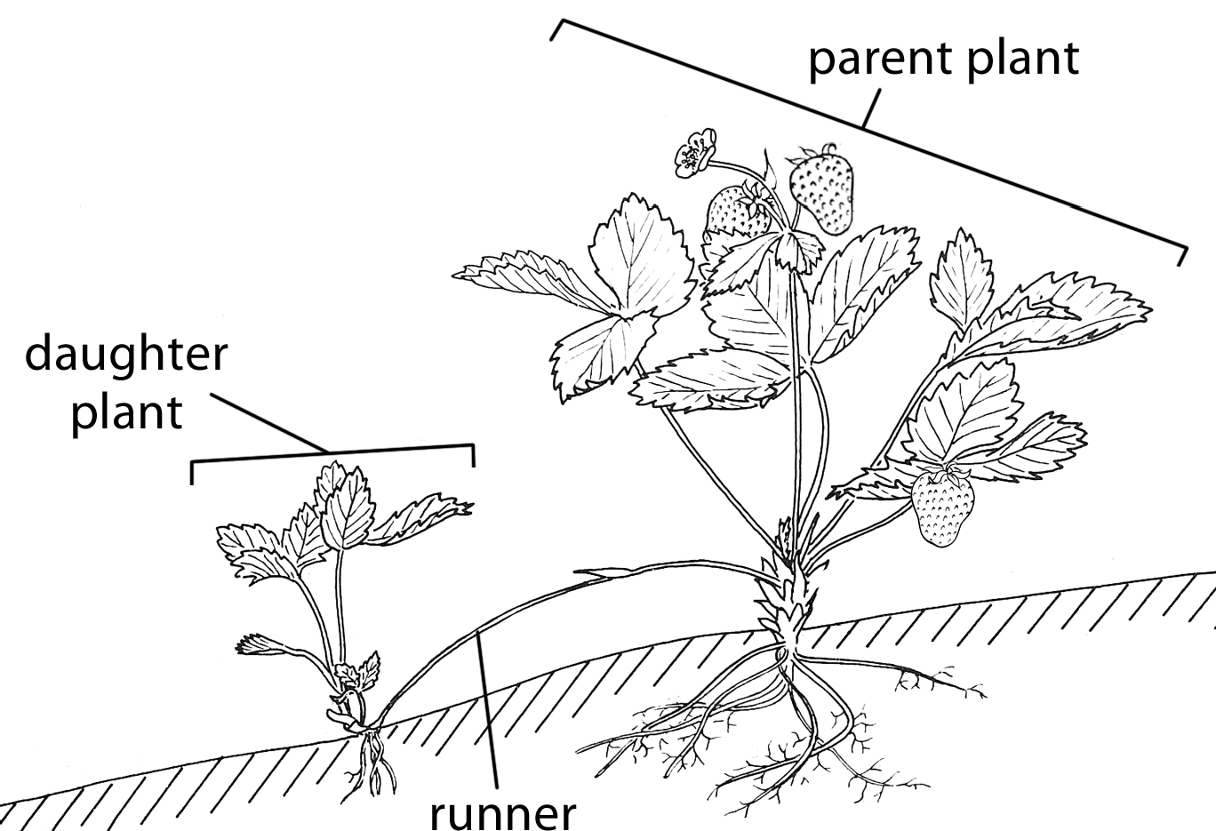

  - The runner is a modified stem. How could you tell this from

    - external observation?

    - viewing a thin section of it under the microscope?

  - What term is used for the type of asexual reproduction that produced the daughter plant?

  - Would you expect the daughter plant to be haploid or diploid?

Explain your answer.

  - What evidence is there in the diagram that sexual reproduction has also taken place?

  - Give one method, other than runners, and not involving seeds, that is used by horticulturists to produce new plants.

MS 2013 4
- 1. Bud(s) or node(s) or leaf

2. Vascular bundles [plural only]

- Vegetative propagation

- Diploid

Product of mitosis or genetically identical (to parent) or clone

- Fruit or (straw)berries or seeds

- Cuttings or layering or grafting or micro-propagation or tissue culture

