Q 2010 3
The diagram shows the structure of Amoeba.
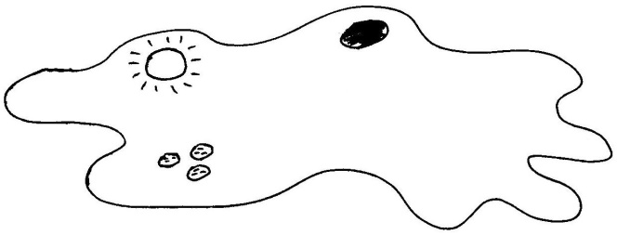
B
A

  - Name the parts labelled A, B and C.

A ………………………………. B ……………………………….. C ……………………………......

  - To which kingdom does Amoeba belong?
  - Is the cell of Amoeba prokaryotic or eukaryotic?
  - Give a reason for your answer to part (c)
  - Give one function of A in Amoeba
(f) 1. Give one function of B in Amoeba
2. Suggest one reason why B is more active in freshwater amoebae than in marine amoebae.

MS 2010 3

3. | (a) | A = pseudopods (false feet); B = contractile vacuole; C = food vacuoles | 3, 2, 1, 0
 | (b) | Protista or Protoctista | 3
 | (c) | Eukaryotic | 3
 | (d) | Membrane-bound organelles or named membrane-bound organelle  [allow nucleus] | 3
 | (e) | Feeding (or explained) or movement | 3
 | (f) | - Osmoregulation or explained [allow excretion or homeostasis]  - Freshwater more hypotonic or more H2O intake or reference to concentration difference | 3  2

