|  |  |  |
| --- | --- | --- |
| **Àt the end of this section you should be able to …** | Y | N |
| Flower structure  Describe the structure and function of the flower parts: |  |  |
|  |  |
| Explain that the pollen grain produces male gametes |  |  |
| Explain that the embryo sac produces an egg cell and polar nuclei (statement only) |  |  |
| Define and describe the methods of pollination; self-pollination and cross-pollination, to include wind and animal pollination. |  |  |
| Define fertilisation |  |  |
| Describe germination of the pollen tube |  |  |
| Describe the role of the generative nucleus in producing gametes |  |  |
| Describe the events leading to fertilisation |  |  |
| Seeds  Classify seeds as monocotyledons and dicotyledons. |  |  |
| Describe and give examples of endospermic and non endospermic seeds |  |  |
| Fruit formation  Give a simple explanation of Fruit formation Note: classification of fruits not required. |  |  |
| Describe the variety of Fruit and Seed dispersal techniques and give examples of wind, animal, and self-dispersal. |  |  |
| Dormancy  Define dormancy  Outline the advantages of dormancy. |  |  |
|  |  |
| Germination  Define germination  Describe the factors necessary for germination  Outline the role of digestion and respiration in germination.  Describe the stages of seedling growth. |  |  |
|  |  |
|  |  |
|  |  |
|  |  |
| Asexual reproduction  Define vegetative propagation.  Give one example each from stem, leaf, and bud. |  |  |
|  |  |
| Compare reproduction by seed with reproduction by vegetative propagation. |  |  |
| Contemporary Issue  Seedless seed production caused by genetic variety of plants and growth regulators.  Mention of dormancy in agricultural and horticultural practices.  Artificial propagation in flowering plants, any four methods used to artificially propagate plants |  |  |
|  |  |
|  |  |
|  |  |
|  |  |
| **Practical Activities**   * Investigate the effect of water, oxygen and temperature on germination. * Use starch agar or skimmed milk plates to show digestive activity during germination. |  |  |
|  |  |
|  |  |
|  |  |

Sepals, petals, stamen, carpel, anther, filament, stigma, style, ovary, ovule, pollen, egg cell, polar nuclei, megaspore, microspore, pollination, endosperm, dispersal, triploid, monocot, dicot, endosperm, cotyledon, testa, embryo, radicle, plumule, hypocotyl, epicotyl, dormancy, germination, growth regulators, seedless fruits

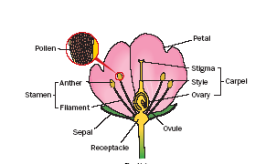

**Flower Structure**

**Function of a flower**: Sexual reproduction

**Parts of a flower**

**Sepals:** protect flower in bud

**Petals**: Attract insects

**Stamens:** Male; Produces pollen. Consists of anther and filament

**Pollen grain** produces male gametes

**Carpel:** Female; Consists of stigma, style, ovary, ovule

**Ovule** contains embryo sac. **Embryo sac** produces an egg cell and polar nuclei

**Receptacle**: Gives rise to and supports flowering parts

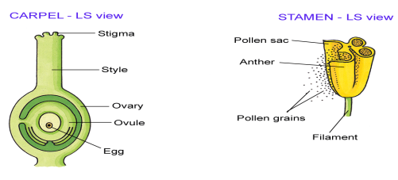

**Pollination**

**Pollination:** The transfer of pollen from an anther to a stigma of a flower from the same species.

**Methods of Pollination:**

* self-pollination: The transfer of pollen from the anther to the stigma on the same flower **or** to a different flower on the **same plant** of the same species.
* cross-pollination: The transfer of pollen from an anther to the stigma to a flower on a **different plant** of the same species. Cross pollination can be brought about by wind and animals.

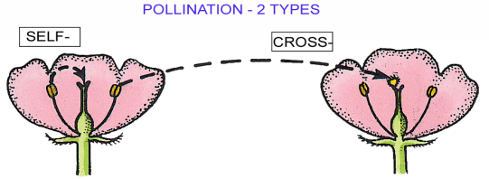

|  |  |
| --- | --- |
| **Wind Pollination** | **Animal pollination** |
| **Petals:** small or absent, not brightly coloured, no scent, no nectarines. | **Petals:** large, brightly coloured, scented, have nectarines. |
| **Pollen**: large amounts, light, small, dry, smooth. | **Pollen**: small amounts, heavy, large, sticky, spiny. |
| **Anthers**: large, outside petals, loosely attached to filament. | **Anthers**: usually small, inide petals, firmly attached to filament. |
| **Stigmas**: large and feathery, outside peals. | **Stigmas**: usually small and sticky, inside petals. |

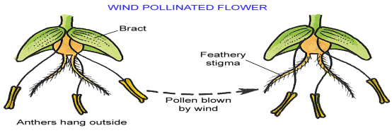

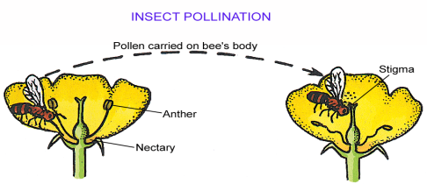F**ertilisation**

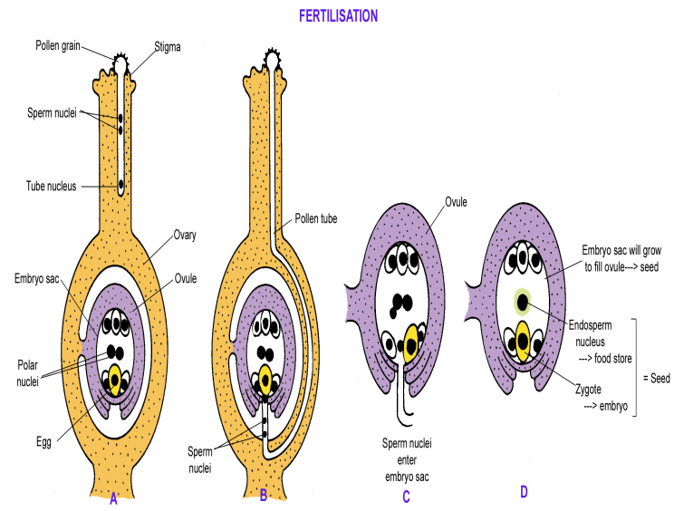

**Fertilisation:** The fusion of a male gamete with a female gamete to form a diploid zygote.

***Events leading to fertilisation***

* When the pollen grain lands on the stigma it germinates forming a pollen tube which grows down through the style to the opening of the embryo sac.
* The generative nucleus divides by mitosis in the tube to form two male gametes.
* One of these male gametes (n) fertilises the female gamete or egg (n) to form a diploid zygote (2n).
* After such fertilisation the **zygote** develops into an **embryo**.
* The second **male gamete** (n) fertilises the 2 **polar nuclei** (both n) resulting in the formation of the **endosperm** (3n)**.**

***Double fertilisation occurs:***

1. Fertilisation of an egg with a male gamete to form a diploid zygote, which develops into an **embryo.**
2. Fertilisation of male gamete with polar nuclei results in the formation of the **endosperm.**

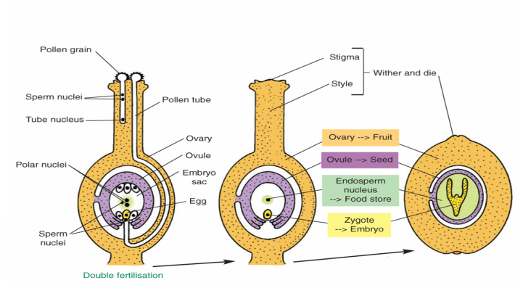

**Events after fertilisation leading to seed formation**

* The **fertilised ovule** becomes the **seed**.
* **Ovary** becomes the **fruit.**
* The **walls of the ovule** dry up to become the **testa**, the wall of the seed.
* **Zygote** becomes the **embryo** (made up of a radical, plumule, and cotyledons).
* **Endosperm nucleus** (3n) divides to form the **endosperm** (food store).

**Seed structure**

As the ovule develops a seed is formed which consists of

* an embryo and
* food supply.

The food supply is contained either in an endosperm (endospermic) or the cotyledons (non endospermic)

|  |  |
| --- | --- |
| **Part** | **Function** |
| Testa | Outer seed coat. Protects the seed. |
| Plumule | Young seed shoot |
| Radicle | Young seed root |
| Embryo | Develops into the young plant |
| Cotyledon | Young seed leaf. Stores food |
| Epicotyl | Region between Cotyledon and Plumule |
| Hypocotyl | Region between Cotyledon and Radicle |
| Endosperm | Food store |

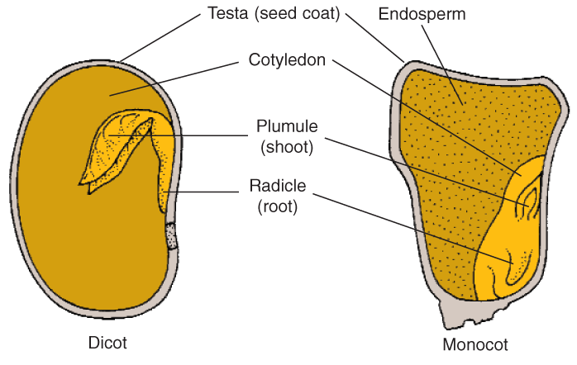

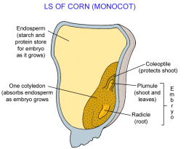

**Classification of seeds**

Seeds can be classified as

* **Monocotyledons:** containing one seed leaf. In monocots, the cotyledon rarely stores food. Instead it absorbs food molecules from the endosperm and passes them on to the embryo. This is known as an endospermic seed e.g. castor oil seed, corn seed
* **Dicotyledons:** containing two seed leaves. In dicots, the cotyledons usually store the food that the embryo uses. This is known as an non endospermic seed e.g. broad bean seed

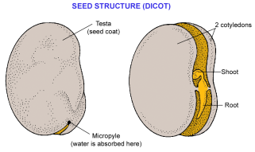

**Fruit formation**

* Developing seeds produce growth regulators to stimulate growth of fruit tissues.
* Seeds are protected by seed coat and may be contained within a fruit.
* **A fruit is a mature ovary** or sometimes a modified floral part (e.g. the receptacle) that may contain seeds.

**Dispersal:** is the transfer of a seed or fruit away from the parent plant.

**The need for dispersal.**

* Seeds are dispersed to ensure a better chance of survival.
* Dispersal avoids overcrowding
* Dispersal reduces competition.

**Examples of wind, water, animal and self dispersal.**

|  |  |  |  |
| --- | --- | --- | --- |
| **Wind dispersal** | **Water dispersal** | **Animal dispersal** | **Self dispersal** |
| Dandelion | Alders | Goose grass (sticky) | Peas |
| Sycamore | Water lilies | Buttercup (sticky) | Beans |
| Ash |  | Strawberries (edible) | gorse |
| Thistles |  | Blackberries (edible) |  |

**Dormancy. A** resting period when seeds undergo no growth and have reduced cell activity or metabolism.

Dormancy may be due to

* Growth inhibitors
* Testa impermeable to water
* Testa too tough
* Lack of growth regulators

**Advantages of dormancy.**

* Allows the plant survive the adverse conditions of winter.
* Give embryo time to fully develop.
* Maximises the growing season for the young plant i.e. starts to gow in spring and well developed by autumn.
* Can form a seed bank

**Germination:**

Is the regrowth of the embryo after a period of dormancy, if the environmental conditions are suitable.

**Factors necessary:**

* Water is needed to allow enzyme reactions to occur. Absorbed from the soil.
* Oxygen needed for aerobic respiration. Absorbed from the soil.
* Suitable temperature required to allow enzyme reactions to take place.

Note: Germination ends with the emergence of the radicle and plumule.

**GERMINATION**

**Stages of seedling growth (Broad bean)**

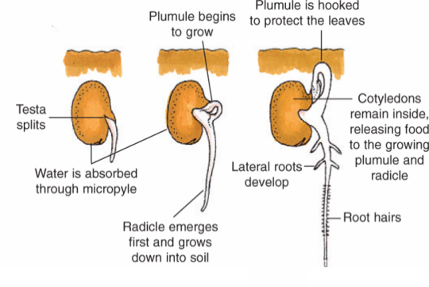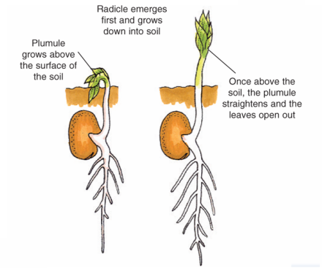

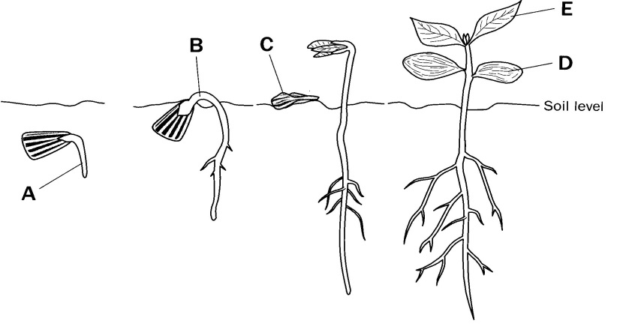

Germination in sunflower (same as broad bean with the differences listed below)

* The region between the emerging radicle and the cotyledons (hypocotyl) grows.
* Causes the cotyledons to be carried above the ground.
* The fruit wall falls off.
* Cotyledons open out, turn green and photosynthesise.
* Plumule emerges from between the cotyledons

**Role of digestion and respiration.**

**Role of digestion and respiration**

* Food stored in the seed in the form of oils, starch and protein.
* Germination begins when the seed absorbs water.
* In germinating seeds
  + Oils are digested to fatty acids and glycerol.
  + Starch is digested to glucose.
  + Proteins are digested to amino acids.
* Products of digestion are moved to the growing embryo.
* Glucose is used to make cell walls and is respired to produce energy.
* Amino acids are used to make enzymes.
* Fats are respired to produce energy.
* The dry weight (mass) of the seed falls due to foods used in respiration.
* As the weight of the food stores (endosperm/cotyledons) falls, the weight of the embryo increases.
* The radicle bursts through the testa.
* The plumule emerges above the ground and form the first foliage leaves.
* Once the leaves start to photosynthesise, the dry weight of the seedling increases again.

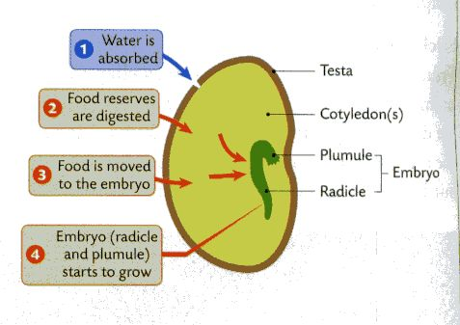

**Note: The Dry Weight of a seed is the weight without water.**

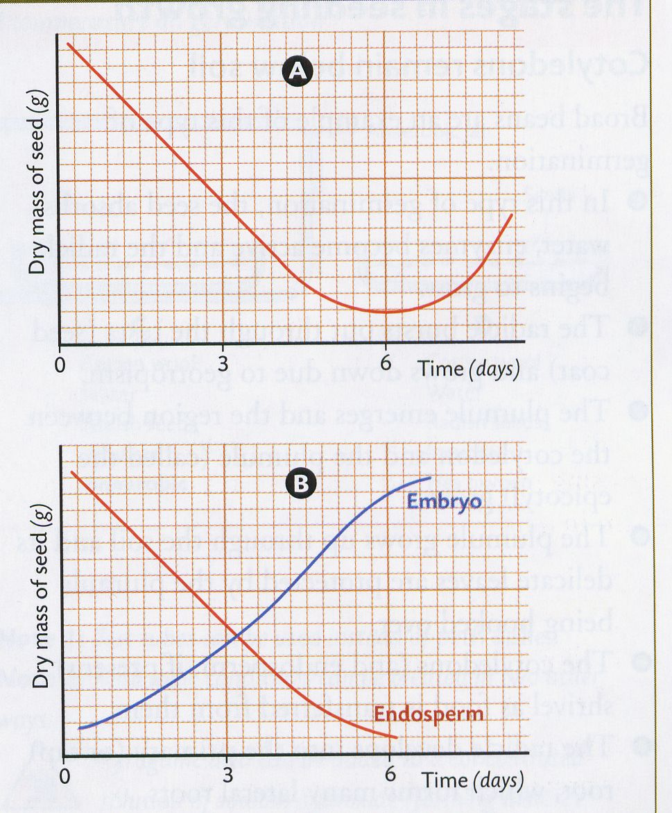

**In graph A**

* The mass of the seed falls from days 0-6, due to respiration.
* From day 6, it increases due to photosynthesis.

**In graph B**

* The loss of weight of the endosperm is matched by a rise in weight of the embryo.
* This suggests that food is passing from the endosperm to the embryo.

**Contemporary Issue**

The development of a fruit without a seed is called parthenocarpy The egg is not fertilised.

Ways of producing seedless fruits

* Seedless fruits can be formed genetically, either naturally or by special breeding programmes e.g. bananas, grapefruit,oranges, grapes.
* Spray plants with growth regulators. If large concentrations of growth regulators e.g. auxins are sprayed on flowers, fruits may form without fertilisation or the production of seeds e.g. seedless grapes, peppers, apricots.

Examples of uses of growth regulators

Growth regulators also cause fruit and vegetables to grow larger.

* The plant growth regulator ethene is used commercially to ripen many fruits.
* Ethene is also used to de green fruits by causing the breakdown of chlorophyll.
* Carbon dioxide inhibits the production of ethene. Fruits and apples can be stored in containers though which carbon dioxide is circulated. This allows apples to be picked in autumn and stored for use in the following summer.

**Dormancy in agricultural and horticultural practices.**

* Storage of seeds
* Stops germination

**Investigate the effect of water, oxygen and temperature on germination.**

* 1. I set up the four Petri dishes with cotton wool in each.
  2. I labelled the dishes A,B,C,D.
  3. In dish A, I left the cotton wool dry – seeds lacking water.
  4. I wet the cotton wool in each of the other dishes.
  5. I placed10 seeds in each dish.
  6. I placed dish D in the fridge – seeds lacking a suitable temperature.
  7. I placed C in the anaerobic jar with a GasPack to create an anaerobic environment– seeds lacking oxygen.
  8. I placed dishes A,B and C, in the incubator at 25oC for a few days. *(Dish B acts as a* ***contro****l – all conditions for germination present.)*
  9. I recorded the results.
  10. I replicated the investigation

Results

|  |  |
| --- | --- |
| **Dish** | **Germination** |
| A- with oxygen and suitable temperature (no water) | **NO** |
| D- with water, oxygen, and a suitable temperature. | **YES** |
| C- with water and suitable temperature (no oxygen) | **NO** |
| B- with water and oxygen (unsuitable temperature) | **NO** |

**Use starch agar or skimmed milk plates to show digestive activity during germination.**

1. I cleaned the lab bench with disinfectant (*kill microorganisms).*
2. 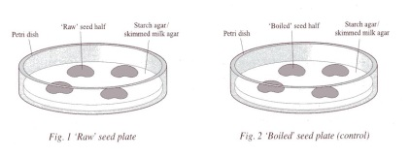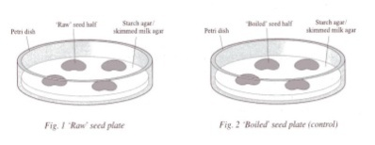I got 2 sterile starch agar plates and labelled them unboiled and boiled.
3. I got 4 soaked seeds.
4. I boiled 2 of the seeds. These acted as **controls**.
5. I split each seed in half*( to separate the cotyledons).*
6. I sterilised all seeds by soaking them in disinfectant and then rinsed them

**Boiled**

**Unboiled**

*( kills microorganisms on surface of seed)*

|  |  |
| --- | --- |
| **Unboiled: Test with iodine** | **Boiled: Test with iodine** |
| Blue black  clear areas under seed where starch digestion took place | All blue black – no clear areas |

1. I sterilised the forceps by flaming it in a Bunsen flame..
2. With minimal opening, I placed all the seed halves

facing down on the agar plates *(minimises contamination).*

1. I incubated the plates upright at 18oC-20oC for 48 hours *(allow germination).*
2. I removed the seeds from the plates.
3. I flooded the plates with iodine solution *(to test for starch)*
4. I poured off the iodine solution.
5. I recorded my results

**3.6.1 Asexual Reproduction**

**Vegetative Propagation (asexual reproduction)**

* Vegetative Propagation is a form of asexual reproduction in plants.
* Forms new plants from a stem, root, leaf or bud.
* Does not involve gametes, flowers, seeds or fruits.
* Only one plant involved.
* Offspring genetically identical to the parent.

**Methods of natural vegetative propagation**



**ROOT**

* A root tuber is a swollen, fibrous root.
* Dormant during winter.
* New shoots grow from the buds at the base of the old stem, which has withered away.
* Example: Dahlia

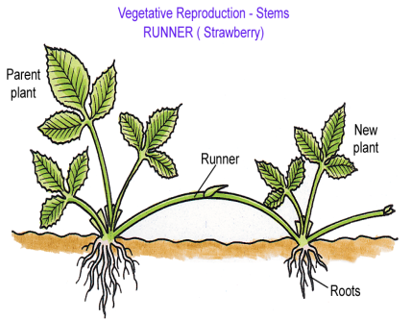**STEM**

* Runners are horizontal stems
* Run above the ground.
* Side stem grow out from a bud at the base of the main stem.
* Where the stem touches the ground a bud develops.
* A new plant with its own root system develops from the bud.
* Example: Strawberries

**BUDS**

* A bulb is a modified bud.
* Fleshy leaves contain food for new shoot.
* In spring the main bud produces new leaves and the flower.
* After flowering the leaves continue to make food which is passed back into the bulb for storage.
* The food enables the plant to survive through dormant periods of their life cycle.
* Example: Daffodil

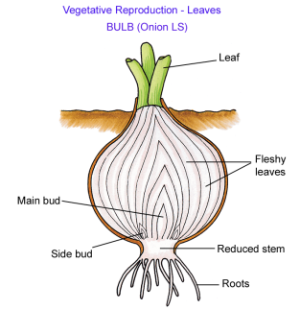

**LEAVES**

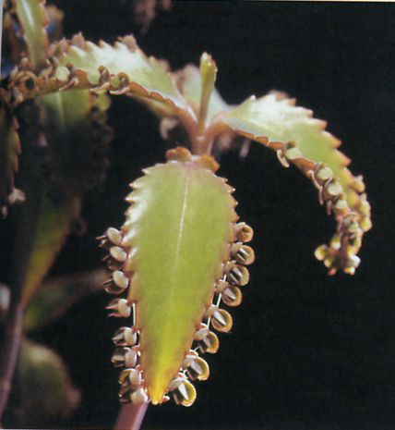

* Many plantlets develop along the length of parent plant.
* When they reach a certain size they fall off, take root and grow into new plants.
* Example: *Bryophyllum* (Mother of thousands)

**A comparison…..**

**Sexual Repoduction vs Asexual Reproduction**

|  |  |
| --- | --- |
| **Sexual (seed)** | **Asexual (Vegetative)** |
| ***Advantages*** | ***Disadvantages*** |
| Offspring show variation from parent | No variation |
| Some plants may be resistant to disease | If one plant susceptible to disease then all plants are. |
| Less competition due to seed dispersal | Overcrowding and competition |
| May remain dormant | No dormancy |
| ***Disadvantages*** | ***Advantages*** |
| Complex process | Simple process |
| Dependent on outside agents (pollination, dispersal) | No outside agents needed |
| Slow growth of young plant to maturity | Rapid growth as young plant attached to parent |
| Wasteful (petals, nectar, pollen, fruit, many seeds) | No waste |

**Contemporary Issue**

**Artificial Propagation**

This is the controlled vegetative reproduction of flowering plants by man ( farmers, gardeners, horticulturalists)

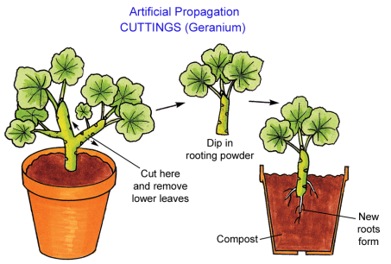

**Cutting:**

* Can be made from stem, root or leaf.
* Can be dipped in rooting powder (promotes root formation)
* When placed in suitable conditions will grow (e.g.compost).
* Easy, fast, cheap
* Example: Geranium

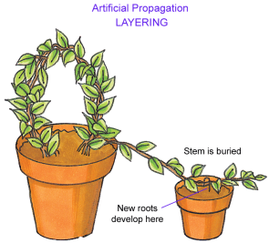

**Layering**

* A branch of the parent plant is bent down and covered in soil, except at the tip.
* Covered part forms roots and exposed tip forms new shoots.
* In time the two plants are separated.

**Grafting**

* 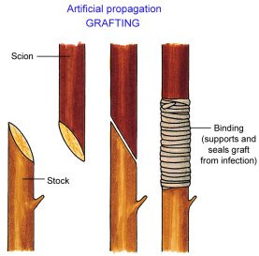Used to combine useful qualities or traits from two different plants into one plant
* New plant has both of the desirable features
* Part of one plant (scion) is removed and attached to a healthy, rooted part of a second plant (scion)
* The graft must achieve good contact between the growth areas (meristems) and vascular tissue of the stock and scion.
* Example: 2 different apple trees, one with good fruit but poor roots grafted to a tree with poor fruit but large strong roots.

**Micropropagation or Tissue Culturing**

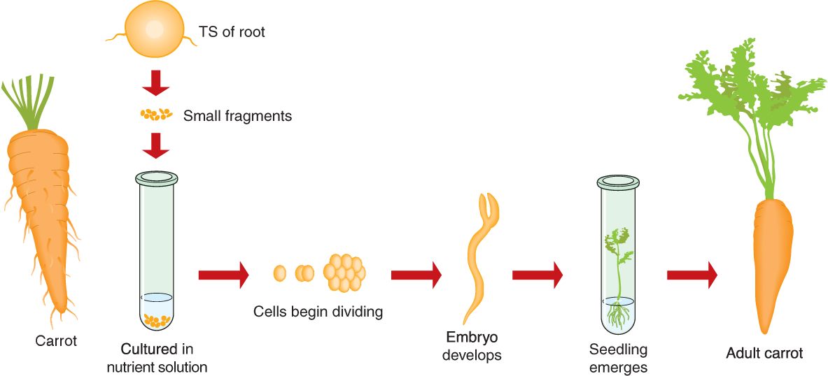

* The cells or small pieces of plant are grown on an artificial medium (e.g. agar)
* Nutrients and growth regulators are added.
* The cells develop into a small plant with roots and shoots.
* Expensive.
* Example: Carrots