3.5.3 Musculoskeletal system:
Description of the structure and functions of the skeleton.
Component parts of the axial skeleton: skull, vertebrate, ribs, and sternum. Position and function of discs in relation to vertebrae.
Component parts of the appendicular skeleton: pectoral and pelvic girdles and their attached limbs.
Macroscopic anatomy of a long bone: medullary cavity, compact bone, spongy bone and cartilage.
Function of the following: cartilage, compact bone, spongy bone ( include red and yellow bone marrows)T.S. of bone not required.
Clasification, location and function of joints: immovable, slightly movable, free-moving or synovial.
Role of cartilage and ligaments in joints.
Role of tendons.
General relation of muscles to the skeleton – antagonistic muscle pairs as exemplified by one human pair.
Contemporary Issue
Disorders of the musculoskeletal system:
One example of a musculoskeletal disorder, from the following: arthritis and osteoporosis; one possible cause, prevention and treatment.
Syllabus P.38

The Musculoskeletal system
Functions of the skeleton:
- Framework of the body
- Protection of internal organs
- Assists in movement

Structural division of the skeleton into two parts – the axial and appendicular.
Component parts of the axial skeleton: skull, vertebrae, ribs, and sternum.
Details of the skull not required.
Position and function of discs in relation to vertebrae.
Vertebrae:
Cervical (17), Thoracic (12), Lumbar (5), and coccyx (4).

Components of the appendicular skeleton:
Pectoral and pelvic girdles and their attached limbs.
Pectoral girdle:
Clavicle (collar bone)
Scapula (shoulder blade)
Attached appendages; humerous, radius, ulna, carpal, metacarpal, digits (fingers) containing phalanges.
Pelvic girdle;
Innominate bones (hip bones) attached to the sacrum surrounding a cavity.
Attached appendages;
Femur, patella, tibia, fibula, tarsals, metatarsals, digits (toes) containing phalanges.

Macroscopic anatomy of a long bone:
Not solid but contains a cavity called a medullary cavity bounded by compact bone tapering to spongy bone, a further layer of compact bone and finally a layer of cartilage.
Structure and function of parts as follows:
Cartilage:
- Acts as a shock absorber
- Composed of protein fibres
- Flexible
Compact bone:
- Gives strength and rigidty
- Consists of living cells which are supplied by blood vessels and nerve fibres.
Spongy bone
- Gives strength and rigidity
- Contains bony bars and plates separated by irregular spaces.
- These spaces are filled with red bone marrow that produces blood cells and yellow bone marrow that contains fat-storage tissue.
Note: T.S. of bone is not required.

Classification, location and function of joints
- Imovable: between skull bones
- Slightly movable: between the vertebrae and also between hip bones.
- Free moving or synovial: describe the structure of one synovial joint. Hinge: e.g. knee or elbow
Ball and socket e.g. hip or shoulder

Contemporary Issue
Disorders of the musculoskeletal system: one example of a musculoskeletal disorder from the following: arthritis and osteoporosis; one possible cause,prevention and treatment

Role of cartilage and ligaments in joints.
Role of tendons
General relation of muscles to the skeleton – antagonistic muscle pairs as exemplified by one human pair e.g. one muscle bends the joint and brings the the limb towards the body, the other muscle straightens the joint and extends the limb.
TG P 69

NOTES

Note
(When you were born, your skeleton had around 350 bones. By the time you become an adult, you will only have around 206 bones. This is because, as you grow, some of the bones join together to form one bone. )

Description of the structure and functions of the skeleton.
Structure:
Structural division of the skeleton into two parts – the axial and appendicular.
Axial skeleton:
Component parts of the axial skeleton: skull, vertebrae, ribs, and sternum.
(Details of the skull not required).
Position and function of discs in relation to vertebrae.
Vertebrae:
Cervical (17), Thoracic (12), Lumbar (5), and coccyx (4).

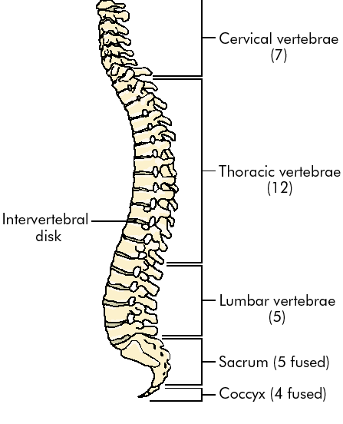

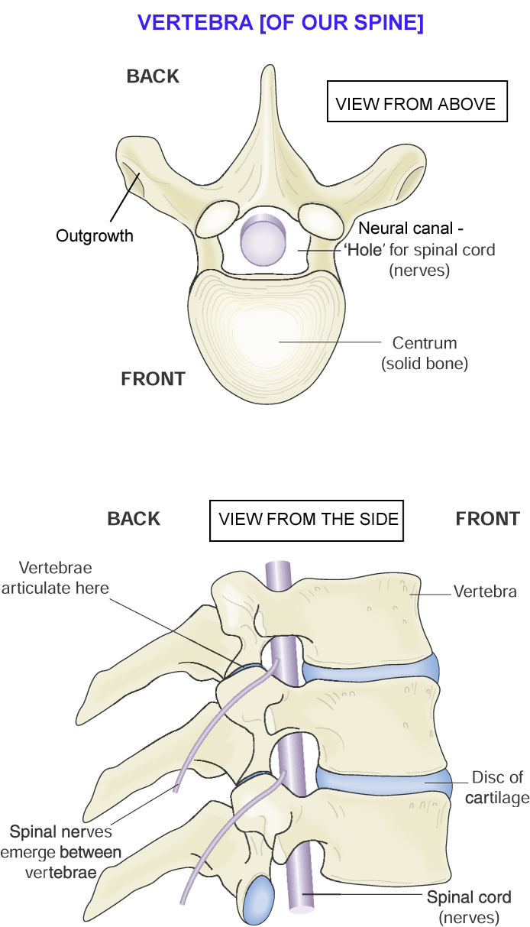

Appendicular skeleton:
Components of the appendicular skeleton:
Pectoral and pelvic girdles and their attached limbs.
Pectoral girdle:
Clavicle (collar bone)
Scapula (shoulder blade)
Attached appendages; humerous, radius, ulna, carpal, metacarpal, digits (fingers) containing phalanges.
Pelvic girdle;
Innominate bones (hip bones) attached to the sacrum surrounding a cavity.
Attached appendages;
Femur, patella, tibia, fibula, tarsals, metatarsals, digits (toes) containing phalanges.

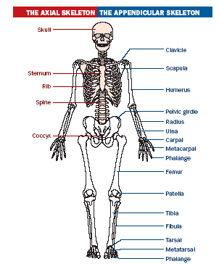

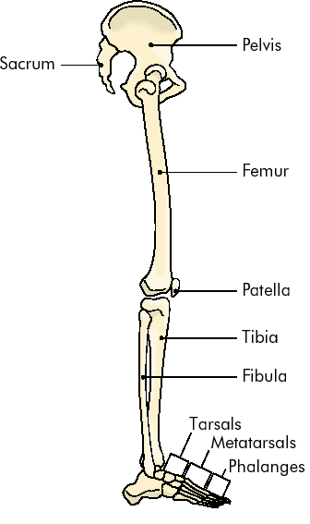
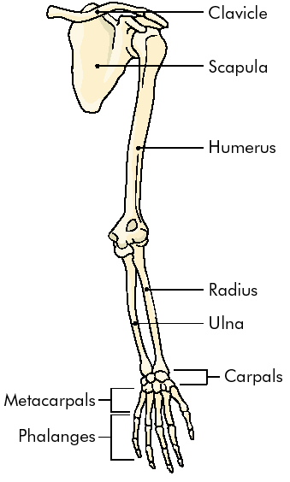

Functions of the skeleton:
- Framework of the body
- Protection of internal organs
- Assists in movement

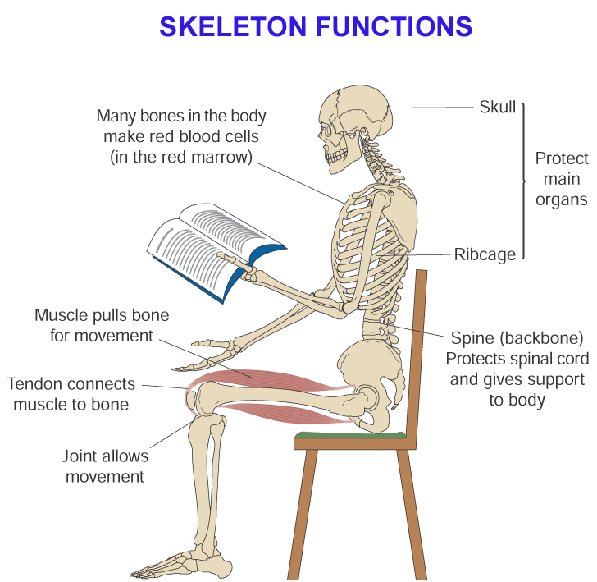

Bones
Macroscopic anatomy of a long bone: Medullary cavity, compact bone, spongy bone and cartilage.
Not solid but contains a cavity called a medullary cavity bounded by compact bone tapering to spongy bone, a further layer of compact bone and finally a layer of cartilage.
Structure and function of parts as follows:
Cartilage:
- Acts as a shock absorber
- Composed of protein fibres
- Flexible
Compact bone:
- Gives strength and rigidty
- Consists of living cells which are supplied by blood vessels and nerve fibres.
Spongy bone
- Gives strength and rigidity
- Contains bony bars and plates separated by irregular spaces.
- These spaces are filled with red bone marrow that produces blood cells and yellow bone marrow that contains fat-storage tissue.

Note (T.S. of bone not required).

Structure of Long Bone
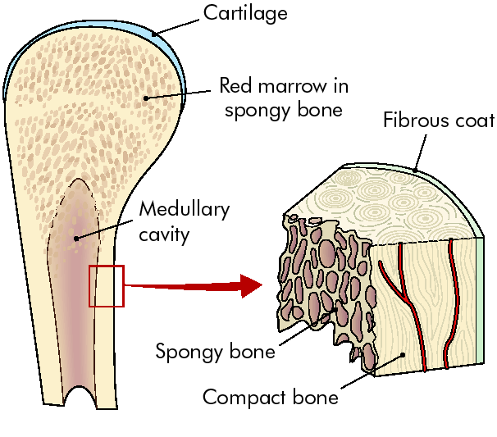

Joints
- Classification, location and function of joints: immovable, slightly movable, free-moving or synovial.
- Joints are found where bone meets bone.
Classification | Location | Function
Imovable | Between skull bones | No movement  Protection
Slightly movable | Between vertebrae  Between hip bones | Allow limited movement  Flexibility
Synovial (free moving) | Knee, elbow, hip, shoulder | Allows free movement
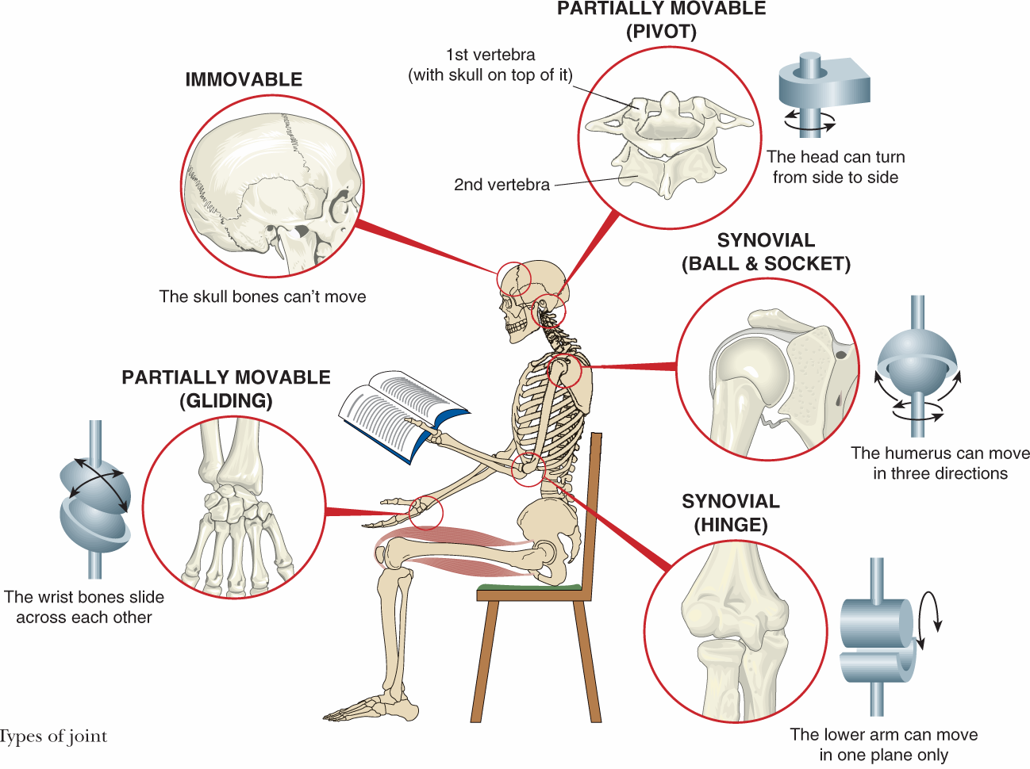

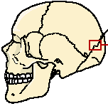
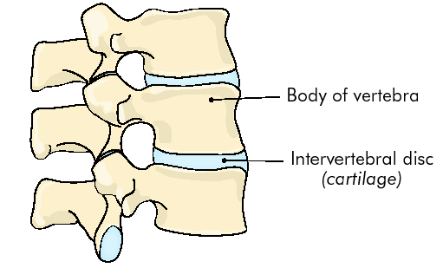

Imovable Joint Slightly Movable Joint

- Structure of a synovial joint:
Hinge e.g. knee or elbow, Ball and socket e.g. hip or shoulder
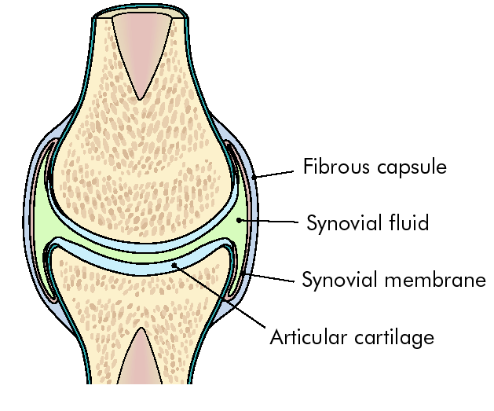

Lubricates the joint

Prevents wear and tear of bones

Role of cartilage and ligaments in joints.
Role of tendons.

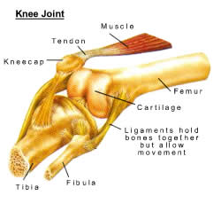
Tendons join muscle to bone
Tough
Inelastic
Ligaments join bone to bone.
Elastic to allow movement
Tough
Cartilage prevents the wear and tear of bone

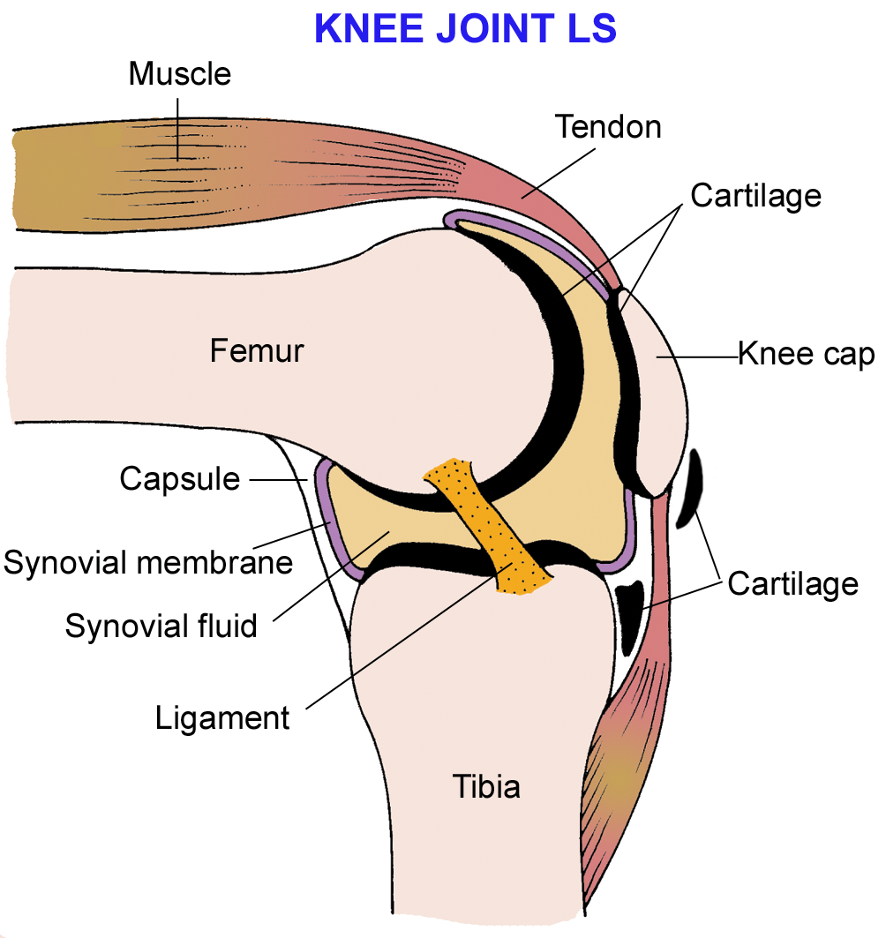

Antagonistic Muscles
Two muscles which cause opposite effects are known as antagonistic pairs of muscles. Muscles can only contract and relax and thus need to work in pairs.

Example:
In the human arm:
- One muscle (Biceps) bends the joint and brings the limb towards the body,
- The other muscle (Triceps) straightens the joint and extends the limb.

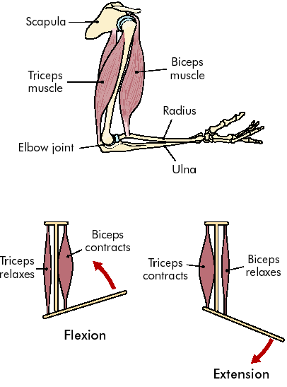

Contemporary Issue
Disorders of the musculoskeletal system: one example of a musculoskeletal disorder from the following: arthritis and osteoporosis; one possible cause, prevention and treatment

Osteoporosis:
Osteoporosis is a disease of the skeleton in which bone is lost and the bone that remains changes in structure.
This results in fragility and a greater likelihood of breakage.

Cause
The bones in the arms, legs and spine have two structurally different parts, cortical bone on the outside which is dense and compact and trabecular bone on the inside which is a honeycomb of vertical and horizontal bracing bars.This structure results in amazing strength.
In osteoporosis it is trabecular bone loss which occurs first and which has the most serious implications.
In the early stages of life bones grow in length, change in structure and undergo mineralization (become impregnated with calcium). By the age of 30, maximum bone mass is reached. These years are critical in terms of maximising the amount of bone which is deposited: a healthy, calcium-rich diet and exercise will result in a higher bone mass and consequently greater strength.
From then on growth is replaced by continuous change in which old bone is resorbed by specialised cells called osteoclasts. To balance this, new bone is deposited by another type of cell called an osteoclast. However, new bone formation is slightly outpaced by bone loss, so that the total skeleton mass slowly declines.
Osteoporosis is caused when more bone is lost over a period of time than is deposited.
Finally, the rate of bone loss accelerates in women at the menopause and in both sexes in old age, correlating with the onset of post-menoposal osteoporosis in women and age-related osteoporosis in both sexes.
Bone mass in females is lower than that of males at all stages of life and so have a greater likelihood of developing osteoporosis.
During and after the menopause there is a marked fall in the production of the sex hormone, oestrogen. Without oestrogen, bones gradually become brittle and prone to breakage.
Research has shown that oestrogen is very beneficial in preventing bone loss and preventing the development of brittle bones – hence the development of hormone replacement therapy (HRT). Bone loss may also accelerate in the elderly of both sexes and in association with some diseases and certain kinds of treatment.

Prevention
In childhood and early youth, provision of adequate calcium and vitamin D especially in females. Vitamin D increases the absorption of calcium from food and plays a vital role in bone mineralization. A well balanced and calcium rich diet and adequate exposure to sunlight are the best route to this.

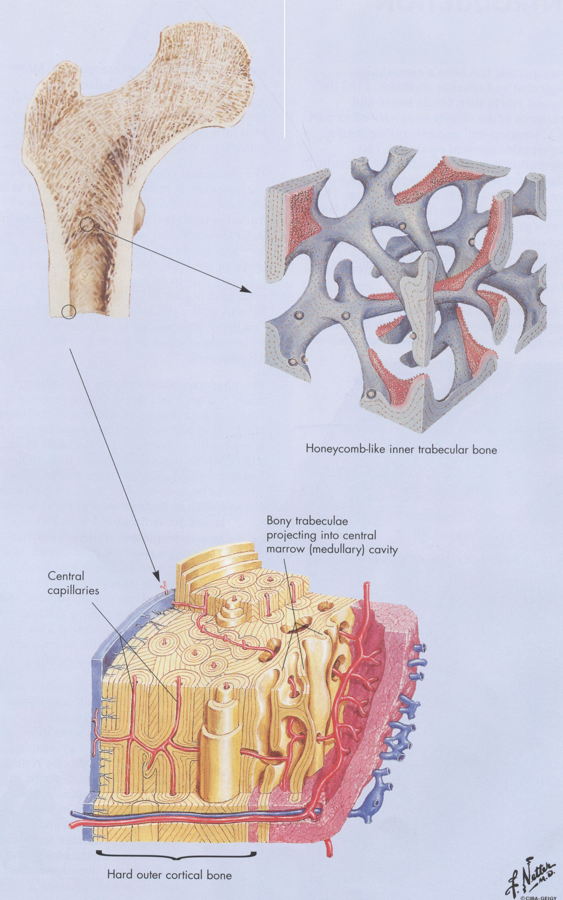
Diagram of bone structure

Nutritional factors
Ethnic origins

Oestrogen level
Genetic factors

OSTEOPOROSIS

Vitamin D

Physical activity

Body build

Factors which affect the risk of getting osteoporosis

Treatment
- For women entering or after menopause, the most widely used is HRT.
- Biphosphonates are non-hormone compounds which bind to trabecular bone and reduce bone loss and so improve bone mass and strength. They have been shown to reduce fractures associated with osteoporosis.
- Calcitonin, a natural hormone produced in the human thyroid gland. It seems to play a part in preventing bone loss.
- Dietary supplements of calcium and Vitamin D may help
Point of information: How Many Bones?
- Skull and upper jaw 21 bones
- 3 tiny bones in each ear
- Lower jaw (mandible)
- Front neck bone (hyoid)
- Backbone or spine (24 vertebrae)
- Sacrum
- Coccyx
- Ribs (12 pairs - same number for men and women)
- Breastbone
- Each upper limb has 32 bones: 2 in shoulder, 3 in arm, 8 in wrist, 19 in hand and fingers.
- Each lower limb has 31 bones: 1 in hip (one side of pelvis), 4 in leg, 7 in ankle, 19 in foot and toes.
Total = 206 bones

